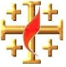

**15 Points**

Name: Class:

**The Book of JOSHUA**

**Yr 6 Holy Bible Study**

**Chapter 7 - *The Sin of Ach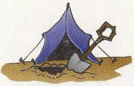an***

1. **Who exactly committed the trespass regarding the accursed things? (Name the person, name their father and to which tribe they belonged to)**

**____________________________________________________________________________**

**____________________________________________________________________________**

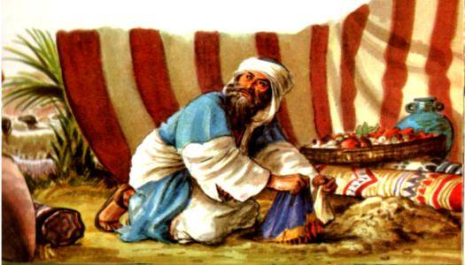

1. **What was the trespass that was committed?**

**____________________________________________________________________________**

**____________________________________________________________________________**

1. **Find the below words in the ‘Word Search’**

ACHAN - AMORITES - ARK OF THE COVENANT – CAMP – CITY – COMPASSED - CURSED

DESTROYED – FIRE – GARMENT – JERICHO – JOSHUA – KING – PRIESTS – SILVER

SON OF CARMI – SPIES – STONES – THEFT- TREASURY OF THE LORD - VALLEY OF ACHOR – VESSELS – ZARHITES



1. **To find out who committed the sin, Joshua firstly took the entire tribe, then the entire family, then the household and then man by man. Don’t you think Achan should have confessed earlier? (But he waited until they found him and then he confessed. So God gave him a chance to come out with the truth and to confess and ask God’s forgiveness, but he chose not to confess his sin), How do you think we can learn from this?**

[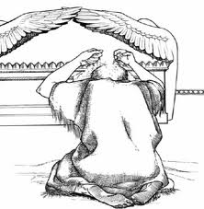](http://images.google.com.au/imgres?imgurl=http://www.calvary-kids-pages.com/5a213_files/image002.jpg&imgrefurl=http://www.calvary-kids-pages.com/5a213.html&usg=__adBBSKbk1HWh7bkklB96Z2WZ9qs=&h=586&w=575&sz=46&hl=en&start=1&tbnid=4apbP0NolPJsDM:&tbnh=135&tbnw=132&prev=/images?q=Joshua+gets+defeated+at+Ai&gbv=2&hl=en)**______________________________________________________________________**

**_____________________________________________________________________**

**Chapter 8 - *The Fall of Ai***

1. **After the sin of Achan was taken care of, The Lord asked the people to fight the city of Ai once more, this time how many men were sent in the war against Ai?**

**____________________________________________________________________________**

**____________________________________________________________________________**

1. **What was the sign that Joshua was to give the men of Israel in order to ambush the city of Ai?**

**____________________________________________________________________________**

**____________________________________________________________________________**

1. **After the destruction of Ai, what did the Lord allow the people of Israel to take from the people of Ai?**

**____________________________________________________________________________**

**____________________________________________________________________________**

***MEMORY VERSE: “..O Israel; you cannot stand before your enemies until you take away the accursed thing from among you.” (Joshua 7:13)***

**Daily Readings:**

|  |  |  |
| --- | --- | --- |
| **Day** | **Reading** | **Tick** |
| **Sunday** | **Josh.7 : 1 – 15** |  |
| **Monday** | **Josh.7 : 16 – 26** |  |
| **Tuesday** | **Josh.8 : 1 – 10** |  |
| **Wednesday** | **Josh.8 : 11 – 20** |  |
| **Thursday** | **Josh.8 : 21 – 30** |  |
| **Friday** | **Josh.8 : 30 – 35** |  |
| **Saturday** | **Bible Study COMPLETE☺** |  |

PARENTS SECTION:

X_____________________________________

This section is for the parents to sign the Holy Bible Study sheet. We kindly ask you as a parent to read (a little each day) in the Holy Bible with your family. You may wish to read The Book of Joshua with Sunday School. Please let us know below what you’re reading with your child and if you have any questions.