

**15 Points**

**The Book of JOSHUA**

**YEAR 6 Holy Bible Study**

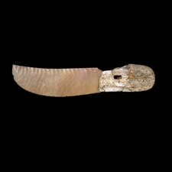**Chapter 5: *The Covenant***

**1. Why did God ask Joshua to circumcise the children of Israel?**

________________________________________________________________

*Knife made from flint stone Joshua 5:2*

________________________________________________________________

**2. What does the circumcision mean to the Jews (Hint: Genesis 17:3-11)?**

____________________________________________________________________________________________

____________________________________________________________________________________________

**3. Who is the Man (capital M) in verse 13?**

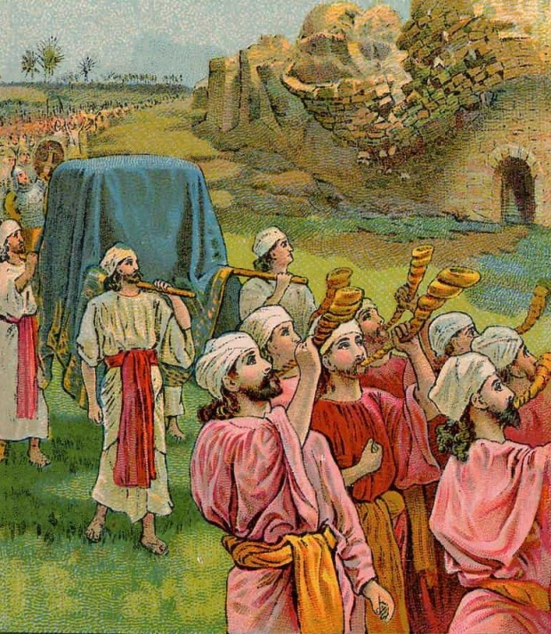____________________________________________________________________________________________

**Chapter 6: *The fall of Jericho***

**4. Complete the missing words**

The Israelites surrounded the _________ of Jericho, and began to walk for _________ days. At the front of the groups walked _______priests carrying _________. Behind them was carried the __________ of _________.

For each of the first ________ days, the Israelites walked in silence around the city, but on the _______ day, they walked ______ times around the city. On that last day, the priests at the front blew their _________ and the people behind them _____________. The _________ of the city fell down.

|  |  |  |
| --- | --- | --- |
| **DAY** | **READING** | **TICK** |
| **Sunday** | **Joshua 5: 1 - 7** |  |
| **Monday** | **Joshua 5 : 8 - 15** |  |
| **Tuesday** | **Joshua 6 : 1 - 11** |  |
| **Wednesday** | **Joshua 6 : 12 - 19** |  |
| **Thursday** | **Joshua 6 : 20 – 26** |  |
| **Friday** | **Bible Study Complete ☺** |  |
| **Saturday** | **Bible Study Complete ☺** |  |

_______________________________________

PARENTS SECTION:

This section is for the parents to sign the Holy Bible Study sheet.

We kindly ask you as a parent to read (a little each day) in the Holy Bible with your family. You may wish to read The Book of Joshua with Sunday School. Please let us know below what you’re reading with your child and if you have any questions.