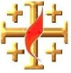

**15 Points**

**The Book of JOSHUA**

**YEAR 6 Holy Bible Study**

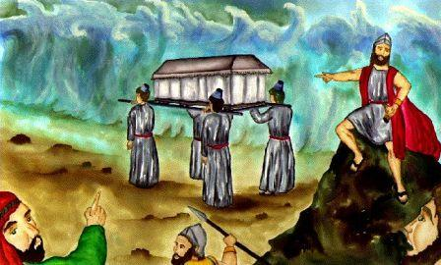**CHAPTER 3 & 4**

**CIRCLE THE CORRECT WORDS:**

1. "So it was, when the people set out from their camp to cross over the (NILE, JORDAN),with the priests bearing the (ARK, ART) of the covenant before the people, and as those who bore the ark came to the Jordan, and the feet of the priests who bore the ark dipped in the edge of the water (for the Jordan overflows all its banks during the whole time of harvest), that the waters which came down from upstream stood (STRONG, STILL), and rose in a heap very far away at Adam, the city that is beside Zaretan. So the waters that went down into the Sea of the Arabah, the Salt Sea, failed, and were cut off; and the people (CROSSED, STOPPED) over opposite Jericho."

**FILL IN THE BLANKS:**

2. "Then the ____________who bore the ark of the covenant of the LORD stood firm on ______ ground in the midst of the Jordan; and all Israel crossed over on dry ground, until all the people had _____________ completely over the Jordan."

**CIRCLE THE CORRECT WORDS:**

**3.** “Take for yourselves ______ men from the people, one man from each tribe.” TWELVE TEN FIFTEEN

4. “And those twelve ______ which they took from the Jordan; Joshua set up in Gilgal.” FISH STONES SHELLS

5. "That all the people of the earth may know the hand of the LORD, that it is ______, that you may fear the LORD your God forever.”

WEAK SCARED MIGHTY



1 ACROSS "That all the people of the earth may know the hand of the LORD, that it is _______, that you may fear the LORD your God forever.”

3 ACROSS "And Joshua said to the people, 'Sanctify yourselves, for tomorrow the LORD will do _________among you.’"

6 ACROSS “For the ________ your God dried up the waters of the Jordan before you until you had crossed over.”

7 ACROSS "The ________ went through the camp; and they commanded the people, saying, 'When you see the ark of the covenant of the LORD your God, and the priests, the Levites, bearing it, then you shall set out from your place and go after it.' "

8 ACROSS "So the waters that went down into the Sea of the Arabah, the Salt Sea, failed, and were cut off; and the people ________ over opposite Jericho."

1 DOWN "And the LORD said to Joshua, 'This day I will begin to ________ you in the sight of all Israel, that they may know that, as I was with Moses, so I will be with you.' "

2 DOWN "Take for yourselves ________ men from the people, one man from each tribe."

4 DOWN “And those twelve ________ which they took from the Jordan, Joshua set up in Gilgal.”

5 DOWN "Then the priests who bore the ark of the covenant of the LORD stood firm on ________ ground in the midst of the Jordan; and all Israel crossed over on dry ground, until all the people had crossed completely over the Jordan.

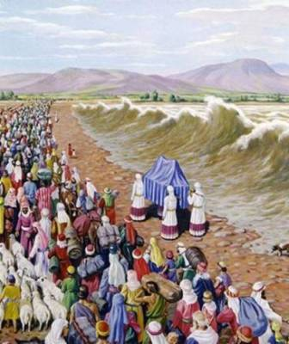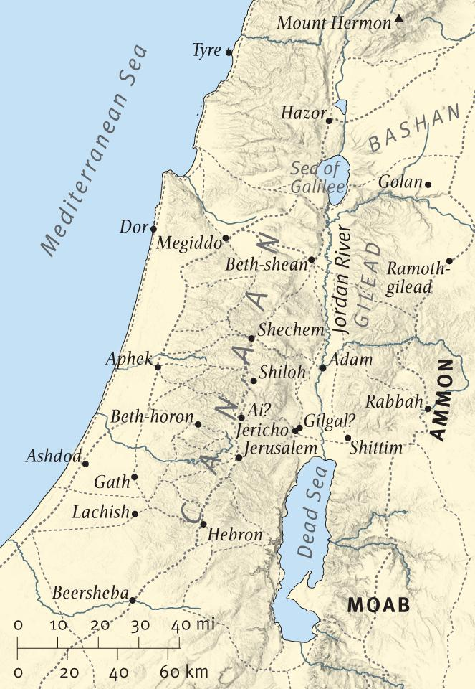

|  |  |  |
| --- | --- | --- |
| **DAY** | **READING** | **TICK** |
| **Sunday** | **Joshua 3: 1 - 6** |  |
| **Monday** | **Joshua 3 : 9 - 13** |  |
| **Tuesday** | **Joshua 3 : 14 - 17** |  |
| **Wednesday** | **Joshua 4 : 1 - 9** |  |
| **Thursday** | **Joshua 4 : 10 – 18** |  |
| **Friday** | **Joshua 4 : 19 - 24** |  |
| **Saturday** | **Bible Study Complete ☺** |  |

_______________________________________

PARENTS SECTION:

This section is for the parents to sign the Holy Bible Study sheet.

We kindly ask you as a parent to read (a little each day) in the Holy Bible with your family. You may wish to read The Book of Joshua with Sunday School. Please let us know below what you’re reading with your child and if you have any questions.