C:\Documents and Settings\suzy\Local Settings\Temporary Internet Files\Content.IE5\3JXW24R5\MC900383922[1].wmfSunday 16th August, 2015

Name:

Class:

Finish Date: Saturday 22nd August, 2015

Completed Bible Study = 15 points

Email Homework by the due date = 5 points

**Year 6 Bible Study John Chapter 21**

**For the questions below Highlight, underline or change the font colour to choose the correct answer.**

* Monday 17th August: Read **John Chapter 21: 1-5** and answer the questions:

### Breakfast by the Sea

*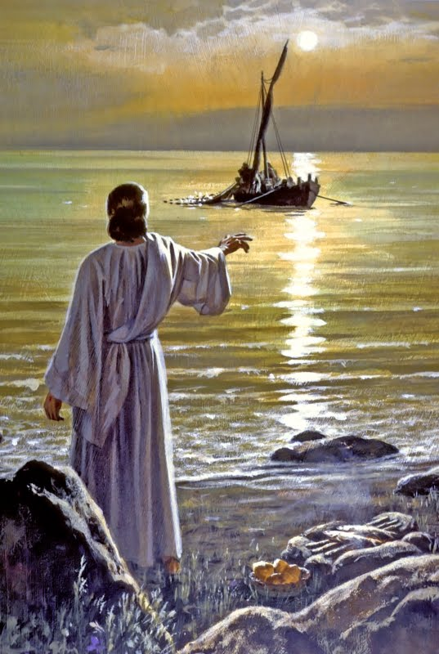1After these things Jesus showed Himself again to the disciples at the Sea of Tiberias, and in this way He showed Himself: 2Simon Peter, Thomas called the Twin, Nathanael of Cana in Galilee, the sons of Zebedee, and two others of His disciples were together. 3Simon Peter said to them, “I am going fishing.”*

*They said to him, “We are going with you also.” They went out and immediatelygot into the boat, and that night they caught nothing. 4But when the morning had now come, Jesus stood on the shore; yet the disciples did not know that it was Jesus. 5Then Jesus said to them, “Children, have you any food?”*

*They answered Him, “No.”*

**Question 1**

Did the disciples recognise Jesus when they first saw Him at the shore? Yes/ No

**Question 2**

1. How many times In Verse 1 were the words “showed Himself” said?
2. What do you think “showed Himself” means?

* Tuesday 25th August: Read **John Chapter 21: 6-10** and answer the questions:

### Breakfast by the Sea continued

*6And He said to them, “Cast the net on the right side of the boat, and you will find some.” So they cast, and now they were not able to draw it in because of the multitude of fish.*

*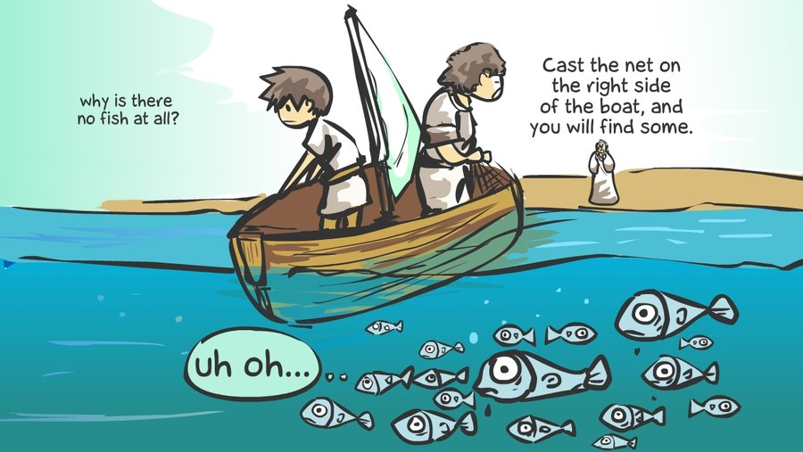7Therefore that disciple whom Jesus loved said to Peter, “It is the Lord!” Now when Simon Peter heard that it was the Lord, he put on his outer garment (for he had removed it), and plunged into the sea. 8But the other disciples came in the little boat (for they were not far from land, but about two hundred cubits), dragging the net with fish. 9Then, as soon as they had come to land, they saw a fire of coals there, and fish laid on it, and bread. 10Jesus said to them, “Bring some of the fish which you have just caught.”*

**Question 3**

The above passage tells us that Simon Peter put on his clothes as soon as he recognised that it was Jesus at the shore (he had previously taken off his clothes while he was fishing). What does this show about the way that we should approach Jesus, and the church?

**Question 4**

In last night’s homework you were asked to explain what was meant by “showed Himself”, which verses in the above passage did Jesus “showed Himself”? Give a reason for your answer.

* Wednesday 26th August: Read **John Chapter 21: 11-14** and answer the questions:

### Breakfast by the Sea continued:

*11Simon Peter went up and dragged the net to land, full of large fish, one hundred and fifty-three; and although there were so many, the net was not broken. 12Jesus said to them, “Come and eat breakfast.” Yet none of the disciples dared ask Him, “Who are You?”—knowing that it was the Lord. 13Jesus then came and took the bread and gave it to them, and likewise the fish.*

*14This is now the third time Jesus showed Himself to His disciples after He was raised from the dead.*

**Question 5**

Use the pictures and the words to fill in the blanks

**Jesus, fishing, successful, nothing, fish**

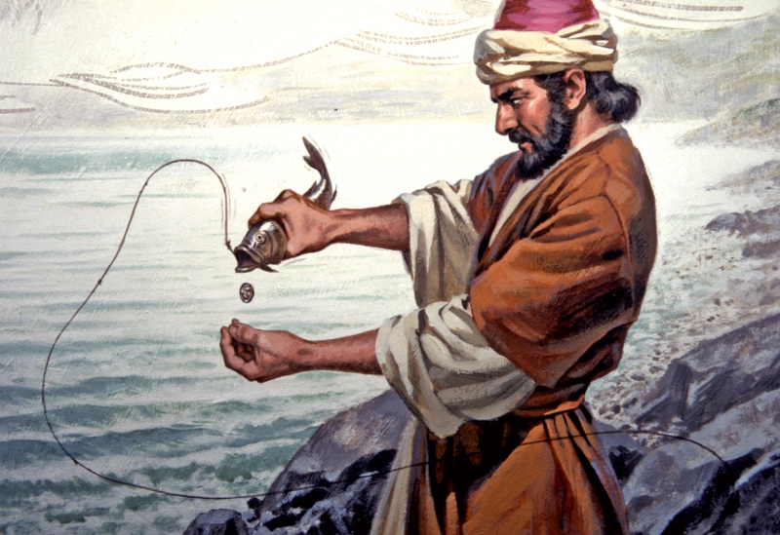

Simon Peter and the disciples wanted to go back to their old job of

but when they went out by themselves they

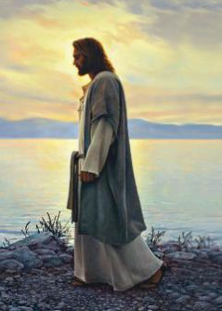

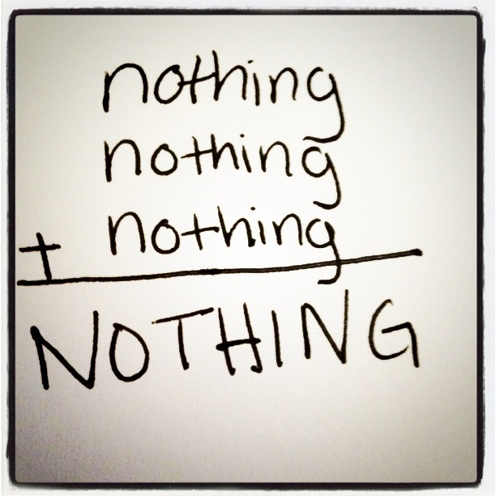

caught . It wasn’t until

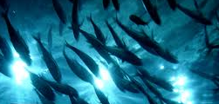

came, that they were able to catch 153

Showing that if we do not have God in everything that we do,



we will not be

* Thursday 27th August: Read **John Chapter 21: 15-17** and answer the questions:

### Breakfast by the Sea continued:

*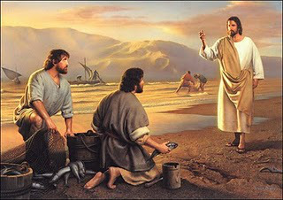15So when they had eaten breakfast, Jesus said to Simon Peter, “Simon, son of Jonah, do you love Me more than these?”*

*He said to Him, “Yes, Lord; You know that I love You.”*

*He said to him, “Feed My lambs.”*

*16He said to him again a second time, “Simon, son of Jonah, do you love Me?”*

*He said to Him, “Yes, Lord; You know that I love You.”*

*He said to him, “Tend My sheep.”*

*17He said to him the third time, “Simon, son of Jonah, do you love Me?” Peter was grieved because He said to him the third time, “Do you love Me?”*

*And he said to Him, “Lord, You know all things; You know that I love You.”*

*Jesus said to him, “Feed My sheep*

**Question 6**

Match the number with the event

153, 3, 1

|  |  |
| --- | --- |
|  | **The number of people that know all things** |
|  | **The amount of times that Jesus asked Simon Peter if he loved Him** |
|  | **The amount of fish that were caught before breakfast** |

**Question 7**

What was Jesus’ instruction to Simon Peter, a person that loved Him?

a) To keep the love of Jesus to himself

b) To look after others (feed and tend)

c) To run away from fishing

d) To ask people if they loved Jesus

* Friday 28th August: Read **John Chapter 21: 18-19** and answer the questions:

### Breakfast by the Sea continued

*18Most assuredly, I say to you, when you were younger, you girded yourself and walked where you wished; but when you are old, you will stretch out your hands, and another will gird you and carry you where you do not wish.” 19This He spoke, signifying by what death he would glorify God. And when He had spoken this, He said to him, “Follow Me.”*

**Question 8**

Who was the other person in the Bible that had to”stretch out” their hands, representing their death

a) John

b) Jesus

c) Judas

d) Lazarus

* Saturday 29th August: Read **John Chapter 21: 23-25** and answer the questions:

*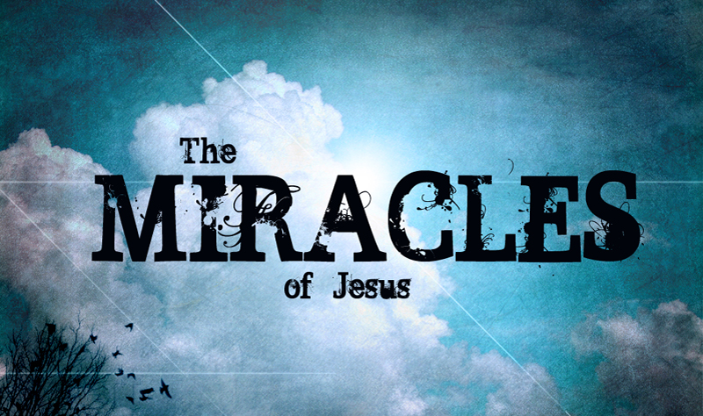23Then this saying went out among the brethren that this disciple would not die. Yet Jesus did not say to him that he would not die, but, “If I will that he remain till I come, what is that to you?”*

*24This is the disciple who testifies of these things, and wrote these things; and we know that his testimony is true.*

*25And there are also many other things that Jesus did, which if they were written one by one, I suppose that even the world itself could not contain the books that would be written. Amen.*

**Question 9**

Verse 25 tells us that if John had written down every single miracle that Jesus did that he would need an endless number of books. List 3 miracles that you have learnt about in the book of John.

1.

2.

3.

***What to do when you finish your Bible Study.***

1. ***Either send it by email to your class email address or print and hand it to your servants next Sunday.***
2. ***If you want to send your Bible Study by email, please select your class email address below:***

[stthomas6b1@gmail.com](mailto:stthomas6b1@gmail.com) Uncle George

[stpeter6b2@gmail.com](mailto:stpeter6b2@gmail.com) Uncle Mina

[stphilip6g@gmail.com](mailto:stphilip6g@gmail.com) Aunty Jacky

***Click on the following link to see how many points you have.***

**Year 6B1 (St Thomas)**  
[https://docs.google.com/spreadsheets/d/1B3hbaPWXLPr-bqV8YIabw159aKTkQlJ3I1pKK7mRhEI/edit?usp=sharing](https://webmail.meriden.nsw.edu.au/owa/redir.aspx?C=b6b7aaaa4ff64c008d6db035dc9d08cb&URL=https%3a%2f%2fdocs.google.com%2fspreadsheets%2fd%2f1B3hbaPWXLPr-bqV8YIabw159aKTkQlJ3I1pKK7mRhEI%2fedit%3fusp%3dsharing" \t "_blank)

**Year 6B2 (St Peter)**

[https://docs.google.com/spreadsheets/d/1-3aY66NbtvgQdVxKQsLKIN32-mekY1UfV-fU-a6A3aE/edit?usp=sharing](https://webmail.meriden.nsw.edu.au/owa/redir.aspx?C=b6b7aaaa4ff64c008d6db035dc9d08cb&URL=https%3a%2f%2fdocs.google.com%2fspreadsheets%2fd%2f1-3aY66NbtvgQdVxKQsLKIN32-mekY1UfV-fU-a6A3aE%2fedit%3fusp%3dsharing" \t "_blank)

**Year 6G (StPhilip)**

[https://docs.google.com/spreadsheets/d/1KKS7TLUdMux972uO8yehkyA-gpRY7so\_qA22MaRSM-I/edit?usp=sharing](https://webmail.meriden.nsw.edu.au/owa/redir.aspx?C=b6b7aaaa4ff64c008d6db035dc9d08cb&URL=https%3a%2f%2fdocs.google.com%2fspreadsheets%2fd%2f1KKS7TLUdMux972uO8yehkyA-gpRY7so_qA22MaRSM-I%2fedit%3fusp%3dsharing" \t "_blank)