C:\Documents and Settings\suzy\Local Settings\Temporary Internet Files\Content.IE5\3JXW24R5\MC900383922[1].wmfSunday 28th June, 2015

Name:

Class:

Finish Date: Saturday 4th July, 2015

Completed Bible Study = 15 points

Email Homework by the due date = 5 points

**Year 6 Bible Study John Chapter 20**

**For the questions below Highlight, underline or change the font colour to choose the correct answer.**

* Monday 29th June: Read **John Chapter 20: 1-10** and answer the questions:

**The Empty Tomb**

*1 Now on the first day of the week Mary Magdalene went to the tomb early, while it was still dark, and saw that the stone had been taken away from the tomb. 2Then she ran and came to Simon Peter, and to the other disciple, whom Jesus loved, and said to them, “They have taken away the Lord out of the tomb, and we do not know where they have laid Him.”*

*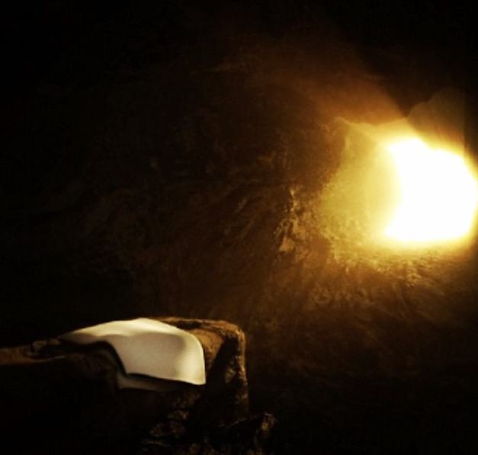3Peter therefore went out, and the other disciple, and were going to the tomb. 4So they both ran together, and the other disciple outran Peter and came to the tomb first. 5And he, stooping down and looking in, saw the linen cloths lying there; yet he did not go in. 6Then Simon Peter came, following him, and went into the tomb; and he saw the linen cloths lying there, 7and the handkerchief that had been around His head, not lying with the linen cloths, but folded together in a place by itself. 8Then the other disciple, who came to the tomb first, went in also; and he saw and believed. 9For as yet they did not know the Scripture, that He must rise again from the dead. 10Then the disciples went away again to their own homes.*

**Question 1**

Verse 2 says Simon Peter was with another disciple, and his description is “whom Jesus loved.” Who was he?

1. Judas
2. John
3. Matthew
4. James

**Question 2**

Read the following tradition and answer the question that follows.

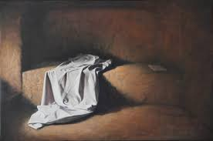

There is an old Jewish tradition that involved a servant with his master. When the servant set the dinner table for the master, he made sure that it was exactly the way that the master wanted it. The table was furnished perfectly, and then the servant would wait, just out of sight, until the master had finished eating, and the servant would not dare touch that table until the master was finished. If the master was done eating, he would rise from the table, wipe his fingers, his mouth, and clean his beard, and would wad up that napkin and toss it onto the table. The servant would then know to clear the table. For in those days, the wadded napkin meant, "I'm done". But if the master got up from the table, folded his napkin, and laid it beside his plate, the servant would not dare touch the table because the servant knew that the folded napkin meant, "I'm not finished yet". The folded napkin meant, "I'm coming back!"

How does this tradition relate to the fact that Simon Peter and John saw the cloth that wrapped Jesus’ head folded?

a) It’s not the same

b) It means that Jesus wanted more food to eat

c) It means that Jesus is “not finished yet” and is coming back for us!

d) It shows that we need to be neat when we are not finished with anything

* Tuesday 30th June: Read **John Chapter 20: 11-18** and answer the questions:

### Mary Magdalene Sees the Risen Lord

*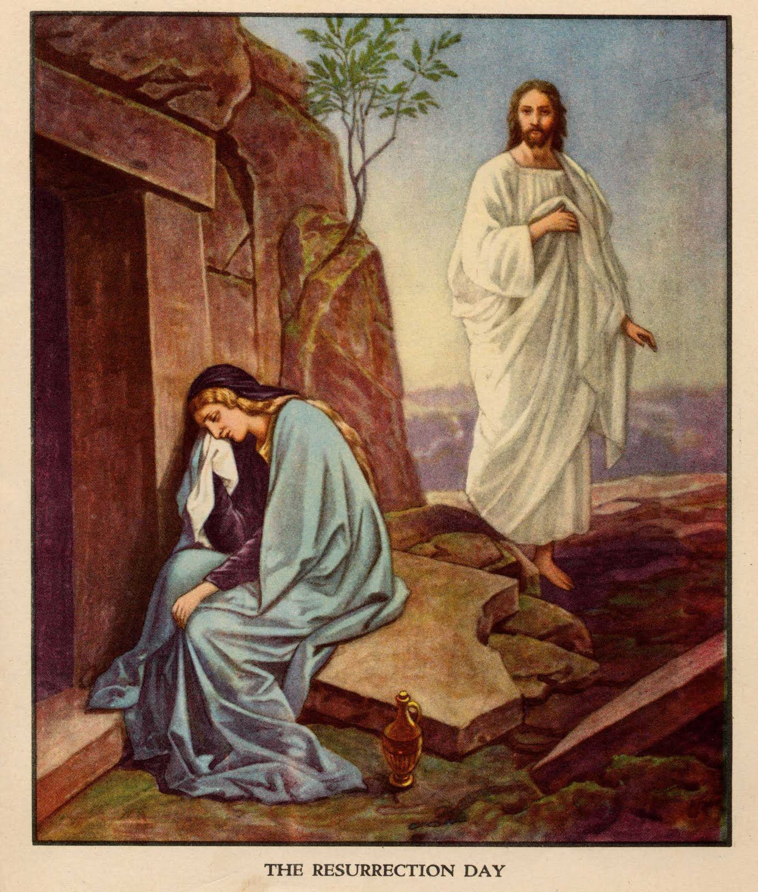11But Mary stood outside by the tomb weeping, and as she wept she stooped down and looked into the tomb. 12And she saw two angels in white sitting, one at the head and the other at the feet, where the body of Jesus had lain. 13Then they said to her, “Woman, why are you weeping?”*

*She said to them, “Because they have taken away my Lord, and I do not know where they have laid Him.”*

*14Now when she had said this, she turned around and saw Jesus standing there, and did not know that it was Jesus. 15Jesus said to her, “Woman, why are you weeping? Whom are you seeking?”*

*She, supposing Him to be the gardener, said to Him, “Sir, if You have carried Him away, tell me where You have laid Him, and I will take Him away.”*

*16Jesus said to her, “Mary!”*

*She turned and said to Him, “Rabboni!” (which is to say, Teacher).*

*17Jesus said to her, “Do not cling to Me, for I have not yet ascended to My Father; but go to My brethren and say to them, ‘I am ascending to My Father and your Father, and to My God and your God.’”*

*18Mary Magdalene came and told the disciples that she had seen the Lord, and that He had spoken these things to her.*

**Question 3**

**True/ False**

Mary was looking for Jesus in the tomb True/ False

Mary was weeping True/ False

There were angels in the tomb True/ False

Mary did not recognise Jesus first because she did not look up True/ False

Mary recognised Jesus after He said her name True/ False

Rabboni means teacher True/ False

Mary did not tell the other disciples that she had seen Jesus True/ False

* Wednesday 1st July: Read **John Chapter 20: 19-23** and answer the questions:

### The Apostles Commissioned

*19Then, the same day at evening, being the first day of the week, when the doors were shut where the disciples were assembled, for fear of the Jews, Jesus came and stood in the midst, and said to them, “Peace be with you.” 20When He had said this, He showed them His hands and His side. Then the disciples were glad when they saw the Lord.*

*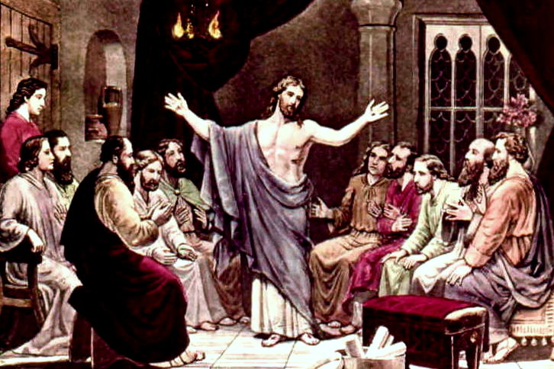*

*21So Jesus said to them again, “Peace to you! As the Father has sent Me, I also send you.” 22And when He had said this, He breathed on them, and said to them, “Receive the Holy Spirit. 23If you forgive the sins of any, they are forgiven them; if you retain the sins of any, they are retained.”*

**Question 4**

Highlight the correct word to complete the sentences

The discsiples were sitting in a (locked/open room.) They were (afraid/not afaraid) of the Jews blaming them for stealing the body of Jesus so they (hid/ stayed in the open.) Jesus appeared inside the room even though He (did/did not) knock on the door for the disciples to open it. When Jesus (breathed/spoke) on the disciples, they received the Holy Spirit and the ability to forgive sins.

* Thursday 2nd July: Read **John Chapter 20: 24-29** and answer the questions:

### Seeing and Believing

*24Now Thomas, called the Twin, one of the twelve, was not with them when Jesus came. 25The other disciples therefore said to him, “We have seen the Lord.”*

*So he said to them, “Unless I see in His hands the print of the nails, and put my finger into the print of the nails, and put my hand into His side, I will not believe.”*

*26And after eight days His disciples were again inside, and Thomas with them. Jesus came, the doors being shut, and stood in the midst, and said, “Peace to you!” 27Then He said to Thomas, “Reach your finger here, and look at My hands; and reach your hand here, and put it into My side. Do not be unbelieving, but believing.”*

*28And Thomas answered and said to Him, “My Lord and my God!”*

*29Jesus said to him, “Thomas, because you have seen Me, you have believed. Blessed are those who have not seen and yet have believed.”*

**Question 5**

Order the events that take place in this passage. The first one has been done for you.

**a)** Thomas believes **b)** Jesus appeared again to the disciples after 8 days **c)** Thomas told the disciples that the only way he would believe would be to put his finger into the mark of the nails **d)** Thomas was not with the disciples when Jesus appeared the first time **e)** Thomas sees Jesus and Jesus tells him to put his finger in His side **f)** Thomas did not believe that the disciples has seen Jesus

|  |  |  |  |  |  |
| --- | --- | --- | --- | --- | --- |
| **d** |  |  |  |  |  |

* Friday 3rd July: Read **John Chapter 20: 30-31** and answer the questions:

### That You May Believe

*30And truly Jesus did many other signs in the presence of His disciples, which are not written in this book; 31but these are written that you may believe that Jesus is the Christ, the Son of God, and that believing you may have life in His name.*

*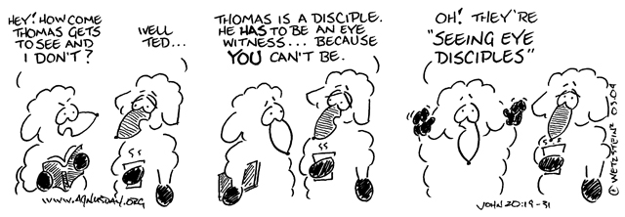***Question 6**

Why are some of these signs mentioned in the Bible?

* Saturday 4th July: Memory verse

For this question I would like you to open a Bible you have at home and find the verse John Chapter 20 verse 29, and copy into the textbox below. It is only one sentence. If you have trouble, ask your parents or an older brother or sister to help you.

HINT: New Testament, fourth book (John)

***What to do when you finish your Bible Study.***

1. ***Either send it by email to your class email address or print and hand it to your servants next Sunday.***
2. ***If you want to send your Bible Study by email, please select your class email address below:***

[stthomas6b1@gmail.com](mailto:stthomas6b1@gmail.com) Uncle George

[stpeter6b2@gmail.com](mailto:stpeter6b2@gmail.com) Uncle Mina

[stphilip6g@gmail.com](mailto:stphilip6g@gmail.com) Aunty Jacky

***Click on the following link to see how many points you have.***

**Year 6B1 (St Thomas)**  
[https://docs.google.com/spreadsheets/d/1B3hbaPWXLPr-bqV8YIabw159aKTkQlJ3I1pKK7mRhEI/edit?usp=sharing](https://webmail.meriden.nsw.edu.au/owa/redir.aspx?C=b6b7aaaa4ff64c008d6db035dc9d08cb&URL=https%3a%2f%2fdocs.google.com%2fspreadsheets%2fd%2f1B3hbaPWXLPr-bqV8YIabw159aKTkQlJ3I1pKK7mRhEI%2fedit%3fusp%3dsharing" \t "_blank)

**Year 6B2 (St Peter)**

[https://docs.google.com/spreadsheets/d/1-3aY66NbtvgQdVxKQsLKIN32-mekY1UfV-fU-a6A3aE/edit?usp=sharing](https://webmail.meriden.nsw.edu.au/owa/redir.aspx?C=b6b7aaaa4ff64c008d6db035dc9d08cb&URL=https%3a%2f%2fdocs.google.com%2fspreadsheets%2fd%2f1-3aY66NbtvgQdVxKQsLKIN32-mekY1UfV-fU-a6A3aE%2fedit%3fusp%3dsharing" \t "_blank)

**Year 6G (StPhilip)**

[https://docs.google.com/spreadsheets/d/1KKS7TLUdMux972uO8yehkyA-gpRY7so\_qA22MaRSM-I/edit?usp=sharing](https://webmail.meriden.nsw.edu.au/owa/redir.aspx?C=b6b7aaaa4ff64c008d6db035dc9d08cb&URL=https%3a%2f%2fdocs.google.com%2fspreadsheets%2fd%2f1KKS7TLUdMux972uO8yehkyA-gpRY7so_qA22MaRSM-I%2fedit%3fusp%3dsharing" \t "_blank)