C:\Documents and Settings\suzy\Local Settings\Temporary Internet Files\Content.IE5\3JXW24R5\MC900383922[1].wmfSunday 14th June, 2015

Name:

Class:

Finish Date: Saturday 20th June, 2015

Completed Bible Study = 15 points

Email Homework by the due date = 5 points

**Year 6 Bible Study John Chapter 18**

**For the questions below Highlight, underline or change the font colour to choose the correct answer.**

* Monday 15th June: Read **John Chapter 18: 1-11** and answer the questions:

### Betrayal and Arrest in Gethsemane

*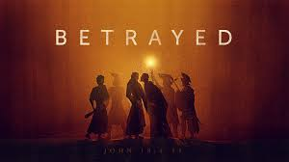1 When Jesus had spoken these words, He went out with His disciples over the Brook Kidron, where there was a garden, which He and His disciples entered. 2And Judas, who betrayed Him, also knew the place; for Jesus often met there with His disciples. 3Then Judas, having received a detachment of troops, and officers from the chief priests and Pharisees, came there with lanterns, torches, and weapons. 4Jesus therefore, knowing all things that would come upon Him, went forward and said to them, “Whom are you seeking?”*

*5They answered Him, “Jesus of Nazareth.”*

*Jesus said to them, “I am He.” And Judas, who betrayed Him, also stood with them. 6Now when He said to them, “I am He,” they drew back and fell to the ground.*

*7Then He asked them again, “Whom are you seeking?”*

*And they said, “Jesus of Nazareth.”*

*8Jesus answered, “I have told you that I am He. Therefore, if you seek Me, let these go their way,” 9that the saying might be fulfilled which He spoke, “Of those whom You gave Me I have lost none.”*

*10Then Simon Peter, having a sword, drew it and struck the high priest’s servant, and cut off his right ear. The servant’s name was Malchus.*

*11So Jesus said to Peter, “Put your sword into the sheath. Shall I not drink the cup which My Father has given Me?”*

**Question 1**

Why did Judas know that Jesus was going to be in the garden of Brook Kidron?

**Question 2**

What does this tell us about the type of things Jesus used to do?

1. He used to have a lot of quiet time to pray
2. He encouraged others to pray with Him
3. He would retreat from the world to “spiritually recharge”
4. All of the above

**Question 3**

True/ False

Jesus ran away when the soldiers asked for Him? True/False

Jesus wanted Simon Peter to use a sword to defend him True/False

**Question 4**

**Identify the people in the picture**

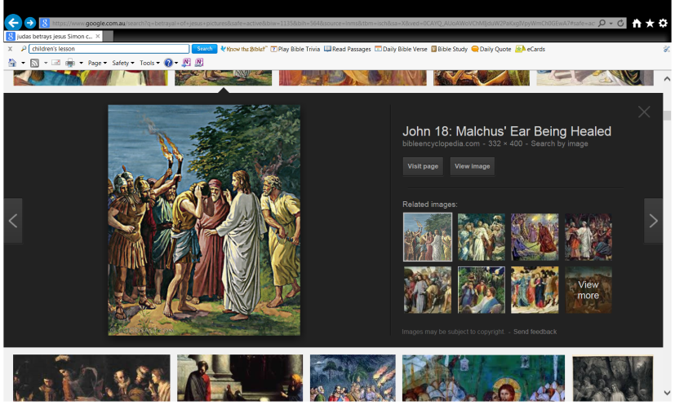

* Tuesday 16th June: Read **John Chapter 18: 12-14** and answer the questions:

### Before the High Priest

*12Then the detachment of troops and the captain and the officers of the Jews arrested Jesus and bound Him. 13And they led Him away to Annas first, for he was the father-in-law of Caiaphas who was high priest that year. 14Now it was Caiaphas who advised the Jews that it was expedient that one man should die for the people.*

**Question 5**

1. Who was Caiaphus?
2. What did Caiaphas advise the Jews of?

### Peter Denies Jesus

*15And Simon Peter followed Jesus, and so did another disciple. Now that disciple was known to the high priest, and went with Jesus into the courtyard of the high priest. 16But Peter stood at the door outside. Then the other disciple, who was known to the high priest, went out and spoke to her who kept the door, and brought Peter in. 17Then the servant girl who kept the door said to Peter, “You are not also one of this Man’s disciples, are you?”*

*He said, “I am not.”*

*18Now the servants and officers who had made a fire of coals stood there, for it was cold, and they warmed themselves. And Peter stood with them and warmed himself.*

**Question 6**

Out of the twelve disciples, how many stayed with Jesus through His trials? Who were they?

* Wednesday 17th June: Read **John Chapter 18: 19-24** and answer the questions:

### Jesus Questioned by the High Priest

*19The high priest then asked Jesus about His disciples and His doctrine.*

*20Jesus answered him, “I spoke openly to the world. I always taught in synagogues and in the temple, where the Jews always meet,and in secret I have said nothing. 21Why do you ask Me? Ask those who have heard Me what I said to them. Indeed they know what I said.”*

*22And when He had said these things, one of the officers who stood by struck Jesus with the palm of his hand, saying, “Do You answer the high priest like that?”*

*23Jesus answered him, “If I have spoken evil, bear witness of the evil; but if well, why do you strike Me?”*

*24Then Annas sent Him bound to Caiaphas the high priest.*

**Question 7**

When Jesus says that He preaches all things openly (Verse20-22), what do you think that this says about how we should be in regards to proclaiming our religion?

Is this something that you do? Why or why not? (write out your answers)

* Thursday 18th June: Read **John Chapter 18: 25-27** and answer the questions:

### Peter Denies Twice More

*25Now Simon Peter stood and warmed himself. Therefore they said to him, “You are not also one of His disciples, are you?”*

*He denied it and said, “I am not!”*

*26One of the servants of the high priest, a relative of him whose ear Peter cut off, said, “Did I not see you in the garden with Him?” 27Peter then denied again; and immediately a rooster crowed.*

**Question 8**

When had Jesus warned Peter that he would deny Him?

* Friday 19th June: Read **John Chapter 18: 28-38** and answer the questions:

### In Pilate’s Court

*28Then they led Jesus from Caiaphas to the Praetorium, and it was early morning. But they themselves did not go into the Praetorium, lest they should be defiled, but that they might eat the Passover. 29Pilate then went out to them and said, “What accusation do you bring against this Man?”*

*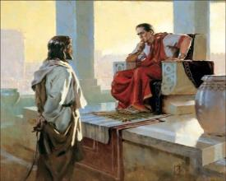30They answered and said to him, “If He were not an evildoer, we would not have delivered Him up to you.”*

*31Then Pilate said to them, “You take Him and judge Him according to your law.”*

*Therefore the Jews said to him, “It is not lawful for us to put anyone to death,” 32that the saying of Jesus might be fulfilled which He spoke, signifying by what death He would die.*

*33Then Pilate entered the Praetorium again, called Jesus, and said to Him, “Are You the King of the Jews?”*

*34Jesus answered him, “Are you speaking for yourself about this, or did others tell you this concerning Me?”*

*35Pilate answered, “Am I a Jew? Your own nation and the chief priests have delivered You to me. What have You done?”*

*36Jesus answered, “My kingdom is not of this world. If My kingdom were of this world, My servants would fight, so that I should not be delivered to the Jews; but now My kingdom is not from here.”*

*37Pilate therefore said to Him, “Are You a king then?”*

*Jesus answered, “You say rightly that I am a king. For this cause I was born, and for this cause I have come into the world, that I should bear witness to the truth. Everyone who is of the truth hears My voice.”*

*38Pilate said to Him, “What is truth?” And when he had said this, he went out again to the Jews, and said to them, “I find no fault in Him at all.*

**Do you know what a Praetorium is?**

*It was in the praetorium that Jesus was questioned by Pilate.*

*The* [*Greek*](http://bible-library.com/dictionary?bookid=44&chapter=0&term=Greek) *word (praitorion) means "common* [*hall*](http://bible-library.com/dictionary?bookid=44&chapter=0&term=hall)*" , "governor's house", "judgment hall," , "Pilate's house", "palace" .*

*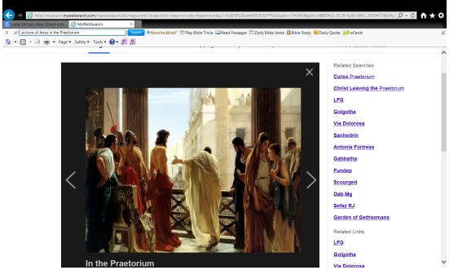This is properly a military word.*

* *It denotes general's* [*tent*](http://bible-library.com/dictionary?bookid=44&chapter=0&term=tent) *or headquarters;*
* *the* [*governor*](http://bible-library.com/dictionary?bookid=44&chapter=0&term=governor)*'s residence,*

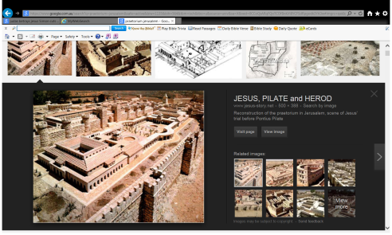

Reconstruction of the praetorium in Jerusalem, scene of Jesus' trial before Pontius Pilate

**Question 9**

Locate the praetorium on the map below

1. 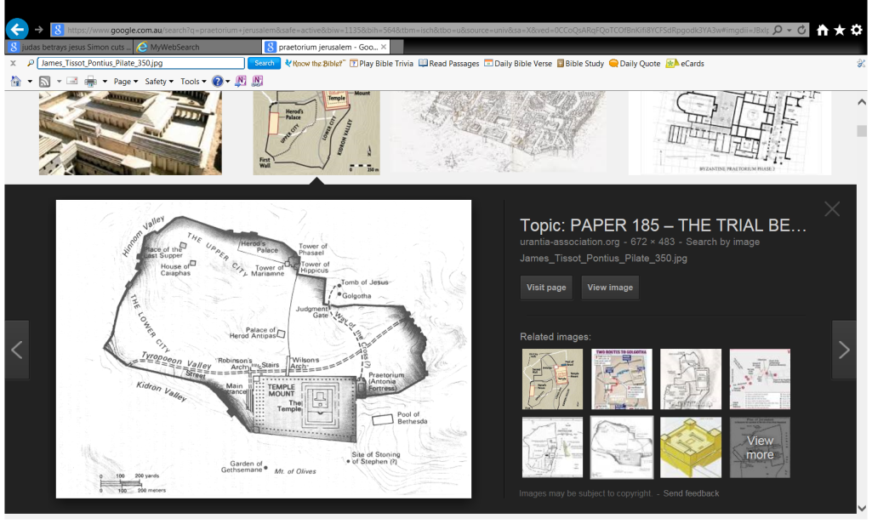A
2. B
3. C
4. D

**B**

**D**

**A**

**C**

**Question 10**

Fill in the blanks

My kingdom is not of this If my were of this world, My servants would

so that I should not be delievered to the but now My

is not from here.”

**Question 11**

Match the names of people listed below to an action carried out by the person:

Malchus, Barabbas, Caiaphas, Peter

|  |  |
| --- | --- |
| **Name** | **Action carried out by the person** |
|  | I was warming myself around a coal of fire while Christ was being  Questioned. |
|  | I was released from prison and Christ took my place. |
|  | My ear was cut off but Christ healed me. |
|  | I advised the Jews it was expedient that one man should die for the  People. |

* Saturday 20th June: Read **John Chapter 18: 39-40** and answer the questions

### Taking the Place of Barabbas

*39“But you have a custom that I should release someone to you at the Passover. Do you therefore want me to release to you the King of the Jews?”*

*40Then they all cried again, saying, “Not this Man, but Barabbas!” Now Barabbas was a robber.*

**Question 12**

Use the images and words below to complete the phrase.

**Jesus, High Priests, crowd, Barabbas**

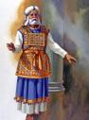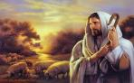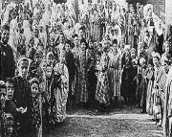

The turned all of the against

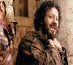

and asked Pilate to release

***What to do when you finish your Bible Study.***

1. ***Either send it by email to your class email address or print and hand it to your servants next Sunday.***
2. ***If you want to send your Bible Study by email, please select your class email address below:***

[stthomas6b1@gmail.com](mailto:stthomas6b1@gmail.com) Uncle George

[stpeter6b2@gmail.com](mailto:stpeter6b2@gmail.com) Uncle Mina

[stphilip6g@gmail.com](mailto:stphilip6g@gmail.com) Aunty Jacky

***Click on the following link to see how many points you have.***

**Year 6B1 (St Thomas)**  
[https://docs.google.com/spreadsheets/d/1B3hbaPWXLPr-bqV8YIabw159aKTkQlJ3I1pKK7mRhEI/edit?usp=sharing](https://webmail.meriden.nsw.edu.au/owa/redir.aspx?C=b6b7aaaa4ff64c008d6db035dc9d08cb&URL=https%3a%2f%2fdocs.google.com%2fspreadsheets%2fd%2f1B3hbaPWXLPr-bqV8YIabw159aKTkQlJ3I1pKK7mRhEI%2fedit%3fusp%3dsharing)

**Year 6B2 (St Peter)**

[https://docs.google.com/spreadsheets/d/1-3aY66NbtvgQdVxKQsLKIN32-mekY1UfV-fU-a6A3aE/edit?usp=sharing](https://webmail.meriden.nsw.edu.au/owa/redir.aspx?C=b6b7aaaa4ff64c008d6db035dc9d08cb&URL=https%3a%2f%2fdocs.google.com%2fspreadsheets%2fd%2f1-3aY66NbtvgQdVxKQsLKIN32-mekY1UfV-fU-a6A3aE%2fedit%3fusp%3dsharing)

**Year 6G (StPhilip)**

[https://docs.google.com/spreadsheets/d/1KKS7TLUdMux972uO8yehkyA-gpRY7so_qA22MaRSM-I/edit?usp=sharing](https://webmail.meriden.nsw.edu.au/owa/redir.aspx?C=b6b7aaaa4ff64c008d6db035dc9d08cb&URL=https%3a%2f%2fdocs.google.com%2fspreadsheets%2fd%2f1KKS7TLUdMux972uO8yehkyA-gpRY7so_qA22MaRSM-I%2fedit%3fusp%3dsharing)