C:\Documents and Settings\suzy\Local Settings\Temporary Internet Files\Content.IE5\3JXW24R5\MC900383922[1].wmfSunday 7th June, 2015

Name:

Class:

Finish Date: Saturday 13th June, 2015

Completed Bible Study = 15 points

Email Homework by the due date = 5 points

**Year 6 Bible Study John Chapter 17**

**For the questions below Highlight, underline or change the font colour to choose the correct answer.**

* Monday 8th June: Read **John Chapter 17: 1-5** and answer the questions:

### Jesus Prays for Himself

*17 Jesus spoke these words, lifted up His eyes to heaven, and said: “Father, the hour has come. Glorify Your Son, that Your Son also may glorify You, 2as You have given Him authority over all flesh, that He should give eternal life to as many as You have given Him. 3And this is eternal life, that they may know You, the only true God, and Jesus Christ whom You have sent. 4I have glorified You on the earth. I have finished the work which You have given Me to do. 5And now, O Father, glorify Me together with Yourself, with the glory which I had with You before the world was.*

**Question 1**

According to this prayer by Jesus, what is eternal life? Write down the verse number that tells you this

* Tuesday 9th June: Read **John Chapter 17: 6-8** and answer the questions:

### Jesus Prays for His Disciples

*6“I have manifested Your name to the men whom You have given Me out of the world. They were Yours, You gave them to Me, and they have kept Your word. 7Now they have known that all things which You have given Me are from You. 8For I have given to them the words which You have given Me; and they have received them, and have known surely that I came forth from You; and they have believed that You sent Me.*

**Do you know what the word “Manifest” means?**

*To make clear, or show plainly- On His time on earth, Jesus made sure that everybody knew the name of God*

**Question 2**

In these few verses Jesus shows us a very important message- that ALL things that He had on earth were from God the Father. If even He, Jesus, had to thank God for what He had, what are some ways that we can do the same?

Highlight the ways that we can do this

1. Dear God, thanks for making me better than my friends
2. Dear God, I thank you for my amazing family that you have blessed me with
3. Dear Heavenly Father, I am glad for I am part of such a loving church that you provided for me
4. Dear Father, I know that you have made me richer than everybody because you love me the most. Thank you

* Wednesday 10th June: Read **John Chapter 17: 9-19** and answer the questions:

### Jesus Prays for His Disciples

*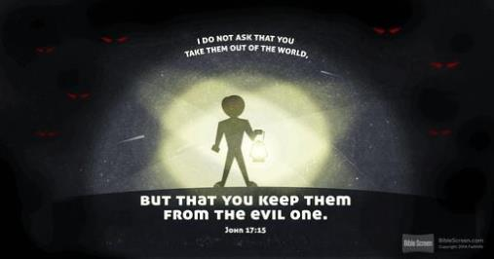9“I pray for them. I do not pray for the world but for those whom You have given Me, for they are Yours. 10And all Mine are Yours, and Yours are Mine, and I am glorified in them. 11Now I am no longer in the world, but these are in the world, and I come to You. Holy Father, keep through Your name those whom You have given Me,that they may be one as We are. 12While I was with them in the world, I kept them in Your name. Those whom You gave Me I have kept; and none of them is lost except the son of perdition, that the Scripture might be fulfilled. 13But now I come to You, and these things I speak in the world, that they may have My joy fulfilled in themselves. 14I have given them Your word; and the world has hated them because they are not of the world, just as I am not of the world. 15I do not pray that You should take them out of the world, but that You should keep them from the evil one. 16They are not of the world, just as I am not of the world. 17Sanctify them by Your truth. Your word is truth. 18As You sent Me into the world, I also have sent them into the world. 19And for their sakes I sanctify Myself, that they also may be sanctified by the truth.*

**Question 3**

Use the pictures below to fill in the blanks for the verse; Hint Verse 14



I have given them



and the



has hated them because they are

Just as I am not of this world.

* Thursday 11th June: Read **John Chapter 17: 19-23** and answer the questions:

### Jesus Prays for All Believers

*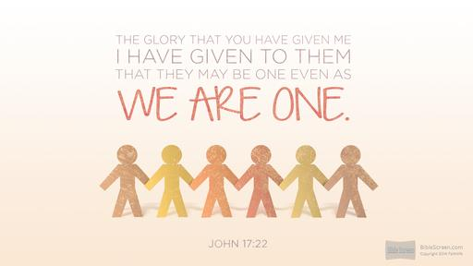20“I do not pray for these alone, but also for those who will believe in Me through their word; 21that they all may be one, as You, Father, are in Me, and I in You; that they also may be one in Us, that the world may believe that You sent Me. 22And the glory which You gave Me I have*

### *given them, that they may be one just as We are one:*

*23I in them, and You in Me; that they may be made perfect in one, and that the world may know that You have sent Me, and have loved them as You have loved Me.*

**Question 4**

Jesus wants us, the believers, to be one (united) According to this passage, which relationship does He want us to base it off?

1. The relationship between Him and the disciples
2. The relationship between the disciples and God the Father
3. The relationship between Him and God the Father
4. The relationship between Him and Mary, His mother

* Friday 12th June: Read **John Chapter 17: 24-26** and answer the questions:

### Jesus Prays for All Believers

**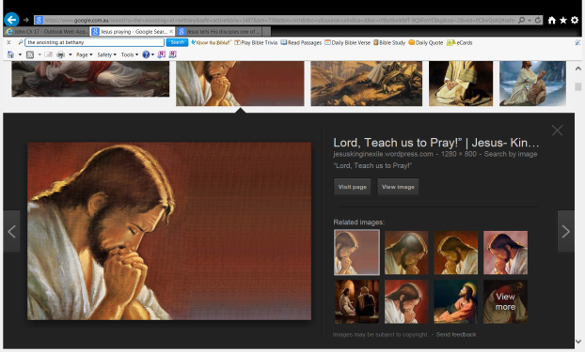***24“Father, I desire that they also whom You gave Me may be with Me where I am, that they may behold My glory which You have given Me; for You loved Me before the foundation of the world. 25O righteous Father! The world has not known You, but I have known You; and these have known that You sent Me. 26And I have declared to them Your name, and will declare it, that the love with which You loved Me may be in them, and I in them.”*

**Question 5**

Jesus says that all of our relationships should be based on

**Question 6**

Jesus showed us the greatest love when he

* Saturday 13th June: Find the verse that talks about enternal life, and copy it down as your memory verse for the week. Write down the reference too! (HINT: Monday’s homework)

***What to do when you finish your Bible Study.***

1. ***Either send it by email to your class email address or print and hand it to your servants next Sunday.***
2. ***If you want to send your Bible Study by email, please select your class email address below:***

[stthomas6b1@gmail.com](mailto:stthomas6b1@gmail.com) Uncle George

[stpeter6b2@gmail.com](mailto:stpeter6b2@gmail.com) Uncle Mina

[stphilip6g@gmail.com](mailto:stphilip6g@gmail.com) Aunty Jacky

***Click on the following link to see how many points you have.***

**Year 6B1 (St Thomas)**  
[https://docs.google.com/spreadsheets/d/1B3hbaPWXLPr-bqV8YIabw159aKTkQlJ3I1pKK7mRhEI/edit?usp=sharing](https://webmail.meriden.nsw.edu.au/owa/redir.aspx?C=b6b7aaaa4ff64c008d6db035dc9d08cb&URL=https%3a%2f%2fdocs.google.com%2fspreadsheets%2fd%2f1B3hbaPWXLPr-bqV8YIabw159aKTkQlJ3I1pKK7mRhEI%2fedit%3fusp%3dsharing)

**Year 6B2 (St Peter)**

[https://docs.google.com/spreadsheets/d/1-3aY66NbtvgQdVxKQsLKIN32-mekY1UfV-fU-a6A3aE/edit?usp=sharing](https://webmail.meriden.nsw.edu.au/owa/redir.aspx?C=b6b7aaaa4ff64c008d6db035dc9d08cb&URL=https%3a%2f%2fdocs.google.com%2fspreadsheets%2fd%2f1-3aY66NbtvgQdVxKQsLKIN32-mekY1UfV-fU-a6A3aE%2fedit%3fusp%3dsharing)

**Year 6G (StPhilip)**

[https://docs.google.com/spreadsheets/d/1KKS7TLUdMux972uO8yehkyA-gpRY7so_qA22MaRSM-I/edit?usp=sharing](https://webmail.meriden.nsw.edu.au/owa/redir.aspx?C=b6b7aaaa4ff64c008d6db035dc9d08cb&URL=https%3a%2f%2fdocs.google.com%2fspreadsheets%2fd%2f1KKS7TLUdMux972uO8yehkyA-gpRY7so_qA22MaRSM-I%2fedit%3fusp%3dsharing)