
Sunday 1st March
Name:
Class:
Due Date: Saturday 7th March
Completed Bible Study = 15 points,
Handed in by the due date = 5 points
St John Chapters 3 &4
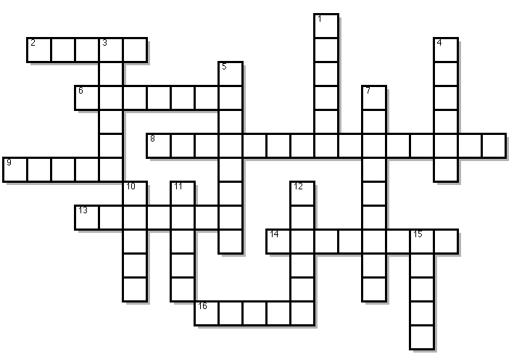
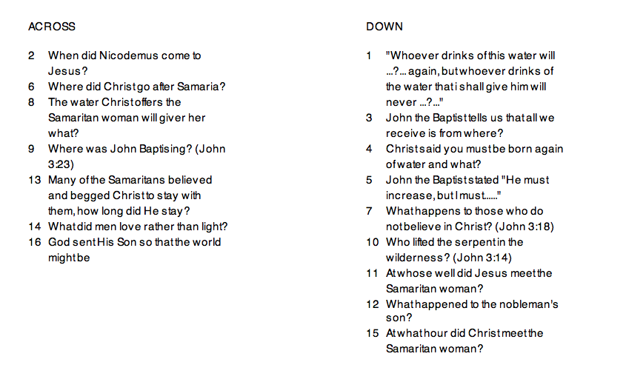

Because you will not be able to write your answers in the crossword please type your answers in the space below.

Reading Plan for the week

- Monday 2nd March: Read JOHN 3: 1-21
Across: Question 2, 14, 16
Down: Question 4, 7, 10.
- Tuesday 3rd March: Read JOHN 3: 22-36
Across: Question 9,
Down: Question 3, 5
- Wednesday 4th March: Read JOHN 4: 1-26
Across: Question 8,
Down: Question 1, 11, 15
- Thursday 5th March: Read JOHN 4: 27-38
- Friday 6th March: Read JOHN 4: 39-45
Across: Question 13
- Saturday 7th March: Read JOHN 4: 46-54
Across: Question 6
Down: Question 12
Across
2.
6.
8.
9.
13.
14.
16.

Down
1.
3.
4.
5.
7.
10.
11.
12.
15.

PARENTS SECTION:
We kindly ask you as a parent to read (a little each day) in the Holy Bible with your family.
Now email your answers to your teacher, choose ONE of the email addresses below.
stthomas6b1@gmail.com Uncle George
or
stpeter6b2@gmail.com Uncle Mina
or
stphilip6g@gmail.com Aunty Jacky

