C:\Documents and Settings\suzy\Local Settings\Temporary Internet Files\Content.IE5\3JXW24R5\MC900383922[1].wmfSunday 8th November, 2015

Name:

Class:

Finish Date: Saturday 14th November, 2015

Completed Bible Study = 15 points

Email Homework by the due date = 5 points

**Year 5 Bible Study James Chapter 3 and 4**

**For the questions below Highlight, underline or change the font colour to choose the correct answer.**

* Monday 9th November: Read **James Chapter 3: 1-5** and answer the questions:

**The Untamable Tongue**

*1 My brethren, let not many of you become teachers, knowing that we shall receive a stricter judgment. 2For we all stumble in many things. If anyone does not stumble in word, he is a perfect man, able also to bridle the whole body. 3Indeed, we put bits in horses’ mouths that they may obey us, and we turn their whole body. 4Look also at ships: although they are so large and are driven by fierce winds, they are turned by a very small rudder wherever the pilot desires. 5Even so the tongue is a little member and boasts great things.*

**Question 1:**

**In verse 1 St. James explains that not all people should be teachers of the faith. Why does he say this?**

1. Because we are not all clever enough.
2. Because if we teach people the wrong thing then God will Judge us for that.
3. Because a teacher needs to study at university first.
4. Because a teacher will get into trouble if they do not have all the answers.

**Question 2:**

**In verses 3 to 5 St. James compares the following things to explain something important:**

1. **Bits in horses mouths 2. The rudder of a large ship 3. And a person’s tongue.**

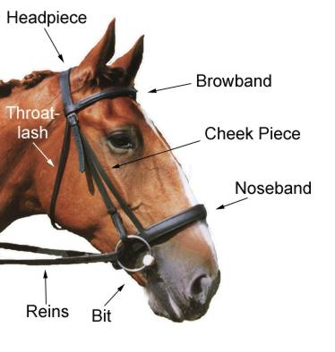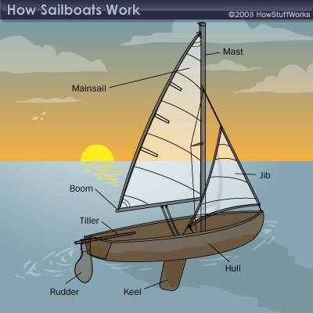

**St. James shows us these things are similar and teach us that:**

1. God made all of them.
2. They are all big things that are controlled by something much smaller than them.
3. They are not similar and St. James was just confusing the readers.
4. They all get wet.

* Tuesday 10th November Read **James Chapter 3: 6-12** and answer the questions:

*See how great a forest a little fire kindles! 6And the tongue is a fire, a world of iniquity. The tongue is so set among our members that it defiles the whole body, and sets on fire the course of nature; and it is set on fire by hell. 7For every kind of beast and bird, of reptile and creature of the sea, is tamed and has been tamed by mankind. 8But no man can tame the tongue. It is an unruly evil, full of deadly poison. 9With it we bless our God and Father, and with it we curse men, who have been made in the similitude of God. 10Out of the same mouth proceed blessing and cursing. My brethren, these things ought not to be so. 11Does a spring send forth fresh water and bitter from the same opening? 12Can a fig tree, my brethren, bear olives, or a grapevine bear figs? Thus no spring yields both salt water and fresh.*

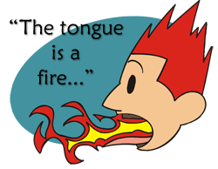**Question 3: Explain what is St. James warming us about in verses 5 and 6?**

**Question 4:**

In verse 8 St. James writes that the tongue is “full of deadly poison”. Think of three types of poison/negative ways that we can use our tongues.

|  |
| --- |
|  |
|  |
|  |

**Question 5: After reading this passage, what lesson can we learn? (hint: focus on verse 10}**

* Wednesday 11th November: Read **James Chapter 3: 13-18** and answer the questions:

### Heavenly Versus Demonic Wisdom

*13Who is wise and understanding among you? Let him show by good conduct that his works are done in the meekness of wisdom. 14But if you have bitter envy and self-seeking in your hearts, do not boast and lie against the truth. 15This wisdom does not descend from above, but is earthly, sensual, demonic. 16For where envy and self-seeking exist, confusion and every evil thing are there. 17But the wisdom that is from above is first pure, then peaceable, gentle, willing to yield, full of mercy and good fruits, without partiality and without hypocrisy. 18Now the fruit of righteousness is sown in peace by those who make peace.*

**Question 6:**

St. James teaches in verse 13 that if a person is wise then they show their wisdom through “good….” what?

1. Words
2. Prayers.
3. Lessons.
4. Conduct.

**Question 7:**

**Using the words in verse 17, how does St. James describe wisdom? Type one word or description in each circle.**

**Question 8:**

**According to verse 18, how can we grow fruits of righteousness?**

* Thursday 12th November: Read **James Chapter 4: 1-6** and answer the questions:

### Pride Promotes Strife

*1 Where do wars and fights come from among you? Do they not come from your desires for pleasure that war in your members? 2You lust and do not have. You murder and covet and cannot obtain. You fight and war. Yet you do not have because you do not ask. 3You ask and do not receive, because you ask amiss, that you may spend it on your pleasures. 4Adulterers and adulteresses! Do you not know that friendship with the world is enmity with God? Whoever therefore wants to be a friend of the world makes himself an enemy of God. 5Or do you think that the Scripture says in vain, “The Spirit who dwells in us yearns jealously”?*

*6But He gives more grace. Therefore He says:*

*“God resists the proud,  
But gives grace to the humble.”*

**Question 9:**

In verses 1-3 St. James explains that sometimes we want the things of this earth and we forget to ask God for the important things. Highlight which of the following prayer requests are pleasing to God? You can have more than one answer.

Please God I want….

1. The best toys.
2. To be more obedient to my parents.
3. To be a good friend.
4. To eat chocolate and lollies every day.
5. To learn how to pray.
6. To be more generous.
7. To sleep in on Sunday morning.

**Question 10:**

**What does St. James mean when he writes “Do you not know that friendship with the world is enmity with God?”**

1. You can’t have friends that are not Egyptian.
2. If you only love and care for the things in the earth then you cannot love God.
3. If we have bad friends then we make God an enemy.
4. There are many people in the world that do not believe in God.

**Question 11: Who does God give grace to?**

* Friday 13th November: Read **James Chapter 4: 7-10** and answer the questions:

### Humility Cures Worldliness

*7Therefore submit to God. Resist the devil and he will flee from you. 8Draw near to God and He will draw near to you. Cleanse your hands, you sinners; and purify your hearts, you double-minded. 9Lament and mourn and weep! Let your laughter be turned to mourning and your joy to gloom. 10Humble yourselves in the sight of the Lord, and He will lift you up.*

**Question 12:**

According to verse 7, how can we make the devil to flee (stay away) from us?

**Question 13:**

**Complete the following verse:**

**“Draw near to and He will draw near to “ Verse 8.**

**Question 14:**

**If we humble ourselves before the Lord what will He do? (Hint: read verse 10).**

* **Saturday 14th November: Read James Chapter 4: 11-17 and answer the questions:**

### Do Not Judge a Brother

*11Do not speak evil of one another, brethren. He who speaks evil of a brother and judges his brother, speaks evil of the law and judges the law. But if you judge the law, you are not a doer of the law but a judge. 12There is one Lawgiver, who is able to save and to destroy. Who[*[*e*](https://www.biblegateway.com/passage/?search=james+4&version=NKJV#fen-NKJV-30350e)*] are you to judge another?*

### Do Not Boast About Tomorrow

*13Come now, you who say, “Today or tomorrow we will go to such and such a city, spend a year there, buy and sell, and make a profit”; 14whereas you do not know what will happen tomorrow. For what is your life? It is even a vapor that appears for a little time and then vanishes away. 15Instead you ought to say, “If the Lord wills, we shall live and do this or that.” 16But now you boast in your arrogance. All such boasting is evil.*

*17Therefore, to him who knows to do good and does not do it, to him it is sin.*

**Question 15: Who is the only one who can judge a person?**

**Question 16:**

According to verses 13-15, St. James reminds us that our lives on earth are only for a short time because we will be in Heaven for eternity. So when we plan our lives on earth we should always say and think what?

1. If there is enough time.
2. If we have enough money.
3. If we want to.
4. If the Lord wills.

***What to do when you finish your Bible Study.***

1. ***Either send it by email to your class email address or print and hand it to your servants next Sunday.***
2. ***If you want to send your Bible Study by email, please select your class email address below:***

[stmatthew5b1@gmail.com](mailto:stmatthew5b1@gmail.com) Uncle Andrew

or  
[stmark5b2@gmail.com](mailto:stmark5b2@gmail.com) Uncle Fady

or  
[saintluke5g1@gmail.com](mailto:saintluke5g1@gmail.com) Aunty Merna

or  
[stjohn5g2@gmail.com](mailto:stjohn5g2@gmail.com) Aunty Angela

***Click on the following link to see how many points you have.***

**Year 5B1 (St Matthew)**

[https://docs.google.com/spreadsheets/d/1YPfk0C0NBJv0XfLlXzhWewt5SbZHkTAmmAVEaydaUYo/edit?usp=sharing](https://webmail.meriden.nsw.edu.au/owa/redir.aspx?C=88057cf25a174c15b69cd7e5055a667f&URL=https%3a%2f%2fdocs.google.com%2fspreadsheets%2fd%2f1YPfk0C0NBJv0XfLlXzhWewt5SbZHkTAmmAVEaydaUYo%2fedit%3fusp%3dsharing)  
**Year 5B2 (St Mark)**

[https://docs.google.com/spreadsheets/d/1IU-qPhJOybm8AH80BISZtK-OVRM-f7DXrPzkonxcraU/edit?usp=sharing](https://webmail.meriden.nsw.edu.au/owa/redir.aspx?C=88057cf25a174c15b69cd7e5055a667f&URL=https%3a%2f%2fdocs.google.com%2fspreadsheets%2fd%2f1IU-qPhJOybm8AH80BISZtK-OVRM-f7DXrPzkonxcraU%2fedit%3fusp%3dsharing)

**Year 5G1 (St Luke)**

[https://docs.google.com/spreadsheets/d/1S9gmI4ZC4ctLiJjYsJGXg_p__H28tM8WXGWcHD8OBKc/edit?usp=sharing](https://webmail.meriden.nsw.edu.au/owa/redir.aspx?C=88057cf25a174c15b69cd7e5055a667f&URL=https%3a%2f%2fdocs.google.com%2fspreadsheets%2fd%2f1S9gmI4ZC4ctLiJjYsJGXg_p__H28tM8WXGWcHD8OBKc%2fedit%3fusp%3dsharing)

**Year 5G2 (St John)**

[https://docs.google.com/spreadsheets/d/1rlhsNVFRZ_MQ00H8UVw1Xb2kvxPZhKiZgdpHZZ9zZtY/edit?usp=sharing](https://webmail.meriden.nsw.edu.au/owa/redir.aspx?C=88057cf25a174c15b69cd7e5055a667f&URL=https%3a%2f%2fdocs.google.com%2fspreadsheets%2fd%2f1rlhsNVFRZ_MQ00H8UVw1Xb2kvxPZhKiZgdpHZZ9zZtY%2fedit%3fusp%3dsharing)