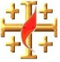

The GOSPEL according to St. JOHN
15 Points
YEAR 6 Holy Bible Study
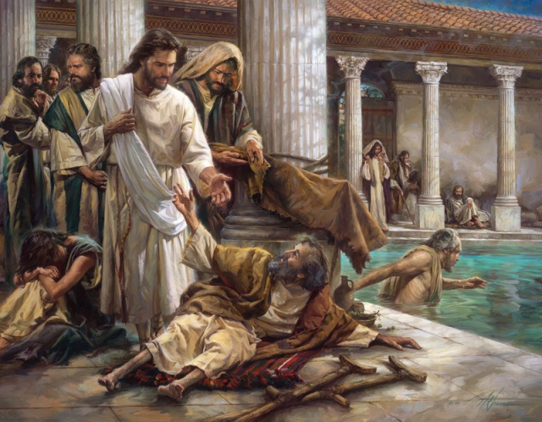
Chapter 5: The witness of Christ
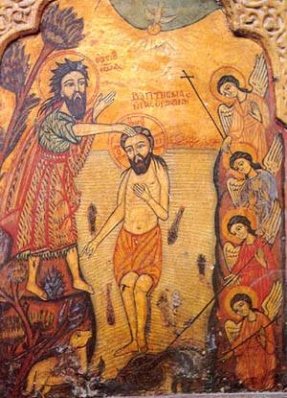
1. How did the Jews find out that Jesus healed the paralytic man on the Sabbath?

________________________________________________________________________________________________________________________________________________________________________
This chapter is broken up into 2 parts, the healing of the paralytic man at the pool of Bethesda, and Jesus explaining to the Jews why He performs these miracles. The miracles that Jesus did show that He is God, the Son, who was sent, by the Father to the earth to redeem it. He said “the Son can do nothing of Himself, but what He sees the Father do” (v 19). The Son has power over creation like the Father. This is why He can heal the paralytic man. Also, Jesus has the power to raise people from the dead, and to take them to Heaven. This is why He came on Earth, to do the greater works (v 20), which is to save mankind by dying on the cross for us.

2. St John the Baptist was also a witness to Christ (v 33), what are the works that bear greater witness than St John the Baptist’s witness (v 36)?

____________________________________________________________________________________________
____________________________________________________________________________________________
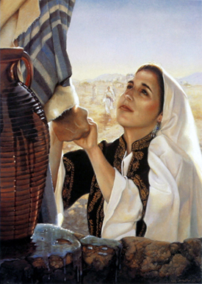
Chapter 4: Jesus, the bread of life

5. Why did Jesus ask Philip “Where shall we buy bread, that these may eat?”
____________________________________________________________________
____________________________________________________________________
6. Why didn’t Jesus want the people to make Him King? (v 15)
___________________________________________________________________________________________
___________________________________________________________________________________________
7. What did Jesus want the people to do in verse 29?
___________________________________________________________________________________________
___________________________________________________________________________________________
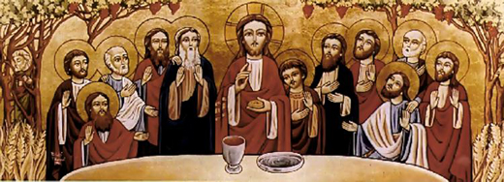
Did you notice that the people asked Jesus for another sign like the one Moses received, where the manna came down from heaven? The people were still thinking of Jesus in an earthly way as provider of food, that is why they wanted to make Him a King after he fed the 5000. The manna went off, and became rotten if not eaten o the same day. The Israelites had to collect the manna every day to feed themselves and their families. This is why they always hungered, but Jesus is the bread of life, who fills us spiritually, so that we never huger.
8. Write down the verse that says that Jesus is the bread of life.
Memory Verse
____________________________________________________________________
____________________________________________________________________
____________________________________________________________________
____________________________________________________________________

Daily Readings:
Day | Reading | Tick
Sunday | John 5: 1-15
Monday | John 5: 16-30
Tuesday | John 5: 31-46
Wednesday | John 6: 1-21
Thursday | John 6: 22-40
Friday | John 3: 41-71
Saturday | BS complete

PARENTS SECTION:
This section is for the parents to sign the Holy Bible Study sheet. X____________________
We kindly ask you as a parent to read (a little each day) in the Holy Bible with your family.
You may wish to read the Gospel according to St. John with Sunday School.
Please let us know below what you’re reading with your child and if you have any questions.

