Handed out Sunday 8th March Name ………………………….
Due Date: 15th March Class ………………………….
Completed Bible Study = 15 points,
Handed in by the due date = 5 points

The GOSPEL according to ST. JOHN
Year 6 – Bible study 3
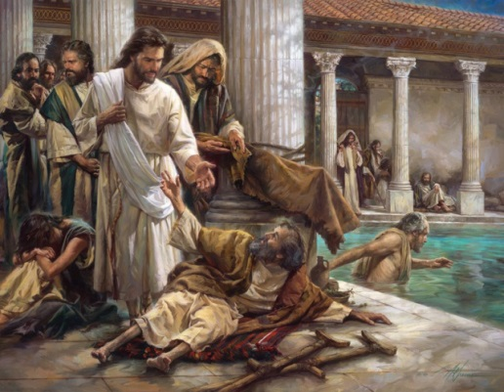
Sunday 8th March Read Chapter 5 verses 1 – 15

- How did the Jews find out that Jesus healed the paralytic man on the Sabbath?

Monday 9th March Read Chapter 5 verses 16 – 30

- Complete the verse
“Most assuredly I say to you, he who hears My word and in Him

who sent Me has everlasting life, and shall not come into but has

passed from into .” (v 24)
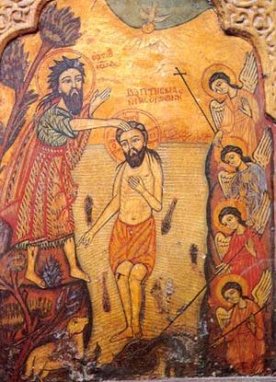
Tuesday 10th March Read Chapter 5 verses 31 – 47

- St John the Baptist was also a witness to Christ (v 33), what are the
works that bear greater witness than St John the Baptist’s witness (v 36)?

Wednesday 11th March Read Chapter 6 verses 1 – 21

- Jesus fed the 5000 with the 5 loaves and the 2 fish the boy had. The boy gave up his lunch for Jesus. Can you think of something to offer Jesus during this lent?

Thursday 12th March Read Chapter 6 verses 22 – 40
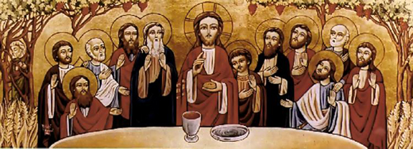
Did you notice that the people asked Jesus for another sign like the one Moses received, where the manna came down from heaven? The people were still thinking of Jesus in an earthly way as provider of food, that is why they wanted to make Him a King after he fed the 5000. The manna went off, and became rotten if not eaten on the same day. The Israelites had to collect the manna every day to feed themselves and their families. This is why they always hungered, but Jesus is the bread of life, who fills us spiritually, so that we never huger.
- Write down the verse that says that Jesus is the bread of life.

Friday 13th March Read Chapter 6 verses 41 – 59
6. If we eat of Christ’s flesh and drink of His blood what shall happen? Underline the correct answer.
a) We abide in Christ
b) Be full
c) Hunger again
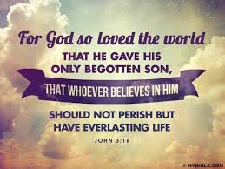
Saturday 14th March Write and memorise the following verse:
PARENTS SECTION:
We kindly ask you as a parent to read (a little each day) in the
Holy Bible with your family.
Now email your answers to your teacher,choose ONE of the email addresses below.
stthomas6b1@gmail.com Uncle George
stpeter6b2@gmail.com Uncle Mina or
stphilip6g@gmail.com Aunty Jacky

