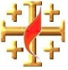

The GOSPEL according to St. JOHN
15 Points
YEAR 6 Holy Bible Study
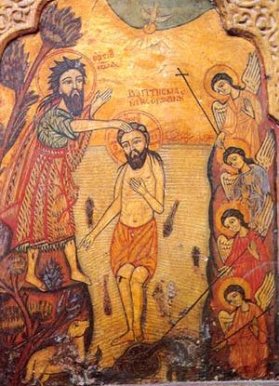
Chapter 3: Why Baptism?
1. Read the story about the conversation between our Lord Jesus and Nicodemus and consider the following points. You can get help from your parents .

- In verse 2, we find out that Nicodemus came by night. Why?
_____________________________________________________________

- What did Jesus mean by "born again"?
____________________________________________________________

____________________________________________________________
- Look at verse 14. How does it relate to Good Friday?

__________________________________________________________________________________

2. Look at verses 5 and 6 in Chapter 3 talking about being born of the "flesh or the spirit". What do they teach us?

________________________________________________________________________________________________________________________________________________________________________________________

3. Which of the Seven Sacraments of the Church are these verses speaking about?
____________________________________________________________________________________________
Memory Verse
4.
Key Verse: Fill in the missing words from the list below:
“For _________so loved the__________ that He _________ His only begotten ______ that whoever believes in ________ should not __________ but have ever lasting ____________.” (John 3: ____)
Memory verse

Son, world, God, life, Him, perish gave

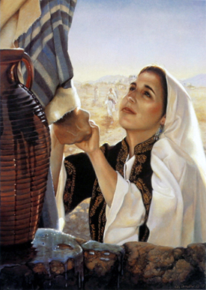
Chapter 4:
Christ, the Saviour

5. Re-read the story of when Christ Jesus meets the Samaritan Woman.
Write Down the quoted words of the Lord in verses 13 and 14!
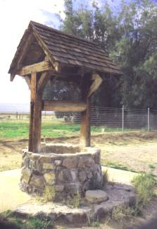
What do you understand these verses to mean?
________________________________________________________________________________________________________________________________________________________________________________________________________________________________________________________________________________________________________________________

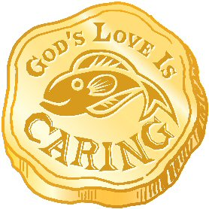

Daily Readings:
Day | Reading | Tick
Sunday | John 3: 1-21
Monday | John 3: 22-35
Tuesday | John 4: 1-26
Wednesday | John 3: 27-38
Thursday | John 3: 39-42
Friday | John 3: 43-54
Saturday | BS complete

PARENTS SECTION:
This section is for the parents to sign the Holy Bible Study sheet. X____________________
We kindly ask you as a parent to read (a little each day) in the Holy Bible with your family.
You may wish to read the Gospel according to St. John with Sunday School.
Please let us know below what you’re reading with your child and if you have any questions.

