
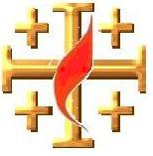
15 Points
Name: Class:
The GOSPEL according to ST. JOHN
YEAR 6 Holy Bible Study, 2008
Jesus Christ is God “Divinity of Christ”

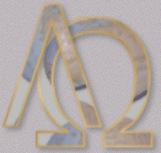

Chapter 1:
Who is the WORD? (Key Verse)

Solve the purple equations below to find the correct letter in the alphabet. For example (z-3 = w).

And the ___ ___ ___ ___ became ___ L ___ ___ ___ and

(z-3) (f+9) (t-2) (m-9) (k-8+3) (b+3) (v-3) (f+2)

___ ___ E ___ ___ among us, and we beheld His

(n+v-32) 23 (x-12) (z-f)

g ___ ___ r ___, the glory as of the ___ ___ l ___

B ___ g ___ ___ t ___ ___ of the

___ ___ T ___ ___ ___, full of ___ r ___ ___ e and

6 (z-y) (e+3) (h-3) (t-2)

t ___ ___ t ___

The Answer:

The “Word” is _________________________ .

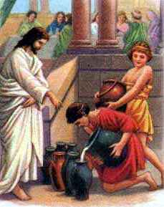
Chapter 2:
Christ is God, the Creator

Re-read and consider carefully Christ’s miracle in converting the water into wine at the Wedding of Cana in Galilee.

1. Why did Jesus go to the wedding, and what Church sacrament was in the story?
_______________________________________________________________________________________

_______________________________________________________________________________________

_______________________________________________________________________________________

2. Are you aware of how many sacraments we have in the church? Can you name some of these sacraments? (5 bonus points for naming all of them)
_______________________________________________________________________________________

_______________________________________________________________________________________

_______________________________________________________________________________________

Did you know that to make wine you need the juice of grapes, yeast and no oxygen whatsoever? Did you also know that water is an organic compound which contains oxygen?
3. What does this miracle tell you about our Lord Jesus Christ?

_____________________________________________________________________________________________________________________________________________________________________________________________________________________________________________________________________

PARENTS SECTION:
This section is for the parents to sign the Holy Bible Study sheet.
We kindly ask you as a parent to read (a little each day) in the Holy Bible with your family.
You may wish to read St. John’s Gospel with Sunday School.
Please let us know below what you’re reading with your child and if you have any questions.

______________________________________________________________________________________________________________________________________________________________________________

