Sunday 22nd February Name ………………………………………….
Finish Date: Saturday 28rd February Class …………………………………………..
Completed Bible Study = 15 points
Handed in by the due date = 5 points

The GOSPEL according to ST. JOHN
Year 6 – Bible study 1


Chapter 1 – John baptises Jesus

- Monday 23 FEBRUARY: Read JOHN 1: 1-10
- Who was the word?

- Complete the missing words JOHN 1:6-9

“There was a man sent from God whose name was .

This man came for a witness, to bear witness of the , that all through him might believe. He was not that light but was sent to bear witness of that light. That was the true light which gives light to every ___________________ coming into the world.”

- Tuesday 24th FEBRUARY: Read JOHN 1:29 -34

- Who did john see coming toward him?
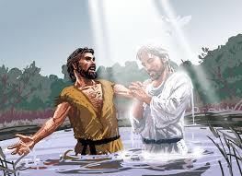

- What does John say that Jesus can take away?
Answer: The of the world.

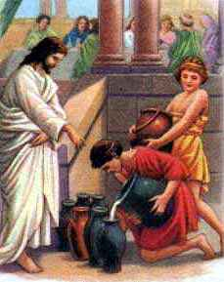

- Wednesday 25th FEBRUARY: Read JOHN 2:1 -11

Chapter 2 – Jesus turns water to wine

- WHO tells Jesus about the wine running out at the wedding?

- Where was the wedding (in which town) where Jesus performed his first miracle?

- What did Jesus do?

- Thursday 26th FEBRUARY: Read JOHN 2:12-21
- Why does Jesus get angry at the temple?

- When Jesus said ‘Destroy this temple and in three days I will raise it up’, what temple did he mean? (Highlight or underline the correct answer).
a) the church b) his body c) Cana temple

- Friday 27th FEBRUARY: Cut out the verse below and stick it up for you to memorise this key verse from the gospel of St John. Keep it safe – you’ll be tested on it in the Bible quiz in a few weeks!

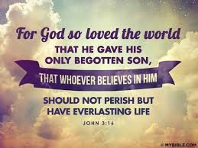

PARENTS SECTION:
We kindly ask you as a parent to read (a little each day) in the Holy Bible with your family.

Now email your answers to your teacher, choose ONE of the email addresses below.
stthomas6b1@gmail.com Uncle George
or
stpeter6b2@gmail.com Uncle Mina
or
stphilip6g@gmail.com Aunty Jacky

