C:\Documents and Settings\suzy\Local Settings\Temporary Internet Files\Content.IE5\3JXW24R5\MC900383922[1].wmfSunday 1st November, 2015

Name:

Class:

Finish Date: Saturday 7th November, 2015

Completed Bible Study = 15 points

Email Homework by the due date = 5 points

**Year 3 Bible Study Genesis Chapter 9**

**For the questions below Highlight, underline or change the font colour to choose the correct answer.**

* Monday 2nd November :Read **Genesis 9: 1-5** and answer the questions:

### God’s Promise to Noah

*1So God blessed Noah and his sons, and said to them: “Be fruitful and multiply, and fill the earth. 2And the fear of you and the dread of you shall be on every beast of the earth, on every bird of the air, on all that move on the earth, and on all the fish of the sea. They are given into your hand. 3Every moving thing that lives shall be food for you. I have given you all things, even as the green herbs. 4But you shall not eat flesh with its life, that is, its blood. 5Surely for your lifeblood I will demand a reckoning; from the hand of every beast I will require it, and from the hand of man. From the hand of every man’s brother I will require the life of man.*

**Question 1**

What was the one condition given to Noah and his family about eating flesh (meat, chicken etc)?

a) It had to be green

b) They should not eat flesh with blood still in it

c) It had to be fruit

d) It must be from the sea

* Tuesday 3rd November: Read **Genesis 9: 6-12** and answer the questions:

**God’s command to Noah**

*6“Whoever sheds man’s blood,  
By man his blood shall be shed;  
For in the image of God  
He made man.  
7And as for you, be fruitful and multiply;  
Bring forth abundantly in the earth  
And multiply in it.”*

**Question 2**

Use the pictures to help you fill in the blanks (God, Man, reflection)

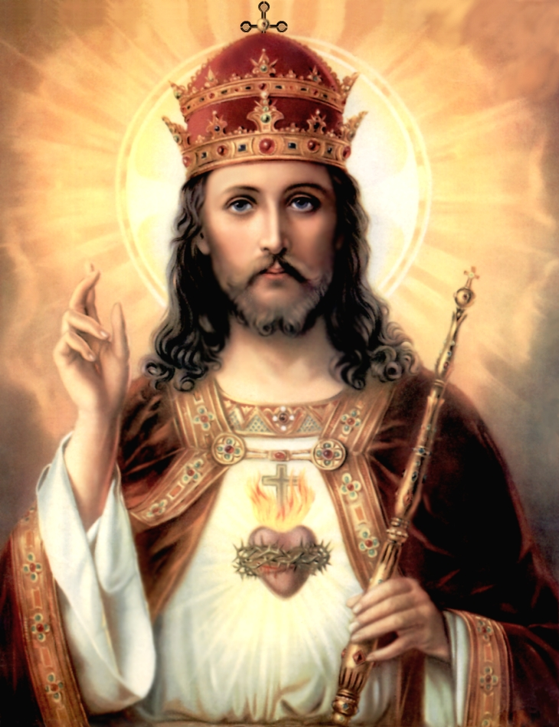



was made in the likeness of

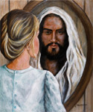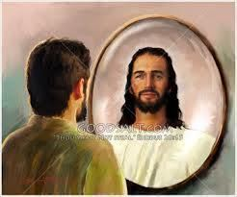

We should always try to be a of Him.

(Genesis 9:6)

* Wednesday 4th November: Read **Genesis 9: 13-14** and answer the questions:

**God’s Covenant with Noah**

*8Then God spoke to Noah and to his sons with him, saying: 9“And as for Me, behold, I establish My covenant with you and with your descendantsafter you, 10and with every living creature that is with you: the birds, the cattle, and every beast of the earth with you, of all that go out of the ark, every beast of the earth. 11Thus I establish My covenant with you: Never again shall all flesh be cut off by the waters of the flood; never again shall there be a flood to destroy the earth.”*

**Question 3**

Write the promise that God made to Noah and all his descendants in the space below (HINT: Verse 11)

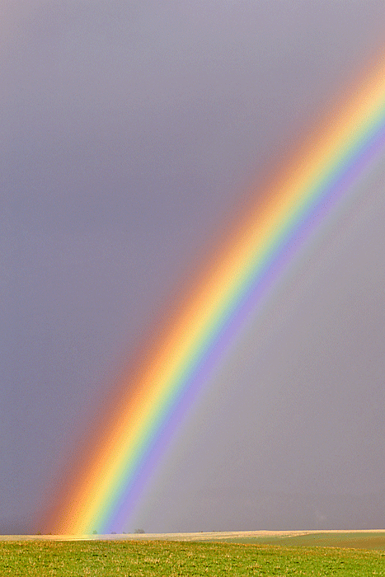

Never again…

* Thursday 5th November: Read **Genesis 9: 15-19** and answer the questions:

**The Rainbow is a sign of God’s promise to Noah**

*12And God said: “This is the sign of the covenant which I make between Me and you, and every living creature that is with you, for perpetual generations: 13I set My rainbow in the cloud, and it shall be for the sign of the covenant between Me and the earth. 14It shall be, when I bring a cloud over the earth, that the rainbow shall be seen in the cloud; 15and I will remember My covenant which is between Me and you and every living creature of all flesh; the waters shall never again become a flood to destroy all flesh. 16The rainbow shall be in the cloud, and I will look on it to remember the everlasting covenant between God and every living creature of all flesh that is on the earth.” 17And God said to Noah, “This is the sign of the covenant which I have established between Me and all flesh that is on the earth.”*

**Question 4**

True/ False

1. A covenant is a promise True/ False
2. The sign that God created to keep his promise was a rainbow True/ False
3. The covenant was between God and Noah only True/ Flase

* Friday 6th November: Read **Genesis 9: 20-21** and answer the questions:

### *Noah and His Sons*

*18Now the sons of Noah who went out of the ark were Shem, Ham, and Japheth. And Ham was the father of Canaan. 19These three were the sons of Noah, and from these the whole earth was populated.*

*20And Noah began to be a farmer, and he planted a vineyard. 21Then he drank of the wine and was drunk, and became uncovered in his tent. 22And Ham, the father of Canaan, saw the nakedness of his father, and told his two brothers outside. 23But Shem and Japheth took a garment, laid it on both their shoulders, and went backward and covered the nakedness of their father. Their faces were turned away, and they did not see their father’s nakedness.*

**Question 5**

Complete the family tree (NOAH, CANAAN, JAPETH)

N

Shem

J

Ham

C

* Saturday 7th November: **Genesis 9: 22**

**Noah curses his younger son and blesses his older sons.**

*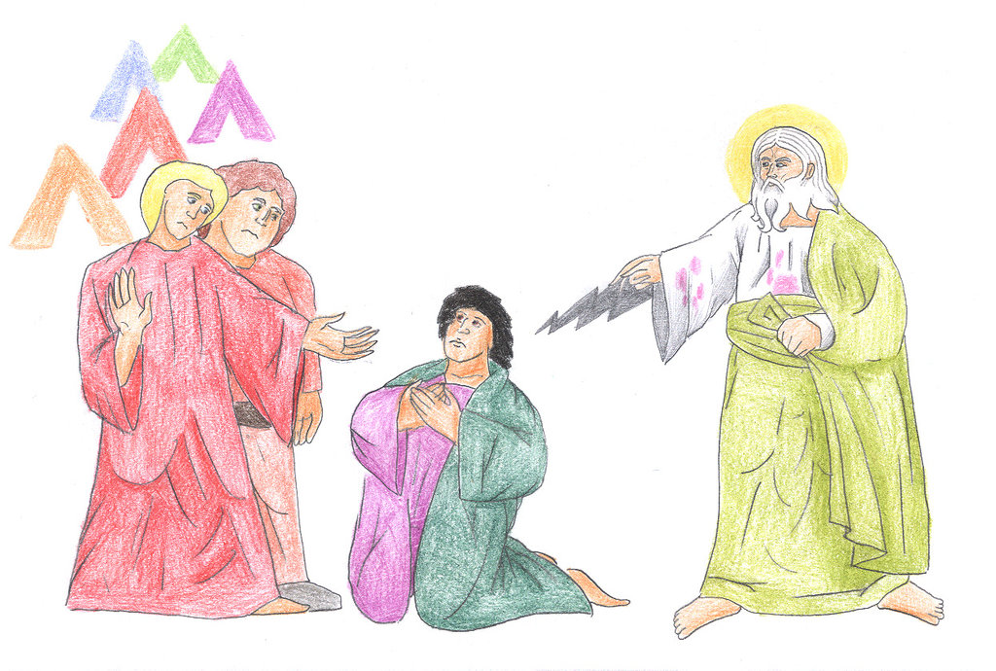24So Noah awoke from his wine, and knew what his younger son had done to him. 25Then he said:*

*“Cursed be Canaan;  
A servant of servants  
He shall be to his brethren.”*

*26And he said:*

*“Blessed be the Lord,  
The God of Shem,  
And may Canaan be his servant.  
27May God enlarge Japheth,  
And may he dwell in the tents of Shem;  
And may Canaan be his servant.”*

*28And Noah lived after the flood three hundred and fifty years. 29So all the days of Noah were nine hundred and fifty years; and he died.*

**Question 6**

What was the punsihment that Ham received for not respecting his father?

a) Nothing

b) His son, Canaan was cursed

c) The descendants of Canaan would have to serve Japeth and Shem

d) Both b and c

***What to do when you finish your Bible Study.***

1. ***Either send it by email to your class email address or print and hand it to your servants next Sunday.***
2. ***If you want to send your Bible Study by email, please select your class email address below:***

**Year 3A St Bishoy**

[stbishoy3a@gmail.com](mailto:stbishoy3a@gmail.com) Uncle Emil

**Year 3B St Shenouda**

[stshenouda3b@gmail.com](mailto:stshenouda3b@gmail.com) Aunty Carol

1. ***Click on the following link to see how many points you have.***

*(Hold Ctrl and left click with your mouse on the following link* ***OR*** *copy and paste the link into your browser)*

**Year 3A (St Bishoy)**

<https://docs.google.com/spreadsheets/d/1n50G0dKZtJp9RWRK8pPrZBlwfk5FfJ4iVBSI9rw_vaY/edit?usp=sharing>

**Year 3B (St Shenouda)**

[*https://docs.google.com/spreadsheets/d/1_95U1Mh8YbvfPowxk0A1nqM2bd9cfUAuH4pDQFjxKPE/edit?usp=sharing*](https://docs.google.com/spreadsheets/d/1_95U1Mh8YbvfPowxk0A1nqM2bd9cfUAuH4pDQFjxKPE/edit?usp=sharing)