C:\Documents and Settings\suzy\Local Settings\Temporary Internet Files\Content.IE5\3JXW24R5\MC900383922[1].wmfSunday 25th October, 2015

Name:

Class:

Finish Date: Saturday 31st October, 2015

Completed Bible Study = 15 points

Email Homework by the due date = 5 points

**Year 3 Bible Study Genesis Chapter 8**

* Monday 26th October :Read **Genesis 8: 1-5**
* Tuesday 27th October: Read **Genesis 8: 6-12**
* Wednesday 28th October: Read **Genesis 8: 13-14**
* Thursday 29th October: Read **Genesis 8: 15-19**
* Friday 30th October: Read **Genesis 8: 20-21**
* Saturday 31st October: **Genesis 8: 22**

**Question 1**

What did God make to pass over the earth, when He remembered Noah and all the animals on the ark?

1. A wind.
2. A storm
3. A cloud
4. A rainbow

**Question 2**

After how many days did the waters begin to decrease?

1. 40 days
2. 100 days
3. 150 days
4. 3 days

**Question 3**

In what month did the Ark rest on the mountain of Ararat?

1. Third month
2. Fourth month
3. Seventh Month
4. August

**Question 4**

When did the tops of the mountains appear?

1. In the seventh month
2. In the nineth month
3. In the tenth month
4. When the waters disappeared.

**Question 5**

Enter the correct number into the boxes below, to show the correct sequence of events.

(The pictures below are in the correct order).

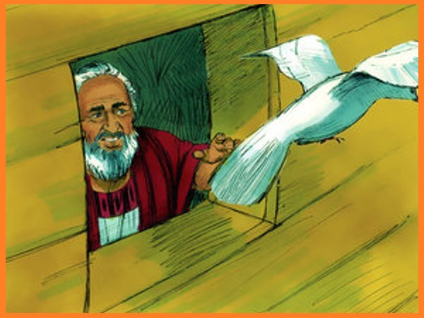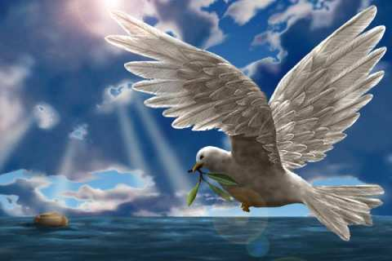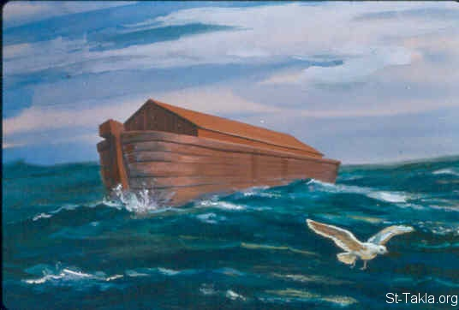

2

3

4

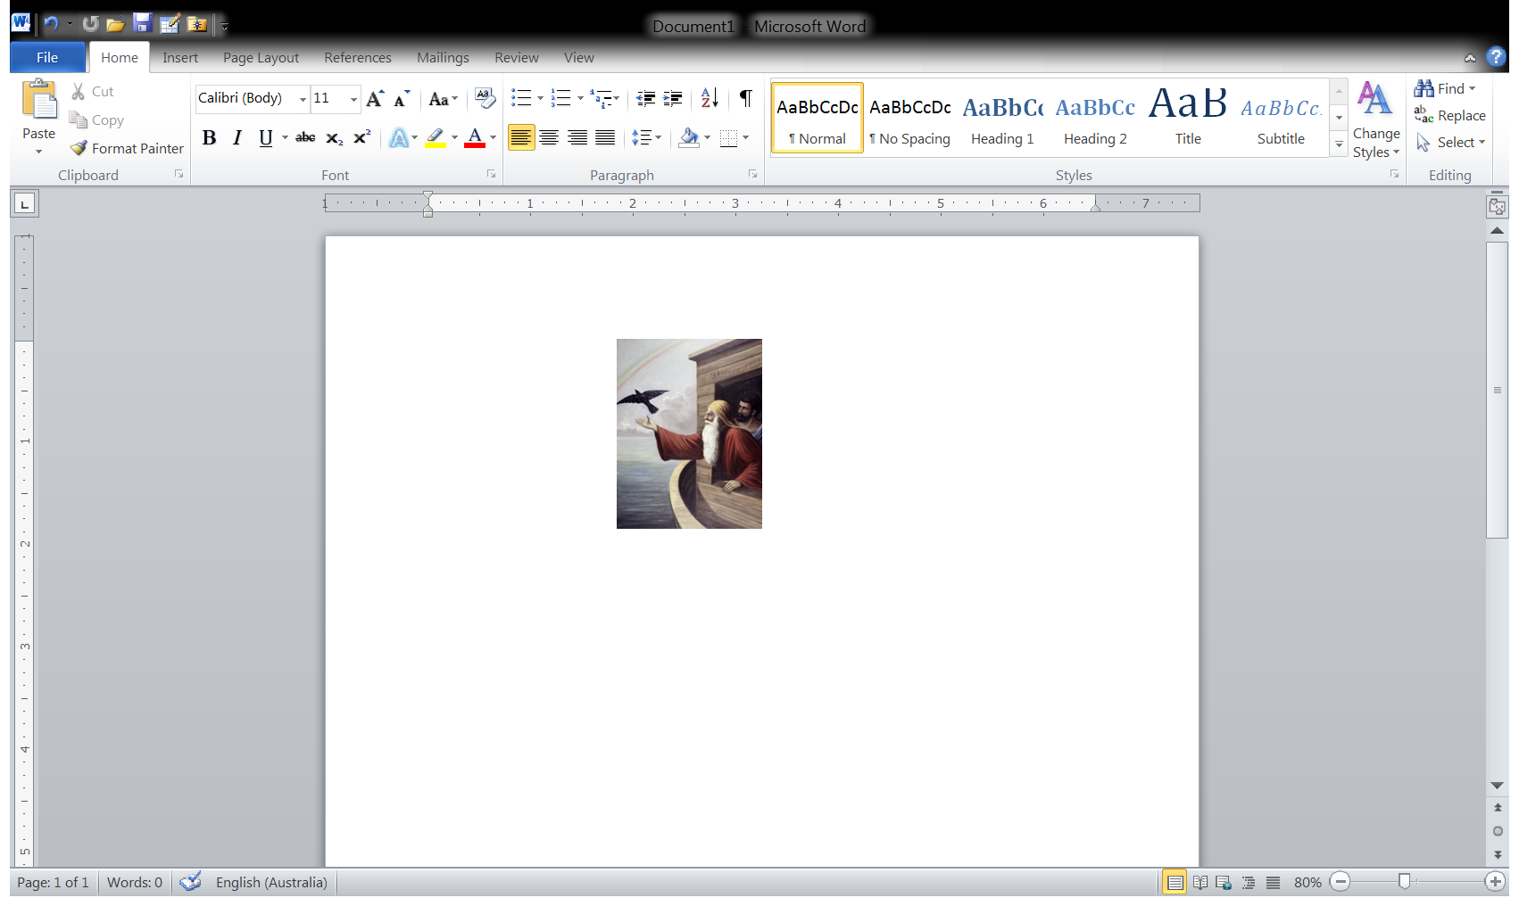

1

*And he waited yet another seven days, and again he sent the dove out from the ark. Then the dove came to him in the evening, and behold, a freshly plucked olive leaf was in her mouth; and Noah knew that the waters had receded from the earth.*

*So it came to pass, at the end of forty days, that Noah opened the window of the ark which he had made. Then he sent out a raven, which kept going to and fro until the waters had dried up from the earth.*

*So he waited yet another seven days and sent out the dove, which did not return again to him anymore.*

*He also sent out from himself a dove, to see if the waters had receded from the face of the ground.But the dove found no resting place for the sole of her foot, and she returned into the ark to him, for the waters were on the face of the whole earth.*

**Question 6**

In our faith and religion, what does the Dove represent?

1. The Holy Spirit
2. Peace
3. Beauty
4. Believers/ the soul
5. All of the above

**Question 7**

Which of the symbols from question 6 relates to the story of Noah?

**Question 8**

Move the numbers into the correct places in the verse below.

Hint: Read verse 13

601st

1st

1st

And it came to pass in the year, in the month, the day of the month, that the waters were dried up from the earth;

**Question 9:**

How do you think Noah and his family felt when he removed the covering from the ark and saw that the land was dry?

**Question 10:**

God gave Noah 3 main instructions once the land was all dry.

List these instructions (read verses 15-17).

**1.**

**2.**

**3.**

**Question 11:**

What did Noah build for the Lord when he left the ark?

**Question 12:**

What did the Lord smell when Noah made an offering on the altar?

**Question 13:**

Think of one thing that you can offer to the Lord that would make Him happy?

**Question 14:**

Look up Genesis 8 verse 22 and type it in the text box below

**Question 15:**

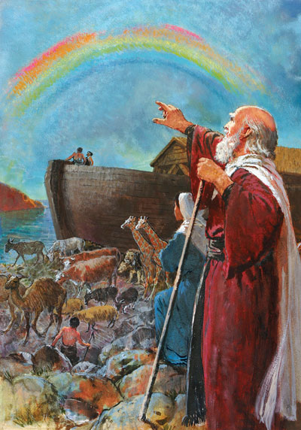In verses 21 and 22 God made a promise. What physical sign did God give to Noah and his family of this promise?

***What to do when you finish your Bible Study.***

1. ***Either send it by email to your class email address or print and hand it to your servants next Sunday.***
2. ***If you want to send your Bible Study by email, please select your class email address below:***

**Year 3A St Bishoy**

[stbishoy3a@gmail.com](mailto:stbishoy3a@gmail.com) Uncle Emil

**Year 3B St Shenouda**

[stshenouda3b@gmail.com](mailto:stshenouda3b@gmail.com) Aunty Carol

1. ***Click on the following link to see how many points you have.***

*(Hold Ctrl and left click with your mouse on the following link* ***OR*** *copy and paste the link into your browser)*

**Year 3A (St Bishoy)**

<https://docs.google.com/spreadsheets/d/1n50G0dKZtJp9RWRK8pPrZBlwfk5FfJ4iVBSI9rw_vaY/edit?usp=sharing>

**Year 3B (St Shenouda)**

[*https://docs.google.com/spreadsheets/d/1_95U1Mh8YbvfPowxk0A1nqM2bd9cfUAuH4pDQFjxKPE/edit?usp=sharing*](https://docs.google.com/spreadsheets/d/1_95U1Mh8YbvfPowxk0A1nqM2bd9cfUAuH4pDQFjxKPE/edit?usp=sharing)