C:\Documents and Settings\suzy\Local Settings\Temporary Internet Files\Content.IE5\3JXW24R5\MC900383922[1].wmfSunday 18th October, 2015

Name:

Class:

Finish Date: Saturday 24th October, 2015

Completed Bible Study = 15 points

Email Homework by the due date = 5 points

**Year 3 Bible Study Genesis Chapter 6 and 7**

* Monday 26th October: Read **Genesis 6: 1-8**
* Tuesday 27th October: Read **Genesis 6: 9-12**
* Wednesday 28th October: Read **Genesis 6: 13-22**
* Thursday 29th October: Read **Genesis 7: 1-12**
* Friday 30th October: Read **Genesis 7: 13-16**
* Saturday 31st October: Read **Genesis 7: 17-24**

**Question 1:**

Who are the sons of God Spoken about in verse 2?

1. Fallen Angels.
2. Superior humans.
3. The prophets at the time.
4. The bible is not clear about who the “sons of God” are/were.

**Question 2:**

In verse three God mentions a number of years. One contemplation of this is God telling Noah how long it would take to build the ark. How many years did He say?

**Question 3:**

Explain in your own words why God decided to destroy man? Hint read verses 5-7

**Question 4:**

Who found Grace in the eyes of the Lord?

**Question 5:**

What were the names of Noah’s three sons?

|  |
| --- |
| **1.** |
| **2.** |
| **3.** |

**Question 6:**

What do YOU think this verse means: “Noah walked with God”?

[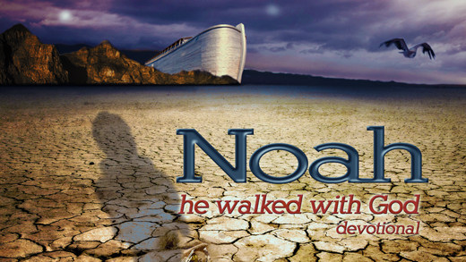](http://www.google.com.au/url?sa=i&rct=j&q=&esrc=s&source=images&cd=&cad=rja&uact=8&ved=0CAcQjRxqFQoTCOrdqdqer8cCFSEjpgodhu0N9g&url=http://www.ica.tv/noah-walked-with-god&ei=p13RVaruE6HGmAWG27ewDw&bvm=bv.99804247,d.dGY&psig=AFQjCNHpocfSpaiKTeFBhiIhfS4k2Cck6w&ust=1439870715673873)**There is NO right or wrong answer. It’s a beautiful image for us to think about and also possibly consider in our lives how we can walk with God.**

1. That Noah physically took strolls with God.
2. That Noah was faithful and honest with God.
3. That Noah had a genuine friendship with God.
4. That Noah feared God and honoured Him in his life.
5. That Noah made all of his decisions based on what he believed God wanted for him.

**Question 7:**

Verse 11 explains that when God looked apon the earth He saw that it was filled with violence and corruption. When God looks to the earth now, what do you think He sees?

**Again there is no right or wrong answer but it is important for us to stop and think about our ways and what God would like us to be. Think about the whole world and then also think about your own personal life.**

*You can just type a few words or thoughts about this.*

**Question 8:**

God gave Noah very specific instructions about how to build the ark. Fill in the missing words below to complete the description.

*Make yourself an ark of*

*make* *in the ark, and cover it inside and*

*outside with*

*The length of the ark shall be*

*Its width****,*** *and its height*

*You shall make a**for the ark, and you*

*shall finish it to a* *from above; and set the door*

*of the ark in its* *You shall make it with lower,*

***,*** *and* *decks.*

* Thirty cubits
* Second
* Cubit
* Window
* third
* Gopherwood
* Three hundred cubits
* Side
* rooms
* Fifty cubits
* Pitch

**Question 9:**

God instructed Noah who and what to take on the ark with him. Lets imagine that as Noah listened to God that he wrote a list of everything God asked him to take. After reading the passage can you write that list? Hint: read verses 18 -21

**Noah’s List of what to take on the ark…**

[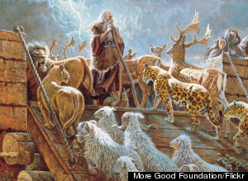](http://www.google.com.au/url?sa=i&rct=j&q=&esrc=s&source=images&cd=&cad=rja&uact=8&ved=0CAcQjRxqFQoTCI_LqKGkr8cCFYcbpgod07oDOQ&url=http://www.huffingtonpost.com/dr-joel-hoffman/quiz-how-well-do-you-know_b_5042884.html&ei=emPRVY-mF4e3mAXT9Y7IAw&bvm=bv.99804247,d.dGY&psig=AFQjCNFfcE7ItviZRtOhxX9RIG6lhqqIaw&ust=1439872222894189)

**Question 10:**

**In verse 2 God asks Noah to take 7 of every clean animal. Which animals were considered clean?**

[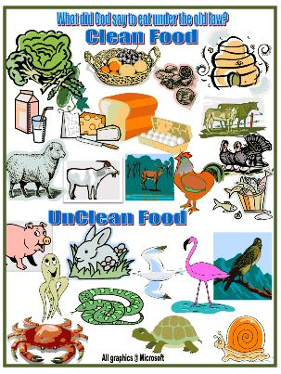](http://www.google.com.au/url?sa=i&rct=j&q=&esrc=s&source=images&cd=&cad=rja&uact=8&ved=0CAcQjRxqFQoTCKb54cWNsccCFQIfpgodqpgIpQ&url=http://www.biblefunforkids.com/2012/10/cornelius-peters-vision.html&ei=GFjSVaaNEYK-mAWqsaKoCg&bvm=bv.99804247,d.dGY&psig=AFQjCNFe2nHmGKBsgzKgZgKz1qwBFmVzGw&ust=1439934845904524)

1. Animals that self groom.
2. Animals that God said the Israelites were not to eat
3. Animals that that were younger than 3 years of age.
4. Animals that die easily.

**Question 11:**

How long did God explain that it would rain for?

**Question 12:**

How old was Noah when the floods came onto the earth?

**Question 13:**

How many days before the rains began to come did Noah and his family enter the ark?

[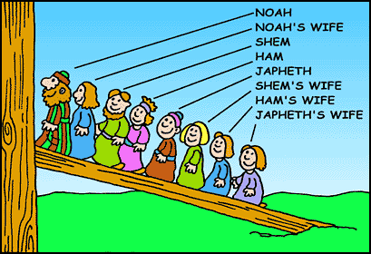](http://www.google.com.au/url?sa=i&rct=j&q=&esrc=s&source=images&cd=&cad=rja&uact=8&ved=0CAcQjRxqFQoTCNGuwsmpr8cCFYHdpgodB3MN8Q&url=http://www.christart.com/christianbooks/read/4661/7&ei=DGnRVdH4NIG7mwWH5rWIDw&bvm=bv.99804247,d.dGY&psig=AFQjCNE90h_aqgvSzs1QU_gIok-UaY6P0g&ust=1439873653999617)

**Question 14:**

Who shut the door of the ark?

[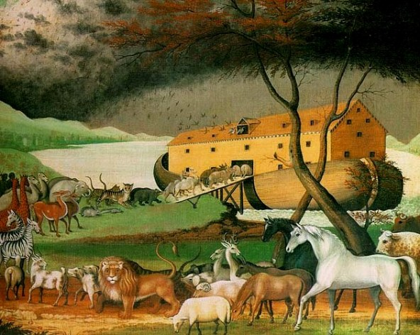](http://www.google.com.au/url?sa=i&rct=j&q=&esrc=s&source=images&cd=&cad=rja&uact=8&ved=0CAcQjRxqFQoTCMfYmu6NsccCFUcdpgodZC0G_g&url=http://www.womeninthebible.net/paintings_noah.htm&ei=bVjSVYfuBce6mAXk2pjwDw&bvm=bv.99804247,d.dGY&psig=AFQjCNHbLzL1T7D64pVZrEBzLLpsq8rMow&ust=1439934952886704)

**Question 15:**

How did the animals enter the ark?

**Question 17:**

How high did the waters of the flood reach?

**God was so upset with the state of mankind that in chapter 6 we read that God was sorry that He had made man. It is very sad that mankind fell so far from God’s will and command that He wished He never created those whom He loved.**

**Something to think about…..**

Do we think about our actions every day and how they make God feel? Do I consider God’s commandments when I make decisions, talk with other people and live my everyday life? God promised to never send another flood to destroy the earth but we will each face God at the end of our lives. Will God be pleased with me or will He be disappointed? Think about something in your life/behaviour that you would like to change in order to be more pleasing and faithful to God.

[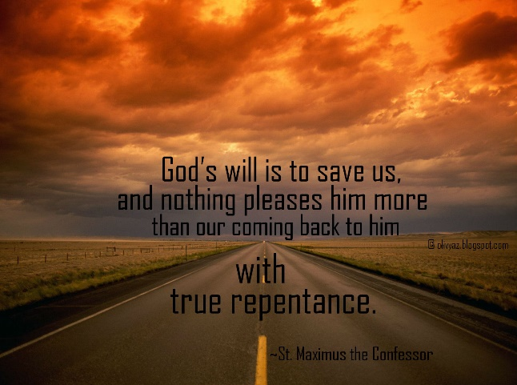](http://www.google.com.au/url?sa=i&rct=j&q=&esrc=s&source=images&cd=&cad=rja&uact=8&ved=0CAcQjRxqFQoTCJP--6GOsccCFSPbpgodztwGdw&url=http://www.suggestkeyword.com/cmVwZW50YW5jZSBxdW90ZXM/&ei=2VjSVdOtJ6O2mwXOuZu4Bw&bvm=bv.99804247,d.dGY&psig=AFQjCNEjStiYyf9pkbg5j5qeMAWkTrSQgg&ust=1439935045853094)

***What to do when you finish your Bible Study.***

1. ***Either send it by email to your class email address or print and hand it to your servants next Sunday.***
2. ***If you want to send your Bible Study by email, please select your class email address below:***

[StMakarios4A@gmail.com](https://webmail.meriden.nsw.edu.au/owa/redir.aspx?C=4adc2b70e10f4d7a852971e205ecbf9c&URL=mailto%3aStMakarios4A%40gmail.com) – bible study servant Shady Alfy

[StBakhomios4B@gmail.com](https://webmail.meriden.nsw.edu.au/owa/redir.aspx?C=4adc2b70e10f4d7a852971e205ecbf9c&URL=mailto%3aStBakhomios4B%40gmail.com) bible study servant Victor Hanna

[StAnthony4C@gmail.com](https://webmail.meriden.nsw.edu.au/owa/redir.aspx?C=4adc2b70e10f4d7a852971e205ecbf9c&URL=mailto%3aStAnthony4C%40gmail.com) bible study servant Melaine Saleeb

1. ***Click on the following link to see how many points you have.***

*(Hold Ctrl and left click with your mouse on the following link* ***OR*** *copy and paste the link into your browser)*

**Year 4A (St Makarios)**

<https://docs.google.com/spreadsheets/d/1svMXXIj8NwuUDGMm0bHIzMrBR62fWNYm9xXlsh6-I1w/edit?usp=sharing>

**Year 4B (St Bakhomios)**

<https://docs.google.com/spreadsheets/d/1wl6OeTuXpxy4T88ATrJOTiCu0HFlBZx9WyKmcOHHz9A/edit?usp=sharing>

**Year 4C (St Anthony)**

<https://docs.google.com/spreadsheets/d/1PgNO1gO77nfTJaty0VOmkZs9_do_XpLNpwpYZZht9I/edit?usp=sharing>