C:\Documents and Settings\suzy\Local Settings\Temporary Internet Files\Content.IE5\3JXW24R5\MC900383922[1].wmfSunday 15thth November, 2015

Name:

Class:

Finish Date: Saturday 21st November, 2015

Completed Bible Study = 15 points

Email Homework by the due date = 5 points

**Year 4 Bible Study Genesis Chapter 48**

**For the questions below Highlight, underline or change the font colour to choose the correct answer.**

* Monday 16th November :Read **Genesis 48: 1-7** and answer the questions:

**Joseph unites with his father Jacob(Israel)**

*1 Now it came to pass after these things that Joseph was told, “Indeed your father is sick”; and he took with him his two sons, Manasseh and Ephraim. 2And Jacob was told, “Look, your son Joseph is coming to you”; and Israel strengthened himself and sat up on the bed. 3Then Jacob said to Joseph: “God Almighty appeared to me at Luz in the land of Canaan and blessed me, 4and said to me, ‘Behold, I will make you fruitful and multiply you, and I will make of you a multitude of people, and give this land to your descendants after you as an everlasting possession.’ 5And now your two sons, Ephraim and Manasseh, who were born to you in the land of Egypt before I came to you in Egypt, are mine; as Reuben and Simeon, they shall be mine. 6Your offspring whom you beget after them shall be yours; they will be called by the name of their brothers in their inheritance. 7But as for me, when I came from Padan, Rachel died beside me in the land of Canaan on the way, when there was but a little distance to go to Ephrath; and I buried her there on the way to Ephrath (that is, Bethlehem).”*

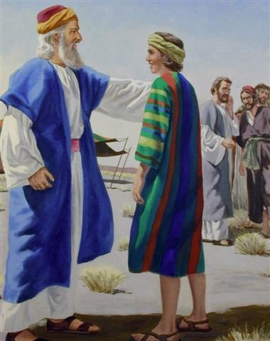**Question 1**

Highlight TRUE or FALSE for the following questions

a) Jacob was also known by the name Israel TRUE / FALSE

b) Joseph’s sons were Manasseh and Ephraim TRUE / FALSE

c) Rachel was the wife of Jospeh TRUE / FALSE

d) Two of Jacob’s sons were Reuben and Simeon TRUE / FALSE

* Tuesday 17th November: Read **Genesis 48:8-11** and answer the questions:

**Joseph introduces his sons to his father**

*8Then Israel saw Joseph’s sons, and said, “Who are these?”*

*9And Joseph said to his father, “They are my sons, whom God has given me in this place.”*

*And he said, “Please bring them to me, and I will bless them.” 10Now the eyes of Israel were dim with age, so that he could not see. Then Joseph brought them near him, and he kissed them and embraced them. 11And Israel said to Joseph, “I had not thought to see your face; but in fact, God has also shown me your offspring!”*

**Question 2**

Read verse 11 again. Why did Israel say to Jospeh that he thought he’d never see him again? (Hint: Read Genesis Chapter 37, Verses 31-35)

1. Israel was blind
2. Joseph’s brothers sold him as a slave but told Israel he had been killed
3. Joseph left home when he was very young
4. Israel had sold him as a slave to make some money

* Wednesday 18th November: Read **Genesis 48: 12-14** and answer the questions:

**Israel blesses Joseph**

*12So Joseph brought them from beside his knees, and he bowed down with his face to the earth. 13And Joseph took them both, Ephraim with his right hand toward Israel’s left hand, and Manasseh with his left hand toward Israel’s right hand, and brought them near him. 14Then Israel stretched out his right hand and laid it on Ephraim’s head, who was the younger, and his left hand on Manasseh’s head, guiding his hands knowingly, for Manasseh was the firstborn.*

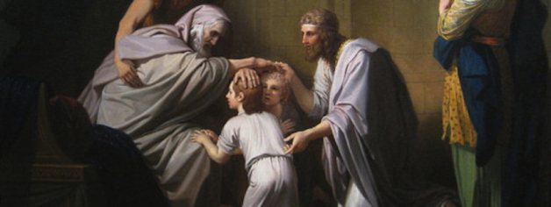**Question 3**

Label the people in the picture using the following names:

Joseph

Israel

Ephraim and Manasseh

* Thursday 19th November: Read **Genesis 48: 15-16** and answer the questions:

**Israel’s blesses Joseph’s sons**

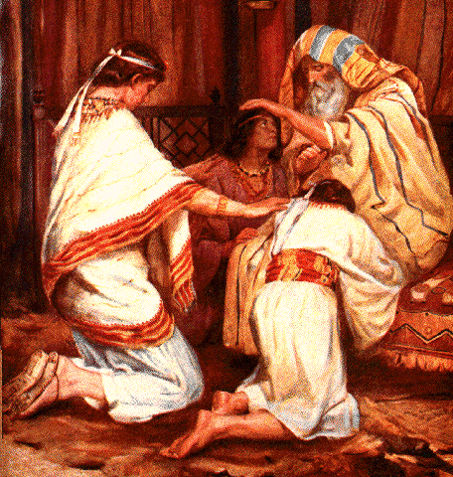*15And he blessed Joseph, and said:*

*“God, before whom my fathers Abraham and Isaac walked,  
The God who has fed me all my life long to this day,  
16The Angel who has redeemed me from all evil,  
Bless the lads;  
Let my name be named upon them,  
And the name of my fathers Abraham and Isaac;  
And let them grow into a multitude in the midst of the earth.”*

**Question 4**

Match the words on the left with their meaning on the right.

|  |  |  |
| --- | --- | --- |
| **Word** | *Matched Number* | **Meaning** |
| Redeemed |  | 1. A large number of people |
| Lads |  | 2. To save |
| Multitude |  | 3. Another word for boys |

* Friday 20th November: Read **Genesis 48: 17-19** and answer the questions:

**Israel gives the firstborn blessing to Joseph’s younger son**

*17Now when Joseph saw that his father laid his right hand on the head of Ephraim, it displeased him; so he took hold of his father’s hand to remove it from Ephraim’s head to Manasseh’s head. 18And Joseph said to his father, “Not so, my father, for this one is the firstborn; put your right hand on his head.”*

*19But his father refused and said, “I know, my son, I know. He also shall become a people, and he also shall be great; but truly his younger brother shall be greater than he, and his descendants shall become a multitude of nations.”*

**Question 5**

Why was Joseph upset when Israel put his right hand on the head of Ephraim?

1. Manasseh was older and it was custom for the older son to receive blessing from the right
2. Israel was blind and couldn’t see what he was doing
3. Israel was meant to put his hand on Joseph’s head

* Saturday 21st November:Look up **Genesis 48: 21-22** and answer the questions:

**Question 6**

Look up Genesis 48 verses 21-22 and copy it in the textbox below

**Question 7**

Did Israel bless Joseph more than his other brothers?

***What to do when you finish your Bible Study.***

1. ***Either send it by email to your class email address or print and hand it to your servants next Sunday.***
2. ***If you want to send your Bible Study by email, please select your class email address below:***

[StBakhomios4B@gmail.com](https://webmail.meriden.nsw.edu.au/owa/redir.aspx?C=4adc2b70e10f4d7a852971e205ecbf9c&URL=mailto%3aStBakhomios4B%40gmail.com) bible study servant Victor Hanna

[StAnthony4C@gmail.com](https://webmail.meriden.nsw.edu.au/owa/redir.aspx?C=4adc2b70e10f4d7a852971e205ecbf9c&URL=mailto%3aStAnthony4C%40gmail.com) bible study servant Melaine Saleeb

1. ***Click on the following link to see how many points you have.***

*(Hold Ctrl and left click with your mouse on the following link* ***OR*** *copy and paste the link into your browser)*

**Year 4B (St Bakhomios)**

<https://docs.google.com/spreadsheets/d/1wl6OeTuXpxy4T88ATrJOTiCu0HFlBZx9WyKmcOHHz9A/edit?usp=sharing>

**Year 4C (St Anthony)**

<https://docs.google.com/spreadsheets/d/1PgNO1gO77nfTJaty0VOmkZs9_do_XpLNpwpYZZht9I/edit?usp=sharing>