C:\Documents and Settings\suzy\Local Settings\Temporary Internet Files\Content.IE5\3JXW24R5\MC900383922[1].wmfSunday 18th October, 2015

Name:

Class:

Finish Date: Saturday 24th October, 2015

Completed Bible Study = 15 points

Email Homework by the due date = 5 points

**Year 4 Bible Study Genesis Chapter 43**

**For the questions below Highlight, underline or change the font colour to choose the correct answer.**

* Monday 26th October :Read **Genesis 43: 1-8** and answer the questions:

### Joseph’s Brothers Return with Benjamin

*1 Now the famine was severe in the land. 2And it came to pass, when they had eaten up the grain which they had brought from Egypt, that their father said to them, “Go back, buy us a little food.”*

*3But Judah spoke to him, saying, “The man solemnly warned us, saying, ‘You shall not see my face unless your brother is with you.’ 4If you send our brother with us, we will go down and buy you food. 5But if you will not send him, we will not go down; for the man said to us, ‘You shall not see my face unless your brother is with you.’”*

**Question 1**

Where was the father telling his sons to go back to, to get more grain for food?

a) Israel

b) Egypt

c) Sydney

d) the Middle East

**Question 2**

Judah says “the man solemnly warned us saying ‘you shall not see my face unless your brother is with you’”. Who is ‘the man’?

**Question 3**

Why do you think Joseph in Egypt asked his brothers to bring the youngest brother with them?

* Tuesday 27th October: Read **Genesis 43: 6-10** and answer the questions:

**Judah reassures Israel that Benjamin will return with them.**

*6And Israel said, “Why did you deal so wrongfully with me as to tell the man whether you had still another brother?”*

*7But they said, “The man asked us pointedly about ourselves and our family, saying, ‘Is your father still alive? Have you another brother?’ And we told him according to these words. Could we possibly have known that he would say, ‘Bring your brother down’?”*

*8Then Judah said to Israel his father, “Send the lad with me, and we will arise and go, that we may live and not die, both we and you and also our little ones. 9I myself will be surety for him; from my hand you shall require him. If I do not bring him back to you and set him before you, then let me bear the blame forever. 10For if we had not lingered, surely by now we would have returned this second time.”*

**Question 4**

At this stage we read that the brothers are afraid to return to Egypt for food without their brother Benjamin as they had been warned by Joseph that they should only return with their youngest brother. How do you think Jacob felt about letting his youngest son go on the journey? Do you think he was thinking of what happened to his beloved Joseph?

**Question 5**

Which of the sons took responsibility for Benjamin’s safety?

1. Joseph
2. Dan
3. Reuben
4. Judah

* Wednesday 28th October: Read **Genesis 43: 11-18** and answer the questions:

**Joseph’s brothers return to Egypt to buy more grain**

*11And their father Israel said to them, “If it must be so, then do this: Take some of the best fruits of the land in your vessels and carry down a present for the man—a little balm and a little honey, spices and myrrh, pistachio nuts and almonds. 12Take double money in your hand, and take back in your hand the money that was returned in the mouth of your sacks; perhaps it was an oversight. 13Take your brother also, and arise, go back to the man. 14And may God Almighty give you mercy before the man, that he may release your other brother and Benjamin. If I am bereaved, I am bereaved!”*

*15So the men took that present and Benjamin, and they took double money in their hand, and arose and went down to Egypt; and they stood before Joseph. 16When Joseph saw Benjamin with them, he said to the steward of his house, “Take these men to my home, and slaughter an animal and make ready; for these men will dine with me at noon.” 17Then the man did as Joseph ordered, and the man brought the men into Joseph’s house.*

*18Now the men were afraid because they were brought into Joseph’s house; and they said, “It is because of the money, which was returned in our sacks the first time, that we are brought in, so that he may make a case against us and seize us, to take us as slaves with our donkeys.”*

**Question 6**

Does Jacob allow Benjamin to go to Egypt with his brothers? YES/NO

**Question 7**

What sort of gifts did Jacob send with his sons to Egypt? Highlight the one that is NOT correct:

Balm, Honey, Spices, Myrrh, Pistachio nuts, Peanuts, and Almonds.

* Thursday 29th October: Read **Genesis 43: 19-23** and answer the questions:

**Joseph speaks to his brothers**

*19When they drew near to the steward of Joseph’s house, they talked with him at the door of the house, 20and said, “O sir, we indeed came down the first time to buy food; 21but it happened, when we came to the encampment, that we opened our sacks, and there, each man’s money was in the mouth of his sack, our money in full weight; so we have brought it back in our hand. 22And we have brought down other money in our hands to buy food. We do not know who put our money in our sacks.”*

*23But he said, “Peace be with you, do not be afraid. Your God and the God of your father has given you treasure in your sacks; I had your money.” Then he brought Simeon out to them.*

**Question 8**

When the sons of Jacob came and told the steward about the money they found in their sacks, his was very ANGRY and RUDE to them. True or FALSE

**Question 9**

What was the name of the brother who had been kept captive and was now released back to them?

1. Simeon
2. Benjamin
3. Joseph
4. Judah

* Friday 30th October: Read **Genesis 43: 24-28** and answer the questions:

**Joseph enquires about his father**

*24So the man brought the men into Joseph’s house and gave them water, and they washed their feet; and he gave their donkeys feed. 25Then they made the present ready for Joseph’s coming at noon, for they heard that they would eat bread there.*

*26And when Joseph came home, they brought him the present which was in their hand into the house, and bowed down before him to the earth. 27Then he asked them about their well-being, and said, “Is your father well, the old man of whom you spoke? Is he still alive?”*

*28And they answered, “Your servant our father is in good health; he is still alive.” And they bowed their heads down and prostrated themselves*

**Question 10**

Here we see that Joseph meets his brothers and what a special time it must have been. The brothers are invited to wash their feet and dine with Joseph and they present their gift to him. What is the first thing that Joseph asks of his brothers? And what was their response?

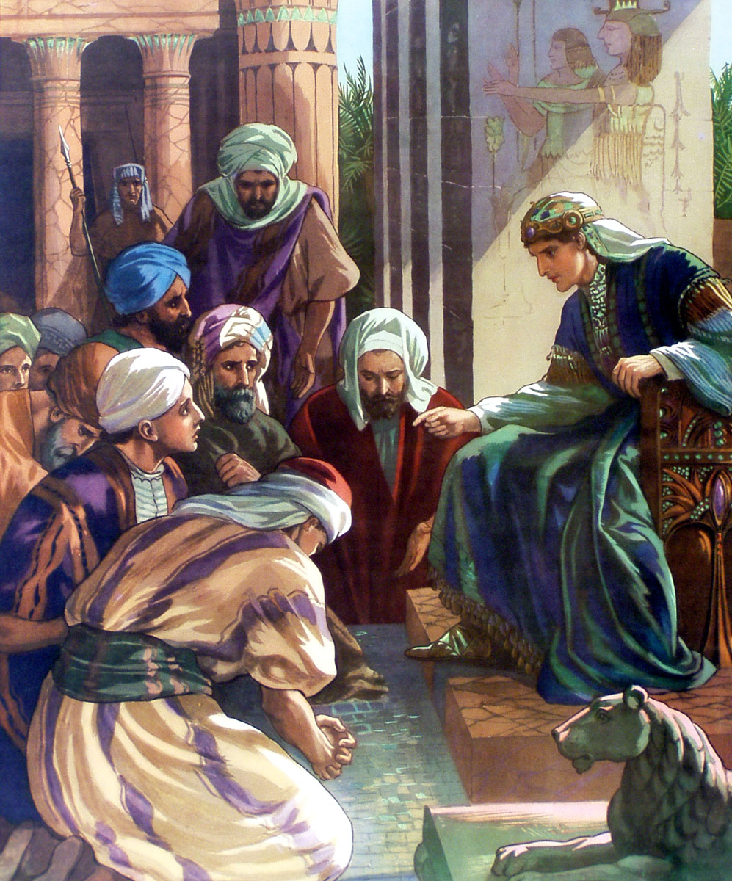

* Saturday 31st October: Read **Genesis 43: 29-34** and answer the questions:

**Joseph weeps when he sees Benjamin**

*29Then he lifted his eyes and saw his brother Benjamin, his mother’s son, and said, “Is this your younger brother of whom you spoke to me?” And he said, “God be gracious to you, my son.” 30Now his heart yearned for his brother; so Joseph made haste and sought somewhere to weep. And he went into his chamber and wept there. 31Then he washed his face and came out; and he restrained himself, and said, “Serve the bread.”*

*32So they set him a place by himself, and them by themselves, and the Egyptians who ate with him by themselves; because the Egyptians could not eat food with the Hebrews, for that is an abomination to the Egyptians. 33And they sat before him, the firstborn according to his birthright and the youngest according to his youth; and the men looked in astonishment at one another. 34Then he took servings to them from before him, but Benjamin’s serving was five times as much as any of theirs. So they drank and were merry with him.*

***What to do when you finish your Bible Study.***

1. ***Either send it by email to your class email address or print and hand it to your servants next Sunday.***
2. ***If you want to send your Bible Study by email, please select your class email address below:***

[StMakarios4A@gmail.com](https://webmail.meriden.nsw.edu.au/owa/redir.aspx?C=4adc2b70e10f4d7a852971e205ecbf9c&URL=mailto%3aStMakarios4A%40gmail.com) – bible study servant Shady Alfy

[StBakhomios4B@gmail.com](https://webmail.meriden.nsw.edu.au/owa/redir.aspx?C=4adc2b70e10f4d7a852971e205ecbf9c&URL=mailto%3aStBakhomios4B%40gmail.com) bible study servant Victor Hanna

[StAnthony4C@gmail.com](https://webmail.meriden.nsw.edu.au/owa/redir.aspx?C=4adc2b70e10f4d7a852971e205ecbf9c&URL=mailto%3aStAnthony4C%40gmail.com) bible study servant Melaine Saleeb

1. ***Click on the following link to see how many points you have.***

*(Hold Ctrl and left click with your mouse on the following link* ***OR*** *copy and paste the link into your browser)*

**Year 4A (St Makarios)**

<https://docs.google.com/spreadsheets/d/1svMXXIj8NwuUDGMm0bHIzMrBR62fWNYm9xXlsh6-I1w/edit?usp=sharing>

**Year 4B (St Bakhomios)**

<https://docs.google.com/spreadsheets/d/1wl6OeTuXpxy4T88ATrJOTiCu0HFlBZx9WyKmcOHHz9A/edit?usp=sharing>

**Year 4C (St Anthony)**

<https://docs.google.com/spreadsheets/d/1PgNO1gO77nfTJaty0VOmkZs9_do_XpLNpwpYZZht9I/edit?usp=sharing>