C:\Documents and Settings\suzy\Local Settings\Temporary Internet Files\Content.IE5\3JXW24R5\MC900383922[1].wmfSunday 4th October, 2015

Name:

Class:

Finish Date: Saturday 10th October, 2015

Completed Bible Study = 15 points

Email Homework by the due date = 5 points

**Year 3 Bible Study Genesis Chapter 4**

**For the questions below Highlight, underline or change the font colour to choose the correct answer.**

* Monday 5th October :Read **Genesis 4: 1-5** and answer the questions:

**Question 1**

What was the name of Adam and Eve’s firstborn child? (read verse 1)

1. Abel b) Enoch c) Seth d) Cain

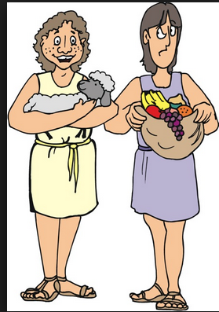

Person “B”

Person “A”

**Question 2**

From the facial expression (countenance) and what the man is carrying

who do you think person “A” and “B” is? (read verses 3 & 4)

Person “A” is

Person “B” is

* Tuesday 6th October: Read **Genesis 4: 6-12** and answer the questions:

**Question 3**

In this passage, which sins led to Cain killing Abel?

1. Jealousy and Anger
2. Lies and cheating
3. Stealing

* Wednesday 7th October: Read **Genesis 4: 13-15** and answer the questions:

**Question 4**

How does God punish Cain for murdering Abel? *Indicate which of the below are true or false.*

(read verses 11 & 12)

|  |  |
| --- | --- |
| God tells him he won’t have any children |  |
| God exiles Cain |  |
| God sends a flood |  |
| God promises that Cain’s crop will never again be fruitful |  |
| God takes away Cain’s firstborn child |  |

* Thursday 8th October: Read **Genesis 4: 16-18** and answer the questions:

**Question 5**

Which land did Cain go to when he left the presence of the Lord ? (read verse 16)

a) Nod b) Eden c) Enoch d) Israel

**Question 6**

What was the name of Cain’s first born ? (read verse 17)

a) Irad b) Enoch c)Lamech

* Friday 9th October: Read **Genesis 4: 25-26** and answer the questions:

What was the name of Adam and Eve newborn? (read verse 25)

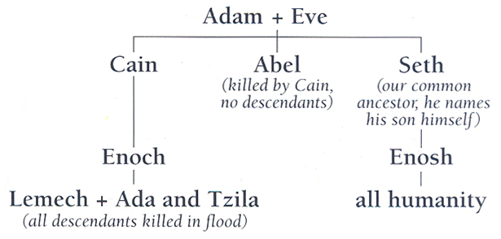

* Saturday 10th October:

Look at the following family tree, in the next chapters we will continue the story of the humanity.

***What to do when you finish your Bible Study.***

1. ***Either send it by email to your class email address or print and hand it to your servants next Sunday.***
2. ***If you want to send your Bible Study by email, please select your class email address below:***

**Year 3A St Bishoy**

[stbishoy3a@gmail.com](mailto:stbishoy3a@gmail.com) Uncle Emil

**Year 3B St Shenouda**

[stshenouda3b@gmail.com](mailto:stshenouda3b@gmail.com) Aunty Carol

1. ***Click on the following link to see how many points you have.***

*(Hold Ctrl and left click with your mouse on the following link* ***OR*** *copy and paste the link into your browser)*

**Year 3A (St Bishoy)**

<https://docs.google.com/spreadsheets/d/1n50G0dKZtJp9RWRK8pPrZBlwfk5FfJ4iVBSI9rw_vaY/edit?usp=sharing>

**Year 3B (St Shenouda)**

<https://docs.google.com/spreadsheets/d/1_95U1Mh8YbvfPowxk0A1nqM2bd9cfUAuH4pDQFjxKPE/edit?usp=sharing>