C:\Documents and Settings\suzy\Local Settings\Temporary Internet Files\Content.IE5\3JXW24R5\MC900383922[1].wmfSunday 27th September, 2015

Name:

Class:

Finish Date: Saturday 5th October, 2015

Completed Bible Study = 15 points

Email Homework by the due date = 5 points

**Year 4 Bible Study Genesis Chapter 39-40**

**For the questions below Highlight, underline or change the font colour to choose the correct answer.**

* Monday 28th September:Read **Genesis 39: 1-6** and answer the questions:

****Question 1**

What important job did Potiphar give Joseph? (the answer is in verse 4)

**Question 2**

Why did Joseph find favour in Potiphar’s sight? (the answer is in verses 3 & 4)

* Tuesday 29th September: Read **Genesis 39: 8-23** and answer the questions:

**Question 3**

1. Did Joseph agree to sin with Potiphar’s wife?
2. How did Potiphar punish Joseph? (verses 19 & 20)

* Wednesday 30th September: Read **Genesis 40: 1-8** and answer the questions:

### Question 4

Who was in the prison with Joseph? (Gen 40: 1-3)

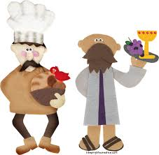

**Question 5** (Genesis 40:6-8)

What reason did the prisoners give to Joseph for looking sad one morning?

1. They missed their jobs
2. They wanted to get out of prison
3. They didn’t have an interpreter to give them the meaning of their dreams

* 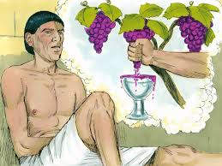Thursday 1st October: Read **Genesis 40: 9-15** and answer the questions:

**Question 6 : Fill in the missing words** (Genesis 40: 10-11)

In the butler’s dream, there were branches on the vine & the butler pressed the grapes in

**Question 7**

What did Joseph tell the butler that the 3 branches mean? (Genesis 40: 12)

a) 3 days b) 3 weeks c) 3 cups

* Friday 2nd October: Read **Genesis 40: 16-19** and answer the questions:

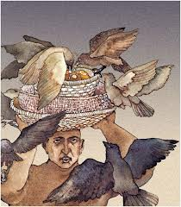**Question 8** (Genesis 40: 16)

**Fill in the missing words by highlighting/ bolding the correct answer**:

“I also was in my dream, and there were (three/ two) white baskets on my head. In the (uppermost/ bottom) basket were all kinds of baked goods for Pharaoh, and the birds ate them out of the basket on my head.”

**Question 9** (Genesis 40: 19)

Again the 3 baskets symbolise three days, but what does Joseph say will happen to the baker in three days?

a) He will return to his old job in the palace

b) He will be hung and birds will feed on his head

c) He will remain in prison and feed the birds

* Saturday 3rd October: Read **Genesis 40: 20-23** and answer the questions:

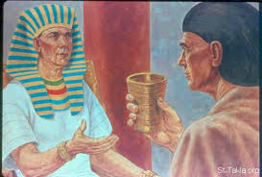**Question 10**

After the dreams become a reality and the baker is killed and the butler returns to his role working for Pharaoh, what does the butler forget to tell Pharaoh as Joseph had asked him? (This relates back to verses 14-15)

a) To spare the baker’s life

b) About Joseph’s ability to interpret dreams

c) That Joseph was wrongfully imprisoned

***What to do when you finish your Bible Study.***

1. ***Either send it by email to your class email address or print and hand it to your servants next Sunday.***
2. ***If you want to send your Bible Study by email, please select your class email address below:***

[StBakhomios4B@gmail.com](https://webmail.meriden.nsw.edu.au/owa/redir.aspx?C=4adc2b70e10f4d7a852971e205ecbf9c&URL=mailto%3aStBakhomios4B%40gmail.com) bible study servant Victor Hanna

[StAnthony4C@gmail.com](https://webmail.meriden.nsw.edu.au/owa/redir.aspx?C=4adc2b70e10f4d7a852971e205ecbf9c&URL=mailto%3aStAnthony4C%40gmail.com) bible study servant Melaine Saleeb

1. ***Click on the following link to see how many points you have.***

*(Hold Ctrl and left click with your mouse on the following link* ***OR*** *copy and paste the link into your browser)*

**Year 4B (St Bakhomios)**

<https://docs.google.com/spreadsheets/d/1wl6OeTuXpxy4T88ATrJOTiCu0HFlBZx9WyKmcOHHz9A/edit?usp=sharing>

**Year 4C (St Anthony)**

<https://docs.google.com/spreadsheets/d/1PgNO1gO77nfTJaty0VOmkZs9_do_XpLNpwpYZZht9I/edit?usp=sharing>