C:\Documents and Settings\suzy\Local Settings\Temporary Internet Files\Content.IE5\3JXW24R5\MC900383922[1].wmfSunday 23rdth August, 2015

Name:

Class:

Finish Date: Saturday 5th September, 2015

Completed Bible Study = 15 points

Email Homework by the due date = 5 points

**Year 4 Bible Study Genesis Chapter 33**

**For the questions below Highlight, underline or change the font colour to choose the correct answer.**

* Monday 24th August: Read **Genesis 33: 1-3** and answer the questions:

### Jacob and Esau Meet

*1 Now Jacob lifted his eyes and looked, and there, Esau was coming, and with him were four hundred men. So he divided the children among Leah, Rachel, and the two maidservants. 2And he put the maidservants and their children in front, Leah and her children behind, and Rachel and Joseph last. 3Then he crossed over before them and bowed himself to the ground seven times, until he came near to his brother.*

**Question 1**

What was the relationship between Jacob and Esau as we read in previous chapters?

1. cousin
2. father and son
3. twin brothers
4. brother and sister

**Question 2**

Why do you think Jacob put Rachel at the back when approaching Esau?

**Question 3**

Answer True or False

Jacob was angry with his long lost brother Esau and was coming to fight with him.

* Tuesday 25th August: Read Genesis 33: 4-7 and answer the questions:

**Esau welcomes Jacob with a hug**

*4But Esau ran to meet him, and embraced him, and fell on his neck and kissed him, and they wept. 5And he lifted his eyes and saw the women and children, and said, “Who are these with you?”*

*So he said, “The children whom God has graciously given your servant.” 6Then the maidservants came near, they and their children, and bowed down. 7And Leah also came near with her children, and they bowed down. Afterward Joseph and Rachel came near, and they bowed down.*

**Question 4**

How do you think Esau felt when he saw Jacob?

1. happy
2. afraid
3. angry
4. jealous

**Question 5**

What did each of Jacob’s family do when they approached Esau?

* Wednesday 26th August: Read **Genesis 33: 8-11** and answer the questions:

**Jacob wants to share God’s blessings with Esau**

*8Then Esau said, “What do you mean by all this company which I met?”*

*And he said, “These are to find favor in the sight of my lord.”*

*9But Esau said, “I have enough, my brother; keep what you have for yourself.”*

*10And Jacob said, “No, please, if I have now found favor in your sight, then receive my present from my hand, inasmuch as I have seen your face as though I had seen the face of God, and you were pleased with me. 11Please, take my blessing that is brought to you, because God has dealt graciously with me, and because I have enough.” So he urged him, and he took it.*

**Question 6**

In this passage we see that Jacob offers Esau a huge gift which he doesn’t want to take, why does the Bible say that he brings this to Esau?

1. to ask forgiveness of Esau
2. to make himself feel better
3. to find favor in the sight of my Esau
4. to show how rich he was

**Question 7**

Jacob insists with Esau and he accepts his offering. Jacob then goes on to liken Esau to God- write down the verse which says this:

**Question 8**

What can we learn from verse 11 . ‘Please, take my blessing that is brought to you, because God has dealt graciously with me, and because I have enough.”

* Thursday 27th August: Read **Genesis 33: 12-14** and answer the questions:

**Esau offers to lead Jacob on their journey back home**

*12Then Esau said, “Let us take our journey; let us go, and I will go before you.”*

*13But Jacob said to him, “My lord knows that the children are weak, and the flocks and herds which are nursing are with me. And if the men should drive them hard one day, all the flock will die. 14Please let my lord go on ahead before his servant. I will lead on slowly at a pace which the livestock that go before me, and the children, are able to endure, until I come to my lord in Seir.”*

**Question 9**

Here we see that Jacob agrees to go back to Esau’s home in Seir.

Esau offers to lead the way but Jacob insists on going ahead in front. This is so the children and the herd that belong to him can cope with the journey at a slower rate so they don’t get too tired and die. **True/False**

* Friday 28th August: Read **Genesis 33: 31-42** and answer the questions:

**Jacob takes a rest from his journey**

*15And Esau said, “Now let me leave with you some of the people who are with me.”*

*But he said, “What need is there? Let me find favor in the sight of my lord.” 16So Esau returned that day on his way to Seir. 17And Jacob journeyed to Succoth, built himself a house, and made booths for his livestock. Therefore the name of the place is called Succoth.*

**Question 10**

Label on the Map where Esau and where Jacob went after they parted from one another. passage. Move the text boxes below to label the map

Esau

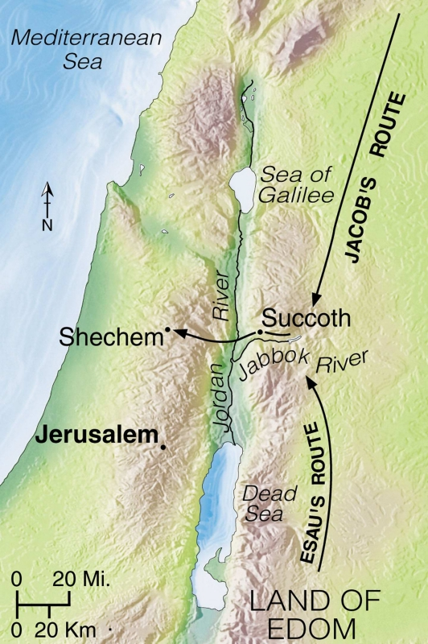

Jacob

Mt Seir ∆

* Saturday 29th August: Read **Genesis 33: 18-20** and answer the questions:

### Jacob Comes to Canaan

*18Then Jacob came safely to the city of Shechem, which is in the land of Canaan, when he came from Padan Aram; and he pitched his tent before the city. 19And he bought the parcel of land, where he had pitched his tent, from the children of Hamor, Shechem’s father, for one hundred pieces of money. 20Then he erected an altar there and called it El Elohe Israel.*

**Question 11**

**Why do you think Jacob built an altar once he had bought the land and settled there?**

1. to make it look like a church
2. to sacrifice and give thanks to God for bringing him and his family there safely
3. to show that he could build an altar

***What to do when you finish your Bible Study.***

1. ***Either send it by email to your class email address or print and hand it to your servants next Sunday.***
2. ***If you want to send your Bible Study by email, please select your class email address below:***

[StMakarios4A@gmail.com](https://webmail.meriden.nsw.edu.au/owa/redir.aspx?C=4adc2b70e10f4d7a852971e205ecbf9c&URL=mailto%3aStMakarios4A%40gmail.com) – bible study servant Shady Alfy

[StBakhomios4B@gmail.com](https://webmail.meriden.nsw.edu.au/owa/redir.aspx?C=4adc2b70e10f4d7a852971e205ecbf9c&URL=mailto%3aStBakhomios4B%40gmail.com) bible study servant Victor Hanna

[StAnthony4C@gmail.com](https://webmail.meriden.nsw.edu.au/owa/redir.aspx?C=4adc2b70e10f4d7a852971e205ecbf9c&URL=mailto%3aStAnthony4C%40gmail.com) bible study servant Melaine Saleeb

1. ***Click on the following link to see how many points you have.***

*(Hold Ctrl and left click with your mouse on the following link* ***OR*** *copy and paste the link into your browser)*

**Year 4A (St Makarios)**

<https://docs.google.com/spreadsheets/d/1svMXXIj8NwuUDGMm0bHIzMrBR62fWNYm9xXlsh6-I1w/edit?usp=sharing>

**Year 4B (St Bakhomios)**

<https://docs.google.com/spreadsheets/d/1wl6OeTuXpxy4T88ATrJOTiCu0HFlBZx9WyKmcOHHz9A/edit?usp=sharing>

**Year 4C (St Anthony)**

<https://docs.google.com/spreadsheets/d/1PgNO1gO77nfTJaty0VOmkZs9_do_XpLNpwpYZZht9I/edit?usp=sharing>