C:\Documents and Settings\suzy\Local Settings\Temporary Internet Files\Content.IE5\3JXW24R5\MC900383922[1].wmfSunday 16th August, 2015

Name:

Class:

Finish Date: Saturday 22nd August, 2015

Completed Bible Study = 15 points

Email Homework by the due date = 5 points

**Year 4 Bible Study Genesis Chapter 32**

**For the questions below Highlight, underline or change the font colour to choose the correct answer.**

* Monday 17th August: Read **Genesis 32: 1-5** and answer the questions:

### Esau Comes to Meet Jacob

*1 So Jacob went on his way, and the angels of God met him. 2When Jacob saw them, he said, “This is God’s camp.” And he called the name of that place Mahanaim.*

*3Then Jacob sent messengers before him to Esau his brother in the land of Seir, the country of Edom. 4And he commanded them, saying, “Speak thus to my lord Esau, ‘Thus your servant Jacob says: “I have dwelt with Laban and stayed there until now. 5I have oxen, donkeys, flocks, and male and female servants; and I have sent to tell my lord, that I may find favor in your sight.”’”*

**Question 1**

The angels met Jacob and the called this place:

1. Seir b) Mahanaim c) Haran

**Question 2**

Jacob sends a messenger to warn Esau that he is coming. Highlight the correct word from his instruction:

“Speak thus to my **(lord/ servant)** Esau, ‘Thus your **(lord/ servant)** Jacob says: “I have dwelt with **(Laban/ Isaac)** and stayed there until now. I have oxen, donkeys, flocks, and male and female servants; and I have sent to tell my lord, that I may find **(favour/ forgiveness)** in your sight.”’

* Tuesday 18th August: Read **Genesis 32: 6-8** and answer the questions:

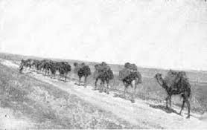

*6Then the messengers returned to Jacob, saying, “We came to your brother Esau, and he also is coming to meet you, and four hundred men are with him.” 7So Jacob was greatly afraid and distressed; and he divided the people that were with him, and the flocks and herds and camels, into two companies. 8And he said, “If Esau comes to the one company and attacks it, then the other company which is left will escape.”*

**Question 3**

**Jacob’s messengers return bringing news that makes Jacob worried that Esau is preparing to fight. What do you think makes Jacob anxious?**

1. Esau is coming to meet Jacob
2. Esau has not sent a present
3. Esau is bringing 400 of his men to meet Jacob

**Question 4**

**What does Jacob do to prevent damages/ loss of his possessions, in case Esau does come starting a war?**

1. Hides his riches in the mountains
2. Divides his people and possessions into two camps
3. Sends Rachel and Leah with his children back to Laban

* Wednesday 19th August: Read **Genesis 32: 9-12** and answer the questions:

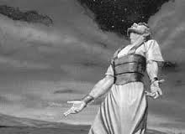

*9Then Jacob said, “O God of my father Abraham and God of my father Isaac, the Lord who said to me, ‘Return to your country and to your family, and I will deal well with you’: 10I am not worthy of the least of all the mercies and of all the truth which You have shown Your servant; for I crossed over this Jordan with my staff, and now I have become two companies. 11Deliver me, I pray, from the hand of my brother, from the hand of Esau; for I fear him, lest he come and attack me and the mother with the children. 12For You said, ‘I will surely treat you well, and make your descendants as the sand of the sea, which cannot be numbered for multitude.’”*

**Question 5**

**Fill in the missing words from Jacob’s prayer.**

“O God of my father Abraham and God of my father the Lord who said to me, ‘Return to your country and to your family, and I will deal with you’: I am not of the least of all the mercies and of all the truth which You have shown Your servant; for I crossed over this Jordan with my staff, and now I have become two companies. Deliver me, I pray, from the hand of my from the hand of Esau; for I fear him, lest he come and attack me and the mother with the children. For You said, ‘I will surely treat you well, and make your descendants as the of the sea, which cannot be numbered for multitude.’

**Question 6**

**Jacob’s honest and powerful prayer shows:**

1. His humility
2. His supplication
3. His gratitude to God
4. All the above

* Thursday 20th August: Read **Genesis 32: 13-21** and answer the questions:

*13So he lodged there that same night, and took what came to his hand as a present for Esau his brother: 14two hundred female goats and twenty male goats, two hundred ewes and twenty rams, 15thirty milk camels with their colts, forty cows and ten bulls, twenty female donkeys and ten foals. 16Then he delivered them to the hand of his servants, every drove by itself, and said to his servants, “Pass over before me, and put some distance between successive droves.” 17And he commanded the first one, saying, “When Esau my brother meets you and asks you, saying, ‘To whom do you belong, and where are you going? Whose are these in front of you?’ 18then you shall say, ‘They are your servant Jacob’s. It is a present sent to my lord Esau; and behold, he also is behind us.’” 19So he commanded the second, the third, and all who followed the droves, saying, “In this manner you shall speak to Esau when you find him; 20and also say, ‘Behold, your servant Jacob is behind us.’” For he said, “I will appease him with the present that goes before me, and afterward I will see his face; perhaps he will accept me.” 21So the present went on over before him, but he himself lodged that night in the camp.*

**Question 7**

**True or False. Which of the following presents did Jacob prepare for Esau?**

|  |  |  |  |
| --- | --- | --- | --- |
|  | **True/ False** |  | **True/ False** |
|  | **True/ False** |  | **True/ False** |
|  | **True/ False** |  | **True/ False** |
|  | **True/ False** |

* Friday 21st August: Read **Genesis 32: 22-29** and answer the questions:

### Wrestling with God

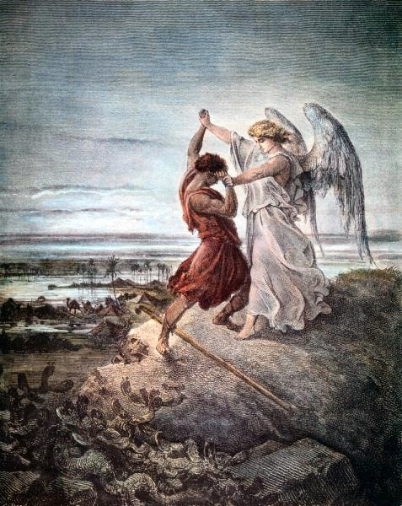 *22And he arose that night and took his two wives, his two female servants, and his eleven sons, and crossed over the ford of Jabbok. 23He took them, sent them over the brook, and sent over what he had. 24Then Jacob was left alone; and a Man wrestled with him until the breaking of day. 25Now when He saw that He did not prevail against him, He touched the socket of his hip; and the socket of Jacob’s hip was out of joint as He wrestled with him. 26And He said, “Let Me go, for the day breaks.”*

*But he said, “I will not let You go unless You bless me!”*

*27So He said to him, “What is your name?”*

*He said, “Jacob.”*

*28And He said, “Your name shall no longer be called Jacob, but Israel; for you have struggled with God and with men, and have prevailed.”*

*29Then Jacob asked, saying, “Tell me Your name, I pray.”*

*And He said, “Why is it that you ask about My name?” And He blessed him there.*

**Question 8**

What does Jacob do when left alone all night?

1. Prepare food for Esau
2. Wrestle with a Man
3. Prepare his sword for battle with Esau

**Question 9**

When the Man wanted to stop, Jacob refused until He gave what as a gift?

a) blessing,

b) food,

c) flocks

**Question 10**

What part of Jacob’s body was hurt in the wrestling?

a) hip

b) thigh

c) calf

**Question 11**

When Jacob finally receives the blessing, what does God change his name to?

* Saturday 22nd August: Read **Genesis 32: 30-32** and answer the questions:

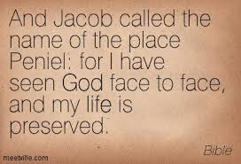

*30So Jacob called the name of the place Peniel: “For I have seen God face to face, and my life is preserved.” 31Just as he crossed over Penuel the sun rose on him, and he limped on his hip. 32Therefore to this day the children of Israel do not eat the muscle that shrank, which is on the hip socket, because He touched the socket of Jacob’s hip in the muscle that shrank.*

**Question 13**

Why do the children of Israel not eat from the muscle on the hip socket?

***What to do when you finish your Bible Study.***

1. ***Either send it by email to your class email address or print and hand it to your servants next Sunday.***
2. ***If you want to send your Bible Study by email, please select your class email address below:***

[StMakarios4A@gmail.com](https://webmail.meriden.nsw.edu.au/owa/redir.aspx?C=4adc2b70e10f4d7a852971e205ecbf9c&URL=mailto%3aStMakarios4A%40gmail.com) – bible study servant Shady Alfy

[StBakhomios4B@gmail.com](https://webmail.meriden.nsw.edu.au/owa/redir.aspx?C=4adc2b70e10f4d7a852971e205ecbf9c&URL=mailto%3aStBakhomios4B%40gmail.com) bible study servant Victor Hanna

[StAnthony4C@gmail.com](https://webmail.meriden.nsw.edu.au/owa/redir.aspx?C=4adc2b70e10f4d7a852971e205ecbf9c&URL=mailto%3aStAnthony4C%40gmail.com) bible study servant Melaine Saleeb

1. ***Click on the following link to see how many points you have.***

*(Hold Ctrl and left click with your mouse on the following link* ***OR*** *copy and paste the link into your browser)*

**Year 4A (St Makarios)**

<https://docs.google.com/spreadsheets/d/1svMXXIj8NwuUDGMm0bHIzMrBR62fWNYm9xXlsh6-I1w/edit?usp=sharing>

**Year 4B (St Bakhomios)**

<https://docs.google.com/spreadsheets/d/1wl6OeTuXpxy4T88ATrJOTiCu0HFlBZx9WyKmcOHHz9A/edit?usp=sharing>

**Year 4C (St Anthony)**

<https://docs.google.com/spreadsheets/d/1PgNO1gO77nfTJaty0VOmkZs9_do_XpLNpwpYZZht9I/edit?usp=sharing>