C:\Documents and Settings\suzy\Local Settings\Temporary Internet Files\Content.IE5\3JXW24R5\MC900383922[1].wmfSunday 14th June, 2015

Name:

Class:

Finish Date: Saturday 20th June, 2015

Completed Bible Study = 15 points

Email Homework by the due date = 5 points

**Year 4 Bible Study Genesis Chapter 29**

**For the questions below Highlight, underline or change the font colour to choose the correct answer.**

* Monday 15th June: Read **Genesis 29: 1-6** and answer the questions:

### Jacob arrives at the well

**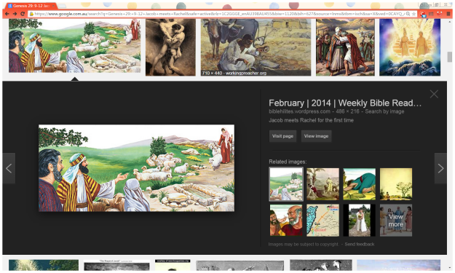***1 So Jacob went on his journey and came to the land of the people of the East. 2And he looked, and saw a well in the field; and behold, there were three flocks of sheep lying by it; for out of that well they watered the flocks. A large stone was on the well’s mouth. 3Now all the flocks would be gathered there; and they would roll the stone from the well’s mouth, water the sheep, and put the stone back in its place on the well’s mouth.*

*4And Jacob said to them, “My brethren, where are you from?”*

*And they said, “We are from Haran.”*

*5Then he said to them, “Do you know Laban the son of Nahor?”*

*And they said, “We know him.”*

*6So he said to them, “Is he well?”*

*And they said, “He is well. And look, his daughter Rachel is coming with the sheep.”*

**Question 1**

When Jacob gets to the land of the people of the East, what does he see beside a well?

**Question 2**  
What was covering the well’s mouth (opening)?

**Question 3**

Where were the men (brethren) from?

1. Haran
2. Canaan
3. Bethel

**Question 4**

When Jacob is speaking to the men, who does he ask after?

a) Nahor

b) Laban

c) Rachel

* Tuesday 16th June: Read **Genesis 29: 9-12** and answer the questions:

### Jacob Meets Rachel

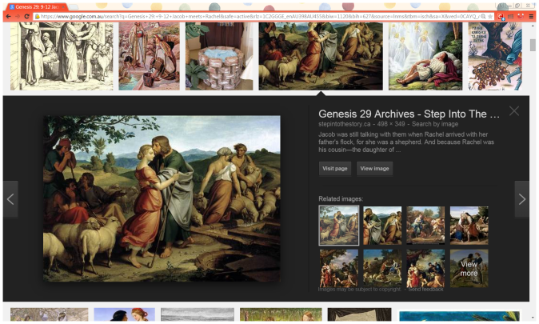*9Now while he was still speaking with them, Rachel came with her father’s sheep, for she was a shepherdess. 10And it came to pass, when Jacob saw Rachel the daughter of Laban his mother’s brother, and the sheep of Laban his mother’s brother, that Jacob went near and rolled the stone from the well’s mouth, and watered the flock of Laban his mother’s brother. 11Then Jacob kissed Rachel, and lifted up his voice and wept. 12And Jacob told Rachel that he was her father’s relative and that he was Rebekah’s son. So she ran and told her father.*

**Question 5**

Rachel works for a living as a:  
a) Farmer

b) Maid

c) Shepherdess

**Question 6**

Identify the verse in the passage that describes what you see in the picture

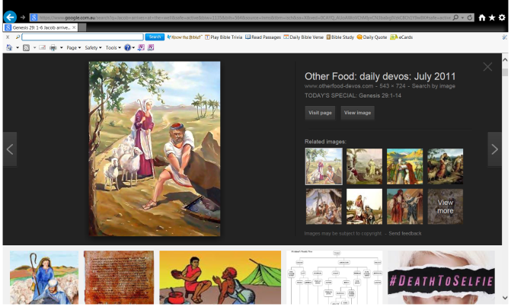

Verse:

**Question 7**

What did Jacob do for Rachel when he saw her?  
 a) rolled the stone from the well’s mouth

b) watered the flock of Laban his mother’s brother

c) all of the above

**Question 8**

What did Jacob do before telling Rachel that he was Rebekah’s son (her cousin)?

1. Kiss her and laugh
2. Kiss her and cried
3. Cried, prayed and ran away with her

**Question 9**

Who ran to tell Laban, Rachel’s father, about Jacob’s arrival?

* Wednesday 17th June: Read **Genesis 29: 13-14** and answer the questions:

**Laban runs to meet Jacob**

*13……………*

*14And Laban said to him, “Surely you are my bone and my flesh.” And he stayed with him for a month.*

**Question 10**

### For this question I would like you to open a Bible you have at home and find the verse Genesis Chapter 29 verse 13, and copy into the textbox below. It is only one sentence. If you have trouble, ask your parents or an older brother or sister to help you.

***HINT: Old Testament, first Book (Genesis)***

**Question 11**

List the 4 things Laban did to welcome Jacob to his home.

* Thursday 18th June: Read **Genesis 29: 15-20** and answer the questions:

### Jacob loves and wants to marry Rachel

*15Then Laban said to Jacob, “Because you are my relative, should you therefore serve me for nothing? Tell me, what should your wages be?” 16Now Laban had two daughters: the name of the elder was Leah, and the name of the younger was Rachel. 17Leah’s eyes were delicate, but Rachel was beautiful of form and appearance.*

*18Now Jacob loved Rachel; so he said, “I will serve you seven years for Rachel your younger daughter.”*

*19And Laban said, “It is better that I give her to you than that I should give her to another man. Stay with me.” 20So Jacob served seven years for Rachel, and they seemed only a few days to him because of the love he had for her.*

**Question 12**

How many years Jacob had to work for Laban in order to marry Rachel?

1. 5
2. 7
3. 12

**Question 13**

What does the following verse mean? *“So Jacob served …….years for Rachel, and they seemed only a few days to him because of the love he had for her.”*

a) Time flew by quickly

b) Time seemed an eternity

c) Laban cut the service to just a few days

* Friday 19th June: Read **Genesis 29: 21-25** and answer the questions:

**Laban deceives Jacob**

*21Then Jacob said to Laban, “Give me my wife, for my days are fulfilled, that I may go in to her.” 22And Laban gathered together all the men of the place and made a feast. 23Now it came to pass in the evening, that he took Leah his daughter and brought her to Jacob; and he went in to her. 24And Laban gave his maid Zilpah to his daughter Leah as a maid. 25So it came to pass in the morning, that behold, it was Leah. And he said to Laban, “What is this you have done to me? Was it not for Rachel that I served you? Why then have you deceived me?”*

*26And Laban said, “It must not be done so in our country, to give the younger before the firstborn. 27Fulfill her week, and we will give you this one also for the service which you will serve with me still another seven years.”*

*28Then Jacob did so and fulfilled her week. So he gave him his daughter Rachel as wife also. 29And Laban gave his maid Bilhah to his daughter Rachel as a maid. 30Then Jacob also went in to Rachel, and he also loved Rachel more than Leah. And he served with Laban still another seven years.*

**Question 14**

How did Laban trick Jacob?

1. Laban gave him a maid instead of Rachel
2. He gave him Leah instead of Rachel
3. Neither of the above

**Question 15**

Fill in the table below by naming Leah or Rachael to answer the question

|  |  |
| --- | --- |
| Question | Leah or Rachel |
| Who did Jacob love more? |  |
| Who did Jacob marry first? |  |
| For whom did Jacob serve Laban for? |  |
| Who was older? |  |
| Who’s maid was Bilhah? |  |
| Who’s maid was Zilpah? |  |

* Saturday 20th June: Read **Genesis 29: 41-46** and answer the questions:

### The Children of Jacob

*31When the Lord saw that Leah was unloved, He opened her womb; but Rachel was barren. 32So Leah conceived and bore a son, and she called his name Reuben;for she said, “The Lord has surely looked on my affliction. Now therefore, my husband will love me.” 33Then she conceived again and bore a son, and said, “Because the Lord has heard that I am unloved, He has therefore given me this son also.” And she called his name Simeon. 34She conceived again and bore a son, and said, “Now this time my husband will become attached to me, because I have borne him three sons.” Therefore his name was called Levi. 35And she conceived again and bore a son, and said, “Now I will praise the Lord.” Therefore she called his name Judah. Then she stopped bearing.*

**Question 16**

Why did God show mercy on Leah and give her a son?

1. Because she was young and sick
2. Because she was unloved
3. Because she was poor and lost

**Question 17**

Write the words/phrases from the list below to best match its meaning:

Barren, opened her womb, conceived, bore, stopped bearing

|  |  |
| --- | --- |
| **Word** | **Meaning** |
|  | Able to have a baby |
|  | Unable to have children |
|  | Have a baby |
|  | Became pregnant |
|  | Stopped having babies |

**Question 18**

Jacob had many children, you will learn about the other children in the next Bible Study.

Below is a picture of 4 women that will bear children for Jacob.

Write down the names of the 4 sons Leah gave birth to in this passage.

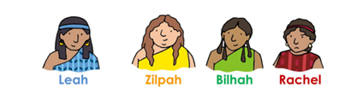

**Question 19**

Each of the names of the sons you identified in question 18 has a meaning. Match the name to its meaning. The reason for the meaning is a hint to help you identify the name.

|  |  |  |
| --- | --- | --- |
| **Name** | **Meaning** | **Reason for the meaning** |
|  | Behold, a son. | This was her statement to Jacob and all others that the Lord had looked upon my affliction. |
|  | Attachment. | Leah still lives in the hope her husband Jacob would love her and become attached to her through the birth of these sons. |
|  | Praise. | Leah stopped naming her children to reflect the pain and longing in her heart. At this point she focused on God and could praise Him. |
|  | Hearing. | Leah hoped all would notice that the Lord has heard her. |

**Question 20**

In today’s Bible study you have learnt that Names often have a meaning.

Example: Christina means “follower of Christ”

John means “God has been gracious”

Gabriella means “God is my strength”

Does your name have a special meaning? If so, what is it?

***What to do when you finish your Bible Study.***

1. ***Either send it by email to your class email address or print and hand it to your servants next Sunday.***
2. ***If you want to send your Bible Study by email, please select your class email address below:***

[StMakarios4A@gmail.com](https://webmail.meriden.nsw.edu.au/owa/redir.aspx?C=4adc2b70e10f4d7a852971e205ecbf9c&URL=mailto%3aStMakarios4A%40gmail.com) – bible study servant Shady Alfy

[StBakhomios4B@gmail.com](https://webmail.meriden.nsw.edu.au/owa/redir.aspx?C=4adc2b70e10f4d7a852971e205ecbf9c&URL=mailto%3aStBakhomios4B%40gmail.com) bible study servant Victor Hanna

[StAnthony4C@gmail.com](https://webmail.meriden.nsw.edu.au/owa/redir.aspx?C=4adc2b70e10f4d7a852971e205ecbf9c&URL=mailto%3aStAnthony4C%40gmail.com) bible study servant Melaine Saleeb

1. ***Click on the following link to see how many points you have.***

*(Hold Ctrl and left click with your mouse on the following link* ***OR*** *copy and paste the link into your browser)*

**Year 4A (St Makarios)**

<https://docs.google.com/spreadsheets/d/1svMXXIj8NwuUDGMm0bHIzMrBR62fWNYm9xXlsh6-I1w/edit?usp=sharing>

**Year 4B (St Bakhomios)**

<https://docs.google.com/spreadsheets/d/1wl6OeTuXpxy4T88ATrJOTiCu0HFlBZx9WyKmcOHHz9A/edit?usp=sharing>

**Year 4C (St Anthony)**

<https://docs.google.com/spreadsheets/d/1PgNO1gO77nfTJaty0VOmkZs9_do_XpLNpwpYZZht9I/edit?usp=sharing>