Sunday 7th June, 2015
Name:
Class:
Finish Date: Saturday 13th June, 2015
Completed Bible Study = 15 points
Email Homework by the due date = 5 points

Year 4 Bible Study Genesis Chapter 28
For the questions below Highlight, underline or change the font colour to choose the correct answer.
- Monday 8th June: Read Genesis 28: 1-5 and answer the questions:

Isaac blesses Jacob
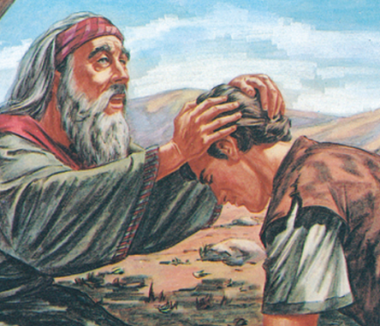
¹ Then Isaac called Jacob and blessed him, and charged him, and said to him: “You shall not take a wife from the daughters of Canaan. ² Arise, go to Padan Aram, to the house of Bethuel your mother’s father; and take yourself a wife from there of the daughters of Laban your mother’s brother.
³ “May God Almighty bless you,
And make you fruitful and multiply you,
That you may be an assembly of peoples;
⁴ And give you the blessing of Abraham,
To you and your descendants with you,
That you may inherit the land
In which you are a stranger,
Which God gave to Abraham.”
⁵ So Isaac sent Jacob away, and he went to Padan Aram, to Laban the son of Bethuel the Syrian, the brother of Rebekah, the mother of Jacob and Esau.
Question 1
Where on the map below where did Isaac tell Jacob to go and find a wife?
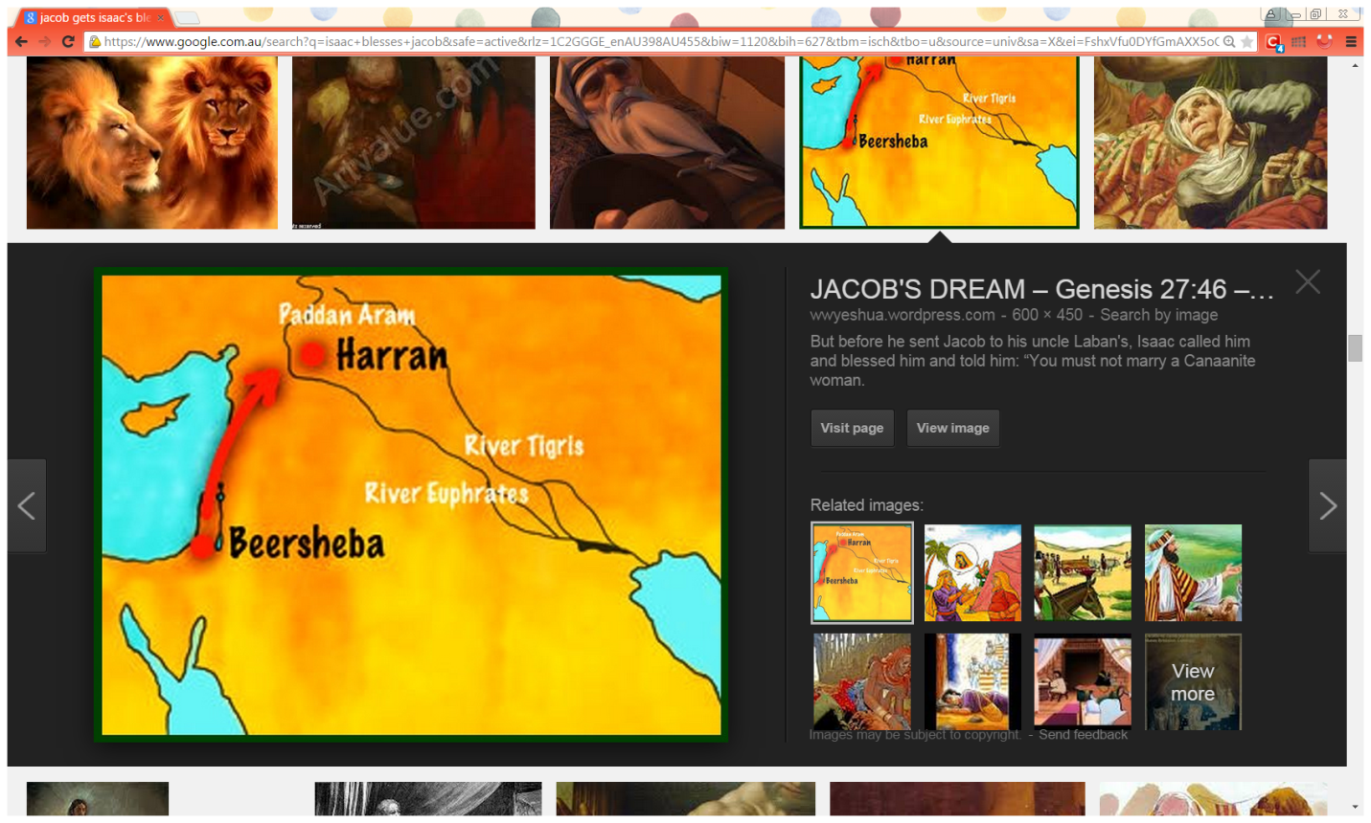
A
C
B
D
A
- A
- B
- C
- D

Question 2
How are the following people related to Jacob?
Rebekah, Bethual, Laban, Esau, Isaac

Name | Relation to Jacob
 | Father
 | Mother
 | Brother
 | His mother’s father
 | His mother’s brother

Question 3
Isaac is now given 2 blessings from Jacob
Blessing 1: Genesis 27:27-29
“Surely, the smell of my son
Is like the smell of a field
Which the Lord has blessed.
²⁸ Therefore may God give you
Of the dew of heaven,
Of the fatness of the earth,
And plenty of grain and wine.
²⁹ Let peoples serve you,
And nations bow down to you.
Be master over your brethren,
And let your mother’s sons bow down to you.
Cursed be everyone who curses you,
And blessed be those who bless you!”

Blessing 2: Genesis 28: 3-4
³ “May God Almighty bless you,
And make you fruitful and multiply you,
That you may be an assembly of peoples;
⁴ And give you the blessing of Abraham,
To you and your descendants with you,
That you may inherit the land
In which you are a stranger,
Which God gave to Abraham.”

- Which Blessing did Jacob receive by pretending to be his bother Esau?

- Which blessing did Isaac give Jacob knowing who he is blessing, it is more complete.

Question 4
Why doesn’t Isaac want Jacob to marry a woman from Canaan?
- Because it is too far away
- Woman from Canaan were not religious
- They were poor
- They were too old

Question 5

From whose daughters does Isaac instruct Jacob to choose a wife?
Question 5
Verses 3 & 4 are the blessing of Isaac to Jacob.
Match the lines of the actual verse with what you think they mean from the list below
- May you become a big nation (country)
- God give you and your children the same blessing Abraham had
- God bless you
- May you take ownership of the land God gave to Abraham
- God give you many children
Isaac’s blessing verses 3-4 | Meanings
“May God Almighty bless you,
And make you fruitful and multiply you,
That you may be an assembly of peoples;
And give you the blessing of Abraham,
To you and your descendants with you,
That you may inherit the land
In which you are a stranger,
Which God gave to Abraham.”

- Tuesday 9th June: Read Genesis 28: 6-9 and answer the questions:

Esau Marries Mahalath
⁶ Esau saw that Isaac had blessed Jacob and sent him away to Padan Aram to take himself a wife from there, and that as he blessed him he gave him a charge, saying, “You shall not take a wife from the daughters of Canaan,” ⁷ and that Jacob had obeyed his father and his mother and had gone to Padan Aram. ⁸ Also Esau saw that the daughters of Canaan did not please his father Isaac. ⁹ So Esau went to Ishmael and took Mahalath the daughter of Ishmael, Abraham’s son, the sister of Nebajoth, to be his wife in addition to the wives he had.

Question 6
How does Esau try to please his parents and perhaps make up for having just upset Rebekah by threatening to kill Jacob?
a) By killing a calf as a gift
b) By taking a wife who is not from Canaan
c) By leaving his parent’s house
Question 7

a) Who is the father of the woman Esau marries?
b) How is that man related to Abraham? He is:
i) Abraham's grandson
ii) Abraham's nephew
iii) Abraham's first born son

- Wednesday 10th June: Read Genesis 28: 10-12 and answer the questions:

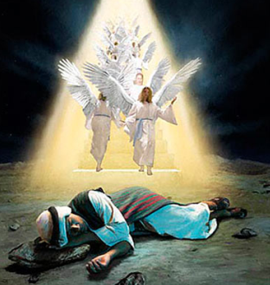
Jacob’s Vow at Bethel
¹⁰ Now Jacob went out from Beersheba and went toward Haran. ¹¹ So he came to a certain place and stayed there all night, because the sun had set. And he took one of the stones of that place and put it at his head, and he lay down in that place to sleep. ¹² Then he dreamed, and behold, a ladder was set up on the earth, and its top reached to heaven; and there the angels of God were ascending and descending on it.
Question 8
Where was Jacob travelling to when night came and he lay down to sleep?

Question 9

What did he use as a pillow?

Question 10
What did he dream about when he fell asleep?
- He saw a ladder with angels going up and down, and God was speaking to him.
- The coming day.
- How he had wronged Esau and his father.

- Thursday 11th June: Read Genesis 28: 13-15 and answer the questions:

God speaks to Jacob in a dream

¹³ And behold, the Lord stood above it and said: “I am the Lord God of Abraham your father and the God of Isaac; the land on which you lie I will give to you and your descendants. ¹⁴ Also your descendants shall be as the dust of the earth; you shall spread abroad to the west and the east, to the north and the south; and in you and in your seed all the families of the earth shall be blessed. ¹⁵ Behold, I am with you and will keep you wherever you go, and will bring you back to this land; for I will not leave you until I have done what I have spoken to you.”

Question 11
Identify the verse number
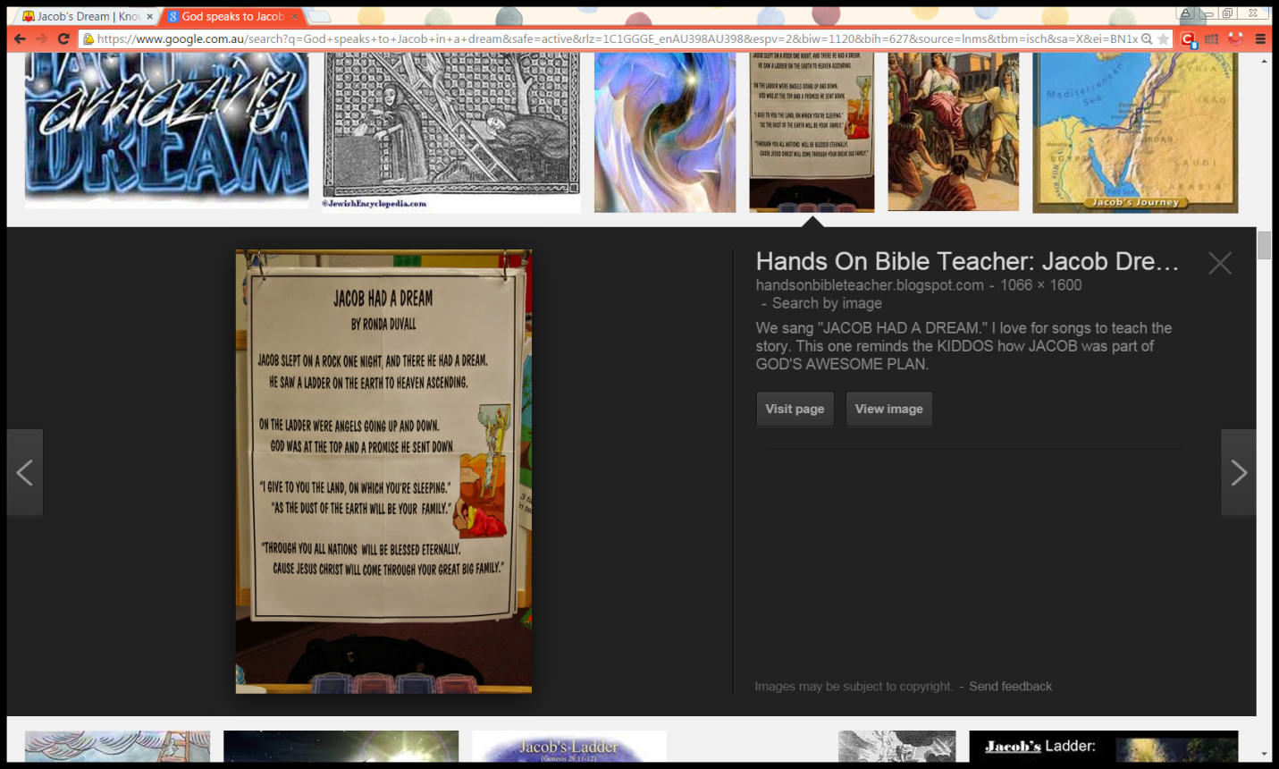
Verse:
Hint: Wednesday’s study

Verse:
Hint: Wednesday’s study

Verse:
Verse:
Verse:

Question 12
In the dream, what did God promise Jacob?
a) God promised to give him this land, to guard him and bring him back safely to this
land, and never to leave him.
b) God promised to give him food for his journey.

- Friday 12th June: Read Genesis 28: 16-17 and answer the questions:

Jacob wakes up from his sleep

¹⁶ Then Jacob awoke from his sleep and said, “Surely the Lord is in this place, and I did not know it.” ¹⁷ And he was afraid and said, “How awesome is this place! This is none other than the house of God, and this is the gate of heaven!”

Question 13
True/False
Why was Jacob afraid?
- Because he was scard from God. True/False
- Because he thought God was going to punish him. True/False
- Because Of God’s amazing Grace and goodness, especially after deceiving his father and dishonestly taking Esau’s blessing. True/False
- Because he felt he was unworthy to receive God’s promise. True/False
- He woke in AWE (amazement) of The LORD and His promise to be with Jacob. True/False
- Because he was in the middle of the wilderness all alone. True/False

- Saturday 13th June: Read Genesis 28: 18-22 and answer the questions:
Jacob’s vow to God
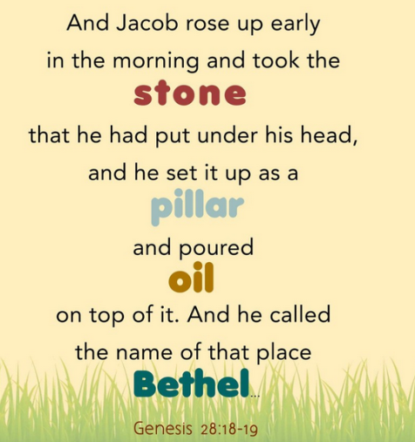
¹⁸ Then Jacob rose early in the morning, and took the stone that he had put at his head, set it up as a pillar, and poured oil on top of it. ¹⁹ And he called the name of that place Bethel; but the name of that city had been Luz previously. ²⁰ Then Jacob made a vow, saying, “If God will be with me, and keep me in this way that I am going, and give me bread to eat and clothing to put on, ²¹ so that I come back to my father’s house in peace, then the Lord shall be my God. ²² And this stone which I have set as a pillar shall be God’s house, and of all that You give me I will surely give a tenth to You.”

Do you know what a pillar is?
A pillar is large post that helps to hold up something (such as a roof).
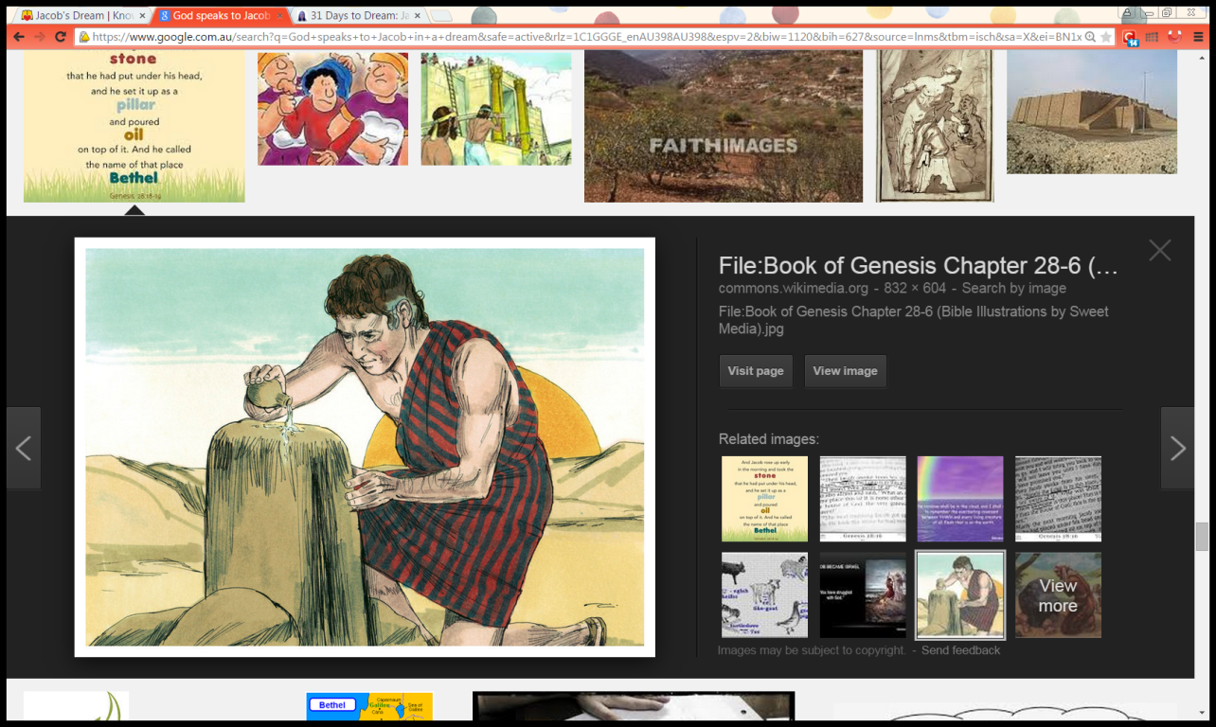
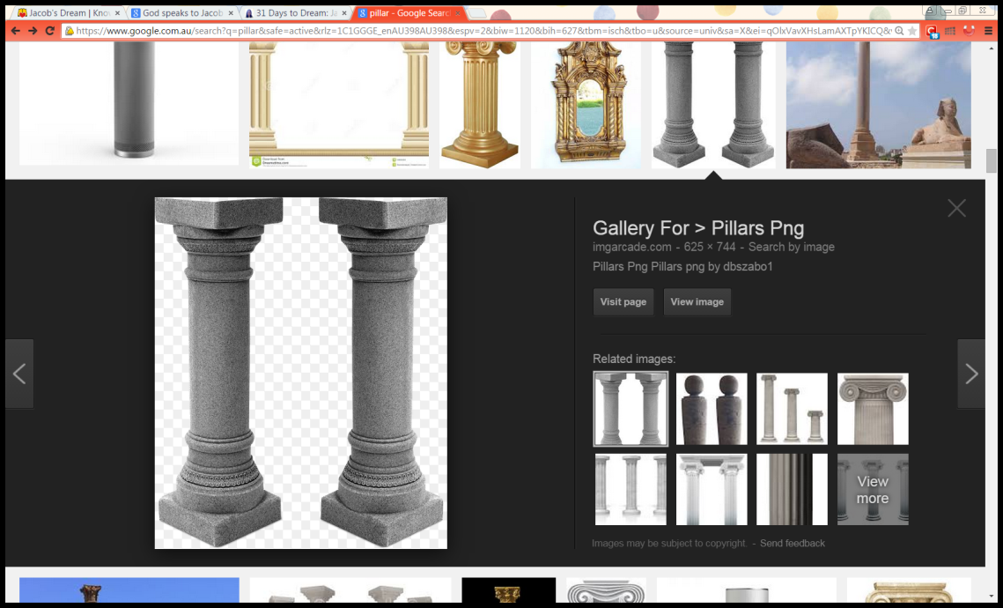
Man-made pillar
Jacob’s pillar

Question 14

When Jacob wakes up, he recognises how precious his dream was and instantly tries to keep up his conversation with God. What does he do with his "pillow" as a permanent reminder of God?

Question 15
As Jacob took the stone, which he had used as a pillow, and set it up as a memorial,
what promise did he make?
a) That he would always save that stone.
b) That he would always worship God and obey His laws.

Question 16
What does Jacob name that place?
a) Bethel
b) Luz
c) Pillar

Question 17
Jacob makes a big vow (promise) to God - what does Jacob promise to give God?
- I will give You my first son.
- I will give You first salary.
- I will give you a tenth (10%) of everything that You give me

Question 18
What does Jacob ask God for? Choose the correct statement:
a) Fine silk clothes / Any clothes
b) God to leave him in peace/ God to stay near him & take him safely home to Isaac
c) Bread to eat/ fattened cows to eat and the best meat.
Question 20
Do you believe that God watches over you wherever you are?
- Yes.
- No.
- I don't know

What to do when you finish your Bible Study.
- Either send it by email to your class email address or print and hand it to your servants next Sunday.
- If you want to send your Bible Study by email, please select your class email address below:
Year 4A (St Makarios)
StMakarios4A@gmail.com Uncle Shady
Year 4B (St Bakhomios)
StBakhomios4B@gmail.com Uncle Joe
Year 4C (St Anthony)
StAnthony4C@gmail.com Aunty Melaine
- Click on the following link to see how many points you have.
(Hold Ctrl and left click with your mouse on the following link OR copy and paste the link into your browser)
Year 4A (St Makarios)
https://docs.google.com/spreadsheets/d/1svMXXIj8NwuUDGMm0bHIzMrBR62fWNYm9xXlsh6-I1w/edit?usp=sharing

Year 4B (St Bakhomios)
https://docs.google.com/spreadsheets/d/1wl6OeTuXpxy4T88ATrJOTiCu0HFlBZx9WyKmcOHHz9A/edit?usp=sharing

Year 4C (St Anthony)
https://docs.google.com/spreadsheets/d/1PgNO1gO77nfTJaty0VOmkZs9_do_XpLNpwpYZZht9I/edit?usp=sharing

