C:\Documents and Settings\suzy\Local Settings\Temporary Internet Files\Content.IE5\3JXW24R5\MC900383922[1].wmfSunday 24th May, 2015

Name:

Class:

Finish Date: Saturday 30th May, 2015

Completed Bible Study = 15 points

Email Homework by the due date = 5 points

**Year 4 Bible Study Genesis Chapter 26**

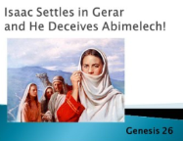 **For the questions below Highlight, underline or change the font colour to choose the correct answer.**

□ Monday 25th May: Read **Genesis 26: 1-5** and answer the questions:

**The Lord appears to Isaac**

*There was a famine in the land, besides the first famine that was in the days of Abraham. And Isaac went to Abimelech king of the Philistines, in Gerar.*

*2Then the Lord appeared to him and said: “Do not go down to Egypt; live in the land of which I shall tell you. 3Dwell in this land, and I will be with you and bless you; for to you and your descendants I give all these lands, and I will perform the oath which I swore to Abraham your father. 4And I will make your descendants multiply as the stars of heaven; I will give to your descendants all these lands; and in your seed all the nations of the earth shall be blessed; 5because Abraham obeyed My voice and kept My charge, My commandments, My statutes, and My laws.”*

**Do you know what the word ‘famine’ means?**

*A famine occurs when there is not enough food in a land, which causes its people to be hungry.*

**Do you know what the word ‘seed” means?**

*Seed is the beginning of many descendants and offspring. It is a word that describes one’s children, grandchildren, great grand children etc.*

*A Seed is like a parent, the beginning of a large extended family. When the seed grows into a plant it has many many branches. When a parent has children, the children grow and marry and have children of their own. This continues for many generations, therefore producing many descendants.*

**Question 1**

Who was Abimelech?

**Question 2**

God promised Isaac many blessings. Find and list the verses in which God blesses him.

|  |  |
| --- | --- |
| God’s promised blessings to Isaac | Verse number |
|  |  |
|  |  |
|  |  |
|  |  |

□ Tuesday 26th May: Read **Genesis 26: 6-9** and answer the questions:

**Isaac lies to Abimelech**

*6So Isaac dwelt in Gerar. 7And the men of the place asked about his wife. And he said, “She is my sister”; for he was afraid to say, “She is my wife,” because he thought, “lest the men of the place kill me for Rebekah, because she is beautiful to behold.” 8Now it came to pass, when he had been there a long time, that Abimelech king of the Philistines looked through a window, and saw, and there was Isaac, showing endearment to Rebekah his wife. 9Then Abimelech called Isaac and said, “Quite obviously she is your wife; so how could you say, ‘She is my sister’?”*

*Isaac said to him, “Because I said, ‘Lest I die on account of her.’”*

Do you know what is meant by endearment (verse 8)?

*Isaac showing Rebekah how much he loves her. Maybe he put his hand around her shoulders, kissed her hand or gave her some flowers.*

**Question 3**

Name person A, B, and C

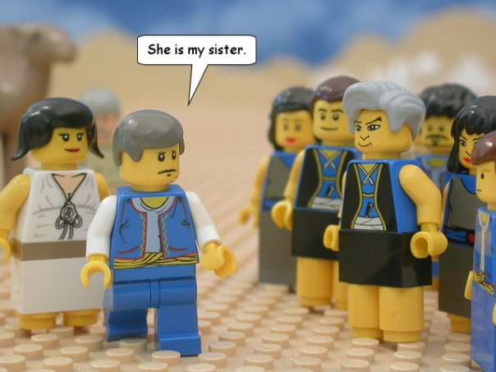

A

B

C

A:

B:

C:

**Question 4**

What did Isaac say to King Abimelech and why?

**Question 5**

Can you think of another person in the Bible who also lied and said his wife was his sister ?

(Hint: Genesis 20:2)

□ Wednesday 27th May: Read **Genesis 26: 10-16** and answer the questions:

**The Lord blesses Isaac**

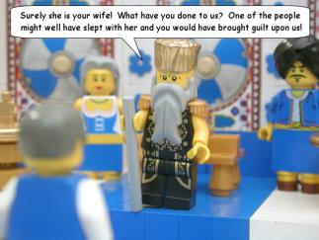*10And Abimelech said, “What is this you have done to us? One of the people might soon have lain with your wife, and you would have brought guilt on us.” 11So Abimelech charged all his people, saying, “He who touches this man or his wife shall surely be put to death.”*

*12Then Isaac sowed in that land, and reaped in the same year a hundredfold; and the Lord blessed him. 13The man began to prosper, and continued prospering until he became very prosperous; 14for he had possessions of flocks and possessions of herds and a great number of servants. So the Philistines envied him. 15Now the Philistines had stopped up all the wells which his father’s servants had dug in the days of Abraham his father, and they had filled them with earth. 16And Abimelech said to Isaac, “Go away from us, for you are much mightier than we.”*

**Question 6**

The Lord blessed Isaac and granted him three possessions. List them.

**Question 7**

Was King Abimelech afraid of Isaac? Which verse(s) supports your answer?

□ Thursday 28th May: Read **Genesis 26: 17-22** and answer the questions:

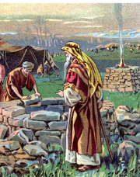

*17Then Isaac departed from there and pitched his tent in the Valley of Gerar, and dwelt there. 18And Isaac dug again the wells of water which they had dug in the days of Abraham his father, for the Philistines had stopped them up after the death of Abraham. He called them by the names which his father had called them.*

*19Also Isaac’s servants dug in the valley, and found a well of running water there. 20But the herdsmen of Gerar quarreled with Isaac’s herdsmen, saying, “The water is ours.” So he called the name of the well Esek, because they quarreled with him. 21Then they dug another well, and they quarreled over that one also. So he called its name Sitnah. 22And he moved from there and dug another well, and they did not quarrel over it. So he called its name Rehoboth, because he said, “For now the Lord has made room for us, and we shall be fruitful in the land.”*

**Do you know what ‘quarrel’ means?**

*A quarrel is an angry argument between two or more people. In this story, Isaac herdsmen and the herdsmen of Gerar quarrel over two wells of water. However, the third well, they did not quarrel over.*

**Question 8**

Complete the table by listing the well which matches the reason Isaac gave it that name.

|  |  |
| --- | --- |
| **Reason** | **Name of well** |
| Because the herdsmen of Gerar quarrelled with Isaac’s herdsmen |  |
| Because they quarrelled again |  |
| Because they did not quarrel over it |  |

□ Friday 29th May: Read **Genesis 26: 26-31** and answer the questions:

**Abimelech makes a promise to Isaac**

*26Then Abimelech came to him from Gerar with Ahuzzath, one of his friends, and Phichol the commander of his army. 27And Isaac said to them, “Why have you come to me, since you hate me and have sent me away from you?”*

*28But they said, “We have certainly seen that the Lord is with you. So we said, ‘Let there now be an oath between us, between you and us; and let us make a covenant with you, 29that you will do us no harm, since we have not touched you, and since we have done nothing to you but good and have sent you away in peace. You are now the blessed of the Lord.’”*

*30So he made them a feast, and they ate and drank. 31Then they arose early in the morning and swore an oath with one another; and Isaac sent them away, and they departed from him in peace.*

**Question 9**

**True/false**

1. Ahuzzath is the enemy of Abimelech.True/False
2. The Lord is with Isaac. True/False
3. Abimelech makes an oath with Isaac to do each other no harm. True/False
4. When Isaac sent Abimelech away, he departed from them in anger. True/False

□ Saturday 30th May: Read **Genesis 26: 31-35** and answer the questions:

**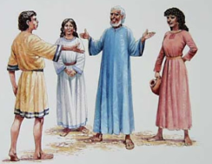***32It came to pass the same day that Isaac’s servants came and told him about the well which they had dug, and said to him, “We have found water.” 33So he called it Shebah.Therefore the name of the city is Beersheba to this day.*

*34When Esau was forty years old, he took as wives Judith the daughter of Beeri the Hittite, and Basemath the daughter of Elon the Hittite. 35And they were a grief of mind to Isaac and Rebekah.*

**Word origins: ‘Beersheba’**

*Beersheba means ‘the well of the oath’. This well was originally dug by Abraham when he entered into an agreement (an ‘oath’) with Abimelech. In this chapter, his son, Isaac, reopens it and gives it the same name, ‘Beersheba’.*

**Question 10**

Complete the family tree, by filling in the names of Esau’s relatives

Use the list below to help you.

Isaac, Jacob, Judith, Rebekah, Basemath.

|  |  |
| --- | --- |
| **Esau’s relative** | **Name** |
| Mother |  |
| Father |  |
| First wife |  |
| Second wife |  |
| Brother |  |

***What to do when you finish your Bible Study.***

1. ***Either send it by email to your class email address or print and hand it to your servants next Sunday.***
2. ***If you want to send your Bible Study by email, please select your class email address below:***

**Year 4A (St Makarios)**

[**StMakarios4A@gmail.com**](https://au-mg6.mail.yahoo.com/neo/b/compose?to=StMakarios4A@gmail.com)Uncle Shady

**Year 4B (St Bakhomios)**

[**StBakhomios4B@gmail.com**](https://au-mg6.mail.yahoo.com/neo/b/compose?to=StBakhomios4B@gmail.com)Uncle Joe

**Year 4C (St Anthony)**

[**StAnthony4C@gmail.com**](mailto:StAnthony4C@gmail.com) Aunty Melaine

1. ***Click on the following link to see how many points you have.***

*(Hold Ctrl and left click with your mouse on the following link* ***OR*** *copy and paste the link into your browser)*

**Year 4A (St Makarios)**

<https://docs.google.com/spreadsheets/d/1svMXXIj8NwuUDGMm0bHIzMrBR62fWNYm9xXlsh6-I1w/edit?usp=sharing>

**Year 4B (St Bakhomios)**

<https://docs.google.com/spreadsheets/d/1wl6OeTuXpxy4T88ATrJOTiCu0HFlBZx9WyKmcOHHz9A/edit?usp=sharing>

**Year 4C (St Anthony)**

<https://docs.google.com/spreadsheets/d/1PgNO1gO77nfTJaty0VOmkZs9_do_XpLNpwpYZZht9I/edit?usp=sharing>