|  |
| --- |
| Name:  Class: |

Sunday 17th May

Finish Date: Saturday 23rd May

Completed Bible Study = **15 points**

Email by the due date = **5 points**

**Year 4 Bible Study 11 - 2015**

C:\Documents and Settings\suzy\Local Settings\Temporary Internet Files\Content.IE5\3JXW24R5\MC900383922[1].wmfAbraham’s last days and the arrival of Esau and Jacob

**Genesis Chapter 25**

**For the questions below Highlight or underline the correct answers**

□ Monday 18th May: Read **Genesis 25: 7-11** and answer the questions:

*Abraham’s Death and Burial*

***7 This is the sum of the years of Abraham’s life which he lived: one hundred and seventy-five years. 8 Then Abraham breathed his last and died in a good old age, an old man and full of years, and was gathered to his people. 9 And his sons Isaac and Ishmael buried him in the cave of Machpelah, ……….10 the field which Abraham purchased from the sons of Heth. There Abraham was buried, and Sarah his wife. 11 And it came to pass, after the death of Abraham, that God blessed his son Isaac. And Isaac dwelt at Beer Lahai Roi.***

1. How old was Abraham when he died?
2. Who did Abraham buy the cave from?

a. Sarah b. Ishmael c. The sons of Heth

□ Tuesday 19th May: Read **Genesis 25:19-22** and answer the questions:

*19****This*is*the genealogy of Isaac, Abraham’s son. Abraham begot Isaac.****20****Isaac was forty years old when he took Rebekah as wife, the daughter of Bethuel the Syrian of Padan Aram, the sister of Laban the Syrian.****21****Now Isaac pleaded with the Lord for his wife, because she*was*barren; and the Lord granted his plea, and Rebekah his wife conceived.****22****But the children struggled together within her; and she said, “If*all is*well, why*am I like*this?” So she went to inquire of the Lord.***

1. What does the word ‘barren’ mean?
2. old
3. not able to have children
4. sick
5. tired
6. How old was Isaac when he married Rebekah?
7. 39
8. 40
9. 41
10. Isaac prayed to God for Rebekah to have children (**TRUE / FALSE**)
11. What did Rebekah ask God about?
    1. The discomfort she felt in her pregnancy
    2. Why God hadn't yet given her any children
    3. How many children she was carrying

* Wednesday 20th May: Read **Genesis 25:23-28** and answer the questions:

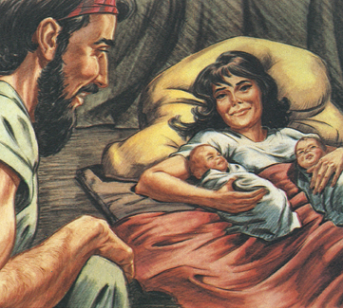**Rebekah gives birth to twins**

*23****And the Lord said to her: “Two nations*are*in your womb, Two peoples shall be separated from your body;* One*people shall be stronger than the other, And the older shall serve the younger.”***

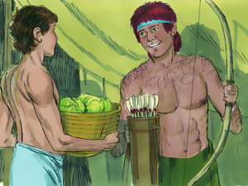*24****So when her days were fulfilled*for her*to give birth, indeed*there were*twins in her womb.****25****And the first came out red.*He was*like a hairy garment all over; so they called his name Esau.****26****Afterward his brother came out, and his hand took hold of Esau’s heel; so his name was called Jacob. Isaac*was *sixty years old when she bore them.***

*27****So the boys grew. And Esau was a skillful hunter, a man of the field; but Jacob was a mild man, dwelling in tents.****28****And Isaac loved Esau because he ate*of his*game, but Rebekah loved Jacob.***

1. Which of Rebekah’s twins were… (Highlight the correct answer)

|  |  |
| --- | --- |
| **a.** Hairy | Esau/ Jacob |
| **b.** Born first | Esau/ Jacob |
| **c.** Holding onto the heel of his brother | Esau/ Jacob |
| **d.**  A skillful hunter | Esau/ Jacob |
| **e.** Loved by Isaac | Esau/ Jacob |

□ Thursday 21st May: Read **Genesis 25: 29-34** and answer the questions:

***Esau Sells His Birthright***

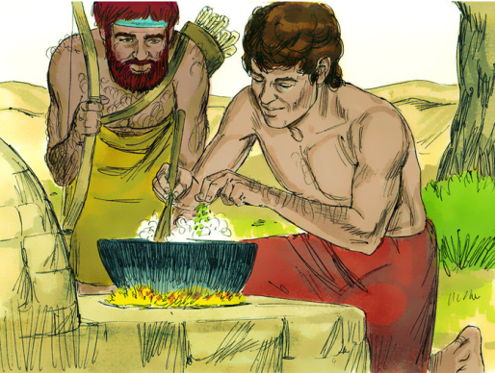*29****Now Jacob cooked a stew; and Esau came in from the field, and he*was *weary.****30****And Esau said to Jacob, “Please feed me with that same red*stew,*for I*am*weary.” Therefore his name was called Edom.*** *31****But Jacob said, “Sell me your birthright as of this day.”***

*32****And Esau said, “Look, I*am*about to die; so what*is*this birthright to me?”*** *33****Then Jacob said, “Swear to me as of this day.” So he swore to him, and sold his birthright to Jacob.****34****And Jacob gave Esau bread and stew of lentils; then he ate and drank, arose, and went his way. Thus Esau despised*his*birthright***

1. Jacob was wrong because he tricked his brother into selling his birthright. (**TRUE / FALSE**)
2. Esau also was wrong because he cared more about food than his birthright

(**TRUE / FALSE**)

□ Friday 22nd May

1. God wants us to treat each other with kindness. Highlight the deeds which represents kindness to other people.

* Cheating on a test
* Befriending a student at school who does not have many friends
* Complaining when your parents call you to ‘Family time Evening’.
* Pushing in the line to buy ice cream from the canteen.
* Cleaning up after yourself

□ Saturday 23rd May: MEMORY VERSE: Copy and Learn by heart: (Genesis 25: 21). You will find this verse written in Wednesday’s homework.

***What to do when you finish your Bible Study.***

1. ***Either send it by email to your class email address or print and hand it to your servants next Sunday.***
2. ***If you want to send your Bible Study by email, please select your class email address below:***

**Year 4A (St Makarios)**

[**StMakarios4A@gmail.com**](https://au-mg6.mail.yahoo.com/neo/b/compose?to=StMakarios4A@gmail.com)Uncle Shady

**Year 4B (St Bakhomios)**

[**StBakhomios4B@gmail.com**](https://au-mg6.mail.yahoo.com/neo/b/compose?to=StBakhomios4B@gmail.com)Uncle Joe

**Year 4C (St Anthony)**

[**StAnthony4C@gmail.com**](mailto:StAnthony4C@gmail.com) Aunty Melaine

1. ***Click on the following link to see how many points you have.***

*(Hold Ctrl and left click with your mouse on the following link* ***OR*** *copy and paste the link into your browser)*

**Year 4A (St Makarios)**

<https://docs.google.com/spreadsheets/d/1svMXXIj8NwuUDGMm0bHIzMrBR62fWNYm9xXlsh6-I1w/edit?usp=sharing>

**Year 4B (St Bakhomios)**

<https://docs.google.com/spreadsheets/d/1wl6OeTuXpxy4T88ATrJOTiCu0HFlBZx9WyKmcOHHz9A/edit?usp=sharing>

**Year 4C (St Anthony)**

<https://docs.google.com/spreadsheets/d/1PgNO1gO77nfTJaty0VOmkZs9-_do_XpLNpwpYZZht9I/edit?usp=sharing>