C:\Documents and Settings\suzy\Local Settings\Temporary Internet Files\Content.IE5\3JXW24R5\MC900383922[1].wmfSunday 27th September, 2015

Name:

Class:

Finish Date: Saturday 3rd October, 2015

Completed Bible Study = 15 points

Email Homework by the due date = 5 points

**Year 3 Bible Study Genesis Chapter 2-3**

**For the questions below Highlight, underline or change the font colour to choose the correct answer.**

* Monday 28th September:Read **Genesis 2: 1-7** and answer the questions:

**Question 1: True/False**

1. God rested on the sixth day, after He had finished all His work. **True/False** (Answer is in Gen 2:2)
2. God formed man from the snow of the ground. **True/False** (Answer is in Gen 2:7)

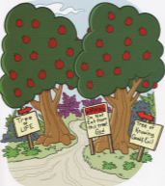

* Tuesday 29th September: Read **Genesis 2: 8-14** and answer the questions:

### Question 2

What was the name of God’s garden which is mentioned in verse 8?

* Wednesday 30th September: Read **Genesis 2: 15-25** and answer the questions:

**Question 3** (Answer is in verse 21 and 22)

1. Name the part of the body God took from Adam to create Eve
2. Locate the part of the body God took from to create Eve on the skeleton.

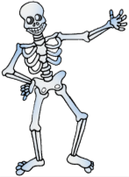

B

C

D

A

1. A b) B c) C d) D

* Thursday 1st October: Read **Genesis 3: 1-7** and answer the questions:

**Question 4**

Which picture shown below is a serpent?

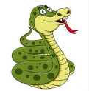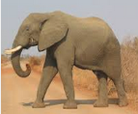

A

B

C

1. A
2. B
3. C

* Friday 2nd October: Read **Genesis 3: 8-13** and answer the questions:

**Question 5**

When did Adam and Eve realise they were naked?

1. Before they ate the forbidden fruit. Before sin
2. After they ate the forbidden fruit. After they sinned.

* 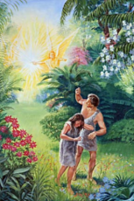Saturday 3rd October: Read and answer the questions:

**Question 6:** (read Genesis 3: 22-24)

1. God let Adam and Eve stay in the Garden of Eden despite what they had done. **True/False**
2. God placed the Cherubim at the west of the Garden of Eden. **True/False**
3. God placed a flaming sword, which turned every way to guard the way to the tree of life. **True/False**

***What to do when you finish your Bible Study.***

1. ***Either send it by email to your class email address or print and hand it to your servants next Sunday.***
2. ***If you want to send your Bible Study by email, please select your class email address below:***

**Year 3A St Bishoy**

[stbishoy3a@gmail.com](mailto:stbishoy3a@gmail.com) Uncle Emil

**Year 3B St Shenouda**

[stshenouda3b@gmail.com](mailto:stshenouda3b@gmail.com) Aunty Carol

1. ***Click on the following link to see how many points you have.***

*(Hold Ctrl and left click with your mouse on the following link* ***OR*** *copy and paste the link into your browser)*

**Year 3A (St Bishoy)**

<https://docs.google.com/spreadsheets/d/1n50G0dKZtJp9RWRK8pPrZBlwfk5FfJ4iVBSI9rw_vaY/edit?usp=sharing>

**Year 3B (St Shenouda)**

<https://docs.google.com/spreadsheets/d/1_95U1Mh8YbvfPowxk0A1nqM2bd9cfUAuH4pDQFjxKPE/edit?usp=sharing>