C:\Documents and Settings\suzy\Local Settings\Temporary Internet Files\Content.IE5\3JXW24R5\MC900383922[1].wmfSunday 8th November, 2015

Name:

Class:

Finish Date: Saturday 14th November, 2015

Completed Bible Study = 15 points

Email Homework by the due date = 5 points

**Year 3 Bible Study Genesis Chapter 11 and 12**

**For the questions below Highlight, underline or change the font colour to choose the correct answer.**

* Monday 9th November :Read **Genesis 11: 1-4** and answer the questions:

### The Tower of Babel

*1 Now the whole earth had one language and one speech. 2And it came to pass, as they journeyed from the east, that they found a plain in the land of Shinar, and they dwelt there. 3Then they said to one another, “Come, let us make bricks and bake them thoroughly.” They had brick for stone, and they had asphalt for mortar. 4And they said, “Come, let us build ourselves a city, and a tower whose top is in the heavens; let us make a name for ourselves, lest we be scattered abroad over the face of the whole earth.”*

**Question 1**

Match the word to the correct phrase

**One, Heaven, Well-known, Bricks**

|  |  |
| --- | --- |
|  | The thing that was used to build the tower |
|  | Where they wanted the tower to reach to |
|  | The number of languages spoken by people on earth |
|  | The people wanted to build the tower to become this |

* Tuesday 10th November: Read **Genesis 11: 5-9** and answer the questions:

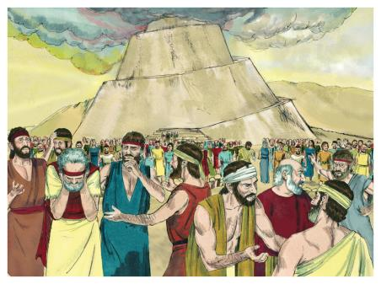

*5But the Lord came down to see the city and the tower which the sons of men had built. 6And the Lord said, “Indeed the people are one and they all have one language, and this is what they begin to do; now nothing that they propose to do will be withheld from them. 7Come, let Us go down and there confuse their language, that they may not understand one another’s speech.” 8So the Lord scattered them abroad from there over the face of all the earth, and they ceased building the city. 9Therefore its name is called Babel, because there the Lord confused the language of all the earth; and from there the Lord scattered them abroad over the face of all the earth.*

**Question 2**

What did God do to the people to make them stop building the tower?

1. Made lighting strike the tower
2. Killed all of the people
3. Changed their language so that they could not communicate
4. Moved all of the people away

* Wednesday 11th November: Read **Genesis 12: 1-3** and answer the questions:

### Promises to Abram

*1 Now the Lord had said to Abram:*

*“Get out of your country,  
From your family  
And from your father’s house,  
To a land that I will show you.  
2I will make you a great nation;  
I will bless you  
And make your name great;  
And you shall be a blessing.  
3I will bless those who bless you,  
And I will curse him who curses you;  
And in you all the families of the earth shall be blessed.”*

*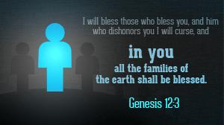***Question 3**

Complete the promises that God gave to Abram

a) I will make you a

b) I will bless you and make

c) I will bless those who bless you, And I will curse

* Thursday 12th November: Read **Genesis 12: 4-9** and answer the questions:

**Abram obeys God and leaves his country to go to Canaan**

*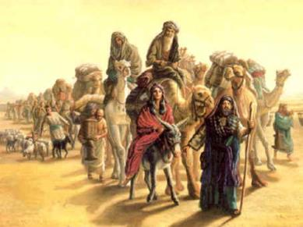4So Abram departed as the Lord had spoken to him, and Lot went with him. And Abram was seventy-five years old when he departed from Haran. 5Then Abram took Sarai his wife and Lot his brother’s son, and all their possessions that they had gathered, and the people whom they had acquired in Haran, and they departed to go to the land of Canaan. So they came to the land of Canaan. 6Abram passed through the land to the place of Shechem, as far as the terebinth tree of Moreh. And the Canaanites were then in the land.*

*7Then the Lord appeared to Abram and said, “To your descendants I will give this land.” And there he built an altar to the Lord, who had appeared to him. 8And he moved from there to the mountain east of Bethel, and he pitched his tent with Bethel on the west and Ai on the east; there he built an altar to the Lord and called on the name of the Lord. 9So Abram journeyed, going on still toward the South.*

**Question 4**

True/ False

1. Abram was 80 years old when he departed True/ False
2. God promised Canaan to the desendants of Abram True/ False
3. Abram travelled with his wife and his brother’s son True/ False
4. The Lord never appeared to Abram True/ False

* Friday 13th November: Read **Genesis 12: 10-13** and answer the questions:

### Abram in Egypt

*10Now there was a famine in the land, and Abram went down to Egypt to dwell there, for the famine was severe in the land. 11And it came to pass, when he was close to entering Egypt, that he said to Sarai his wife, “Indeed I know that you are a woman of beautiful countenance. 12Therefore it will happen, when the Egyptians see you, that they will say, ‘This is his wife’; and they will kill me, but they will let you live. 13Please say you are my sister, that it may be well with me for your sake, and that I may live because of you.”*

**Question 5**

Copy out the verse that tells us what would happen to Sarai if the Egyptians found out that she was Abram’s wife?

* Saturday 14th November: Read **Genesis 12: 14-20** and answer the questions:

*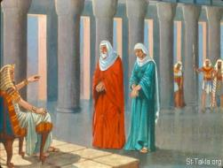14So it was, when Abram came into Egypt, that the Egyptians saw the woman, that she was very beautiful. 15The princes of Pharaoh also saw her and commended her to Pharaoh. And the woman was taken to Pharaoh’s house. 16He treated Abram well for her sake. He had sheep, oxen, male donkeys, male and female servants, female donkeys, and camels.*

*17But the Lord plagued Pharaoh and his house with great plagues because of Sarai, Abram’s wife. 18And Pharaoh called Abram and said, “What is this you have done to me? Why did you not tell me that she was your wife? 19Why did you say, ‘She is my sister’? I might have taken her as my wife. Now therefore, here is your wife; take her and go your way.” 20So Pharaoh commanded his men concerning him; and they sent him away, with his wife and all that he had.*

**Question 6**

Name the woman who is described as beautiful in verse 14 and 15.

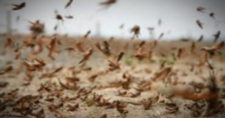**Question 7**

What is meant by a plague?

1. drought
2. flood
3. Lots of pests like insects or sudden outbursts of disease.
4. famine

***What to do when you finish your Bible Study.***

1. ***Either send it by email to your class email address or print and hand it to your servants next Sunday.***
2. ***If you want to send your Bible Study by email, please select your class email address below:***

**Year 3A St Bishoy**

[stbishoy3a@gmail.com](mailto:stbishoy3a@gmail.com) Uncle Emil

**Year 3B St Shenouda**

[stshenouda3b@gmail.com](mailto:stshenouda3b@gmail.com) Aunty Carol

1. ***Click on the following link to see how many points you have.***

*(Hold Ctrl and left click with your mouse on the following link* ***OR*** *copy and paste the link into your browser)*

**Year 3A (St Bishoy)**

<https://docs.google.com/spreadsheets/d/1n50G0dKZtJp9RWRK8pPrZBlwfk5FfJ4iVBSI9rw_vaY/edit?usp=sharing>

**Year 3B (St Shenouda)**

[*https://docs.google.com/spreadsheets/d/1_95U1Mh8YbvfPowxk0A1nqM2bd9cfUAuH4pDQFjxKPE/edit?usp=sharing*](https://docs.google.com/spreadsheets/d/1_95U1Mh8YbvfPowxk0A1nqM2bd9cfUAuH4pDQFjxKPE/edit?usp=sharing)