C:\Documents and Settings\suzy\Local Settings\Temporary Internet Files\Content.IE5\3JXW24R5\MC900383922[1].wmfSunday 20th September, 2015

Name:

Class:

Finish Date: Saturday 26th September, 2015

Completed Bible Study = 15 points

Email Homework by the due date = 5 points

**Year 3 Bible Study Genesis Chapter 1**

**For the questions below Highlight, underline or change the font colour to choose the correct answer.**

* Monday 21st September:Read **Genesis 1: 1-5** **(The History of Creation – Day 1)**:

**Question 1** (the answer is in verse 5)

1. God called the light “sun’. True/False
2. 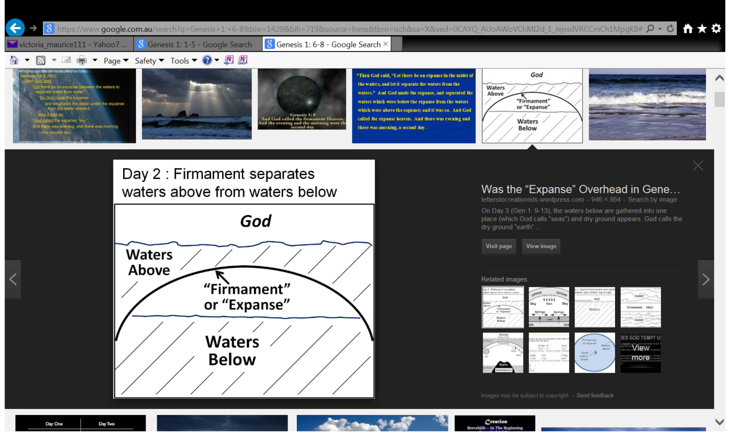God called the darkness ‘night’. True/False

* Tuesday 22nd September: Read **Genesis 1: 6-8 (The History of Creation – Day 2)**:

### Question 2 (the answer is in verse 8)

What did God call the firmanent?

* 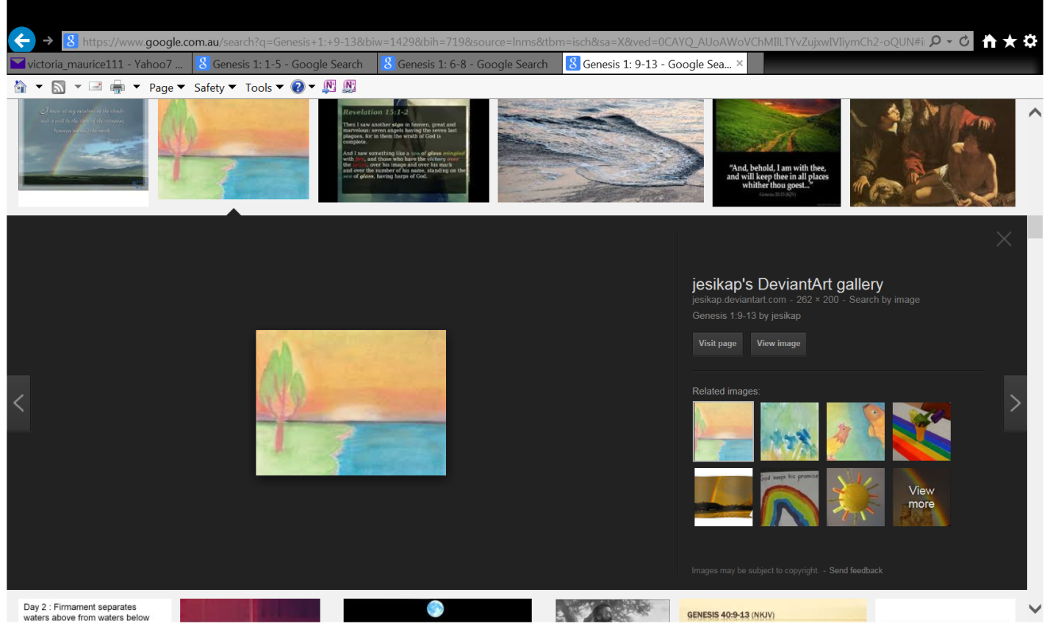Wednesday 23rd September: Read **Genesis 1: 9-13** **(The History of Creation – Day 3)**:

**Question 3** (the answer is in verses 9 to 12)

Underline 3 things God makes on the third day.

Earth – Sky – Seas – Grass – Fruit tree

* Thursday 24th September: Read **Genesis 1: 16-19** **(The History of Creation – Day 4)**:

**Question 4**

What are the two light sources that God created on the fourth day (verse 16-17). Look at the picture to help you answer the question

* Friday 25th September: Read **Genesis 1: 20-23** **(The History of Creation – Day 5)**:

**Question 5:**

What does the word “abundance” mean?

a) Very little b) Some c) Plenty

* 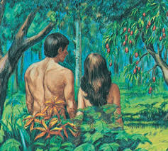Saturday 26th September: Read **Genesis 1: 26-31** **(The History of Creation – Day 6)**:

**Question 6:**

Fill in the missing words in Genesis 1:26, using the words below:

“Let us make mankind in our , in our likeness, so that they may over the fish in the sea and the birds in the sky, over the livestock and all the wild animals, and over all the creatures that   
 along the ground.”

**Move – Image - Rule**

***What to do when you finish your Bible Study.***

1. ***Either send it by email to your class email address or print and hand it to your servants next Sunday.***
2. ***If you want to send your Bible Study by email, please select your class email address below:***

**Year 3A St Bishoy**

[stbishoy3a@gmail.com](mailto:stbishoy3a@gmail.com) Uncle Emil

**Year 3B St Shenouda**

[stshenouda3b@gmail.com](mailto:stshenouda3b@gmail.com) Aunty Carol

1. ***Click on the following link to see how many points you have.***

*(Hold Ctrl and left click with your mouse on the following link* ***OR*** *copy and paste the link into your browser)*

**Year 3A (St Bishoy)**

<https://docs.google.com/spreadsheets/d/1n50G0dKZtJp9RWRK8pPrZBlwfk5FfJ4iVBSI9rw_vaY/edit?usp=sharing>

**Year 3B (St Shenouda)**

<https://docs.google.com/spreadsheets/d/1_95U1Mh8YbvfPowxk0A1nqM2bd9cfUAuH4pDQFjxKPE/edit?usp=sharing>