|  |  |
| --- | --- |
| Name |  |
| Class |  |

Sunday 3rd May

Finish Date: Saturday 9th May

Completed Bible Study = **15 points**

Email by the due date = **5 points**

**Year 4 Bible Study 9 - 2015**

C:\Documents and Settings\suzy\Local Settings\Temporary Internet Files\Content.IE5\3JXW24R5\MC900383922[1].wmfGenesis: Sarah’s death and burial

**Read Genesis Chapter 23 & Chapter 24: 1-21**

**For the questions below Highlight or underline the correct answers**

□ Monday 4th May: Read **Genesis 23: 1-9** and answer the questions:

*Sarah’s Death and Burial*

***1 Sarah lived one hundred and twenty-seven years; these were the years of the life of Sarah. 2 So Sarah died in Kirjath Arba (that is, Hebron) in the land of Canaan, and Abraham came to mourn for Sarah and to weep for her. 3 Then Abraham stood up from before his dead, and spoke to the sons of Heth, saying, 4 “I am a foreigner and a visitor among you. Give me property for a burial place among you, that I may bury my dead out of my sight.” 5 And the sons of Heth answered Abraham, saying to him, 6 “Hear us, my lord: You are a mighty prince among us; bury your dead in the choicest of our burial places. None of us will withhold from you his burial place, that you may bury your dead.”***

***7 Then Abraham stood up and bowed himself to the people of the land, the sons of Heth. 8 And he spoke with them, saying, “If it is your wish that I bury my dead out of my sight, hear me, and meet with Ephron the son of Zohar for me,9 that he may give me the cave of Machpelah which he has, which is at the end of his field. Let him give it to me at the full price, as property for a burial place among you.”***

1. How old was Sarah when she died?
   1. 127 **b**. 137 **c**. 120
2. What does Abraham ask from the sons of Heth?
3. Land to farm on
4. A cave for storage
5. A place to bury his dead people

□ Tuesday 5th May: Read **Genesis 23:10-16** and answer the questions:

***10 Now Ephron dwelt among the sons of Heth; and Ephron the Hittite answered Abraham in the presence of the sons of Heth, all who entered at the gate of his city, saying, 11 “No, my lord, hear me: I give you the field and the cave that is in it; I give it to you in the presence of the sons of my people. I give it to you. Bury your dead!”***

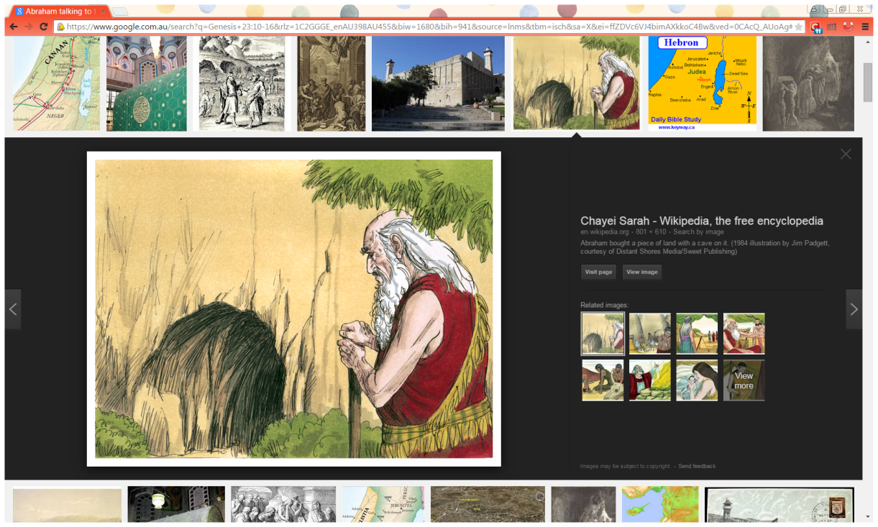***12 Then Abraham bowed himself down before the people of the land; 13 and he spoke to Ephron in the hearing of the people of the land, saying, “If you will give it, please hear me. I will give you money for the field; take it from me and I will bury my dead there.”***

***14 And Ephron answered Abraham, saying to him, 15 “My lord, listen to me; the land is worth four hundred shekels of silver. What is that between you and me? So bury your dead.” 16 And Abraham listened to Ephron; and Abraham weighed out the silver for Ephron which he had named in the hearing of the sons of Heth, four hundred shekels of silver, currency of the merchants.***

1. When Abraham insisted on paying for the land, how many shekels of silver did he pay?
   1. 300 **b**. 400 **c**. 500
2. Although Abraham was like a king living with the sons of Heth. They used to call him “lord”, he was very honest and he insisted to pay the price of the land in full.

(**TRUE / FALSE**)

* Wednesday 6th May: Read **Genesis 24:1-9** and answer the questions:

*A Bride for Isaac*

**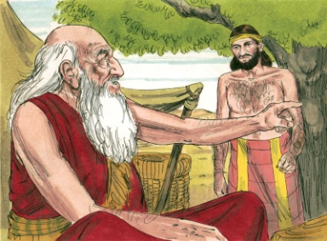***1****Now Abraham was old, well advanced in age; and the Lord had blessed Abraham in all things.****2****So Abraham said to the oldest servant of his house, who ruled over all that he had, “Please, put your hand under my thigh,****3****and I will make you swear by the Lord, the God of heaven and the God of the earth, that you will not take a wife for my son from the daughters of the Canaanites, among whom I dwell;****4****but you shall go to my country and to my family, and take a wife for my son Isaac.”*** *5****And the servant said to him, “Perhaps the woman will not be willing to follow me to this land. Must I take your son back to the land from which you came?”*** *6****But Abraham said to him, “Beware that you do not take my son back there.****7****The Lord God of heaven, who took me from my father’s house and from the land of my family, and who spoke to me and swore to me, saying, ‘To your descendants I give this land,’ He will send His angel before you, and you shall take a wife for my son from there.****8****And if the woman is not willing to follow you, then you will be released from this oath; only do not take my son back there.”****9****So the servant put his hand under the thigh of Abraham his master, and swore to him concerning this matter.***

1. Abraham said to his servant, “Take my son back to the land of my fathers.”

(**TRUE / FALSE**)

1. If the woman was not willing to follow the servant, then he would be released from this oath. (**TRUE / FALSE**)
2. The servant put his hand under the thigh of Abraham his master, and swore to him concerning the matter of finding a bride for Isaac. (**TRUE / FALSE**)

□ Thursday 7th May: Read **Genesis 24: 10-14** and answer the questions:

*10****Then the servant took ten of his master’s camels and departed, for all his master’s goods*were in*his hand. And he arose and went to Mesopotamia, to the city of Nahor.****11****And he made his camels kneel down outside the city by a well of water at evening time, the time when women go out to draw*water.***12****Then he said, “O Lord God of my master Abraham, please give me success this day, and show kindness to my master Abraham.****13****Behold,*here*I stand by the well of water, and the daughters of the men of the city are coming out to draw water.****14****Now let it be that the young woman to whom I say, ‘Please let down your pitcher that I may drink,’ and she says, ‘Drink, and I will also give your camels a drink’—*let*her*be the one*You have appointed for Your servant Isaac. And by this I will know that You have shown kindness to my master.”***

1. The servant went to the city of Nahor, and he selected the most beautiful woman as a bride for Isaac. (**TRUE / FALSE**)
2. The Servant prayed to God for success in his mission. He trusted in God to bring the right woman.

When you have a problem and you don’t know what to do, do you pray to God and trust Him to answer your prayers and guide you into the right direction?

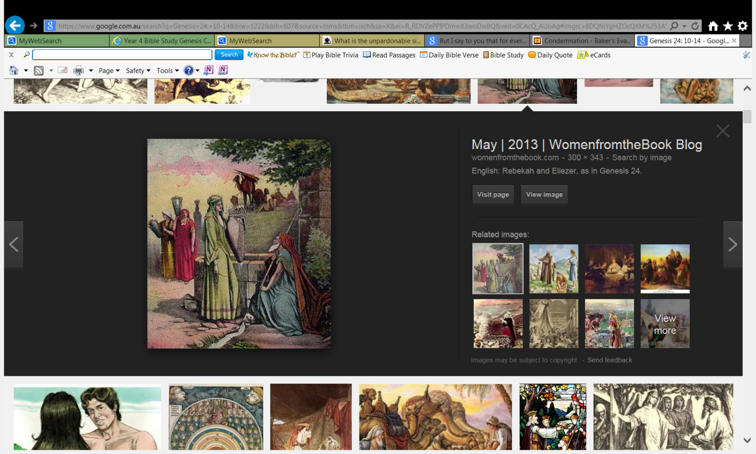□ Friday 8th May: Read **Genesis 24: 15-21** and answer the questions:

***15 And it happened, before he had finished speaking, that behold, Rebekah, who was born to Bethuel, son of Milcah, the wife of Nahor, Abraham’s brother, came out with her pitcher on her shoulder. 16 Now the young woman was very beautiful to behold, a virgin; no man had known her. And she went down to the well, filled her pitcher, and came up. 17 And the servant ran to meet her and said, “Please let me drink a little water from your pitcher.” 18 So she said, “Drink, my lord.” Then she quickly let her pitcher down to her hand, and gave him a drink. 19 And when she had finished giving him a drink, she said, “I will draw water for your camels also, until they have finished drinking.” 20 Then she quickly emptied her pitcher into the trough, ran back to the well to draw water, and drew for all his camels.***

***21 And the man, wondering at her, remained silent so as to know whether the Lord had made his journey prosperous or not.***

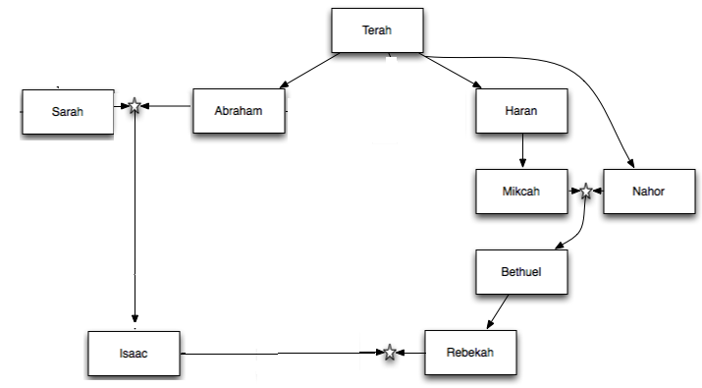

1. Rebekah was the grand daughter of Nahor, Abraham’s brother (**TRUE / FALSE**)
2. Rebekah was very generous with Abraham’s servant although she didn’t know him

(**TRUE / FALSE**)

□ Saturday 9th May: MEMORY VERSE:

II Copy and Learn by heart: (Genesis 24: 12). You will find this verse written in Thursday’s homework.

***What to do when you finish your Bible Study.***

1. ***Either send it by email to your class email address or print and hand it to your servants next Sunday.***
2. ***If you want to send your Bible Study by email, please select your class email address below:***

**Year 4A (St Makarios)**

[**StMakarios4A@gmail.com**](https://au-mg6.mail.yahoo.com/neo/b/compose?to=StMakarios4A@gmail.com)Uncle Shady

**Year 4B (St Bakhomios)**

[**StBakhomios4B@gmail.com**](https://au-mg6.mail.yahoo.com/neo/b/compose?to=StBakhomios4B@gmail.com)Uncle Victor

**Year 4C (St Anthony)**

[**StAnthony4C@gmail.com**](mailto:StAnthony4C@gmail.com) Aunty Melaine

1. ***Click on the following link to see how many points you have.***

*(Hold Ctrl and left click with your mouse on the following link* ***OR*** *copy and paste the link into your browser)*

**Year 4A (St Makarios)**

<https://docs.google.com/spreadsheets/d/1svMXXIj8NwuUDGMm0bHIzMrBR62fWNYm9xXlsh6-I1w/edit?usp=sharing>

**Year 4B (St Bakhomios)**

<https://docs.google.com/spreadsheets/d/1wl6OeTuXpxy4T88ATrJOTiCu0HFlBZx9WyKmcOHHz9A/edit?usp=sharing>

**Year 4C (St Anthony)**

<https://docs.google.com/spreadsheets/d/1PgNO1gO77nfTJaty0VOmkZs9-_do_XpLNpwpYZZht9I/edit?usp=sharing>