Name:



**Moses speaks to Pharaoh**

Chapters 5 & 6

What did the Lord do to reassure Moses ? _______________________________________________

*know that I am ________ __________ your _________ who brings you out from under the ___________*

*of the Egyptians. Ch6:7*

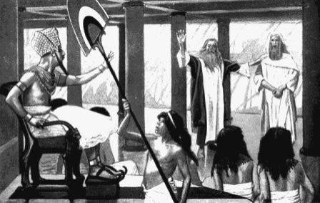

|  |  |
| --- | --- |
| Levi | 137 |
| Kohath | 137 |
| Moses | 133 |
| Amram | 120 |



___________ Class: ___

__________

**15 Points**



Bible Study for Year 5

The Book of Exodus

***Memory Verse****: I will take you as my____________, and I will be________________. Then you shall*

In Chapter 5 verses (1 – 9), What happened to the children of Israel after Moses first spoke to Pharaoh ?

___________________________________________________________

___________________________________________________________

___________________________________________________________

___________________________________________________________

a) In Chapter 5 verses (22 – 23), did Moses question God’s plan? Why ? _______ , _____________

__________________________________________________________________________________

__________________________________________________________________________________

**b) In Chapter 6 verses 1-9 ….**

_________________________________________________________________________________

What does Moses do to reassure the children of Israel ? ____________________________________

_________________________________________________________________________________

Did the children of Israel believe Moses ? Why ? _______ , _________________________________

_________________________________________________________________________________



|  |  |  |  |  |  |  |  |  |  |
| --- | --- | --- | --- | --- | --- | --- | --- | --- | --- |
|  | | |  | | |  | **Tick** | **when done** |  |
|  | **Day** |  |  | **Reading** |  |
|  | | |  | | |
| Sunday | | | (Exodus Ch 5 : 1-9 ) | | |  | □ | |  |
| Monday | | | (Exodus Ch 5:10 - 18) | | | □ | | | |
| Tuesday | | | (Exodus Ch 5:19 – 23) | | | □ | | | |
| Wednesday | | | (Exodus Ch 6: 1-8) | | | □ | | | |
| Thursday | | | (Exodus Ch 6: 9 – 19) | | | □ | | | |
| Friday | | | (Exodus Ch 6: 20 - 30) | | | □ | | | |
| Saturday | | | Finish Bible Study | | | □ | | | |

c) What was Moses’ fathers name?___________________________________________ d) What was Aaron’s wife’s name?___________________________________________

**Daily Bible Reading – Exodus Chapters 5 & 6**

PARENTS SECTION: X______________________

This section is for the parents to sign the Holy Bible Study sheet. We kindly ask you as a parent to read (a little each day) in the Holy Bible with your family. You may wish to read The Gospel of St Luke with Sunday School. Please let us know below what you’re reading with your child and if you have any questions.