**C:\Documents and Settings\suzy\Local Settings\Temporary Internet Files\Content.IE5\3JXW24R5\MC900383922[1].wmf Bible study 8** **- 2013**

Name:_______________Class:________________

Chapter Six

The Gospel of Mark

Learn the Key Words

|  |  |  |
| --- | --- | --- |
| **astonished** |  | **amazed/surprised** |
| **wisdom** |  | **good judgment** |
| **honor** |  | **respect** |
| **He marveled** |  | **He did wonderful things** |
| **circuit** |  | **path** |
| **copper** |  | **coins** |
| **tunics** |  | **loose clothes** |
| **testimony** |  | **witness** |
| **opportune** |  | **suitable** |
| **haste** |  | **rush** |
| **Just** |  | **Fair** |
| **oaths** |  | **words of promise** |
| **an executioner** |  | **a killer** |
| **corpse** |  | **A dead body** |
| **astonished** |  | **amazed/surprised** |
| **wisdom** |  | **good judgment** |

KEY VERSE: I Copy and Learn by heart: (Mark 10:45).

__________________________________________________________________________________________________________________________________________

MEMORY VERSE:

II Copy and Learn by heart: (Mark 6:50). _______________________________________________________________________________________________________________________________________________________________________________________________________________

III Answer the following questions:

1. ***Who did the people think Jesus was?*** [The people thought Jesus was E______________.]

**2** ***Who did Herod think Jesus was?***

[Herod thought Jesus was J_____________________________________ come back from the dead.]

**3** ***Why did Herod put John in prison?***

[Herod put John in prison because John told him it wasn't right to marry his b_________________________.]

**4** ***.What did Herod’s step-daughter ask for?***

[She asked for the head of ____________________________________________ on a ________________.]

**5**  ***Why Herod was afraid of John the Baptist?***

[Herod was afraid of John, for so many of the people b_________________ in him and f____________ him.

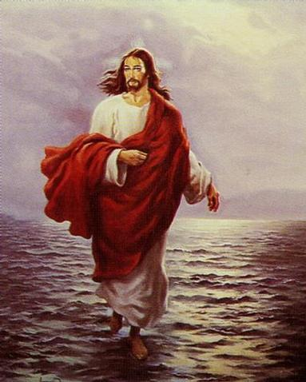

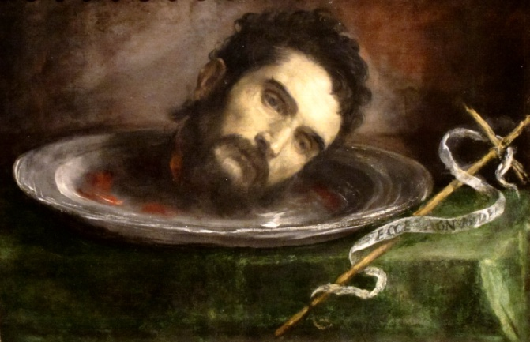IV Match Pictures with text in different colours:

**1. Jesus fed over 5000 people with a 2 fish and 5 loaves of bread.**

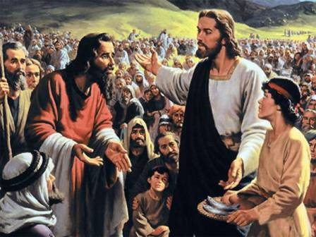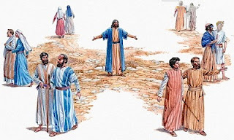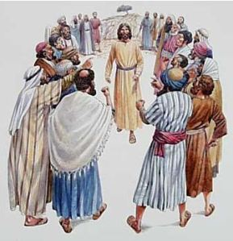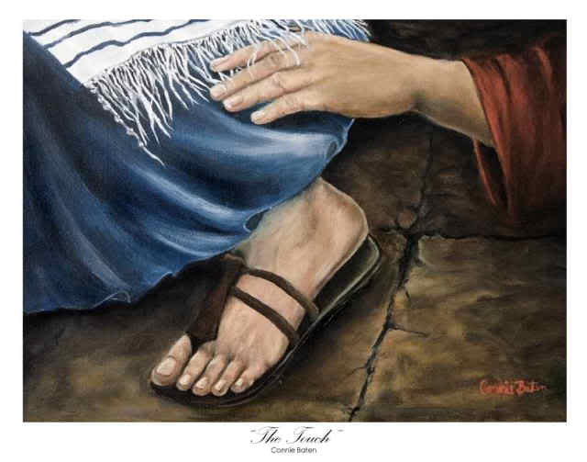

**2. King Herod killed John the Baptist, the same prophet who preached repentance.**

**6. “A prophet is not without honor (respect) except in his own country, among his own relatives, and in his own house.”**

**4. Jesus sent His disciples out two by two.**

**5. And as many as touched Him were made well.**

***3. “Be of good cheer! It is I; do not be afraid.”***