**C:\Documents and Settings\suzy\Local Settings\Temporary Internet Files\Content.IE5\3JXW24R5\MC900383922[1].wmf Bible study 13** **- 2013**

Name:_______________Class:________________

Chapter Eleven

The Gospel of Mark

Learn the Key Words

|  |  |
| --- | --- |
| **colt** | **foal** |
| **Hosanna** | **Save now** |
| **perhaps** | **probably** |
| **sought** | **wanted** |
| **withered** | **shrunken** |

KEY VERSE: I Copy and Learn by heart: (Mark 10:45).

__________________________________________________________________________________________________________________________________________

MEMORY VERSE:

II Copy and Learn by heart: (Mark 11:24). _______________________________________________________________________________________________________________________________________________________________________________________________________________

III Answer the following questions:

1. ***What did Jesus ask His disciples to bring?*** [He asked them to bring a __________.]

**2 When some of the people asked, “What are you doing, loosing the colt?”, how did the disciples speak*?***

[They spoke to them just as Jesus __________ _________________________ . So they let them go.]

3 **‘Blessed *is* He who comes in the name of the Lord!’ Who is “He”?** [He is _______________]

4 **What tree that had been cursed and dried up in this chapter?** [It was a _______ _________.]

***P e w r o* – F r e c o - *J u g d e m n t e* - R s p e t e c - *R l u e -***

**P r e m i o s s n i – P r v i l e i e g s - I n l f u e n e c**

IV The word ‘Authority’ is filled with meaning. Un-jumble the above words and write them around the word “Authority”:

**Jesus has ________________ above all things.**

**[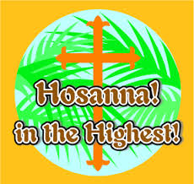](http://www.google.com/imgres?q=hosanna+means&num=10&hl=en&authuser=0&biw=1473&bih=683&tbm=isch&tbnid=6MKxjKW936siWM:&imgrefurl=http://scripturelady.com/?p=8366&docid=hWWkhV1mIAddgM&imgurl=http://scripturelady.com/wp-content/uploads/2013/03/Post-Hosanna-pic.jpg&w=288&h=273&ei=h_hbUf_UL4ejkwXVmoBg&zoom=1&iact=hc&vpx=1009&vpy=266&dur=1625&hovh=218&hovw=230&tx=134&ty=114&page=1&tbnh=146&tbnw=154&start=0&ndsp=30&ved=1t:429,r:13,s:0,i:123)**V Match Pictures with text in different colours:

**1**“And whenever you stand praying, if you have anything against anyone, forgive him, that your Father in heaven may also forgive you your trespasses.

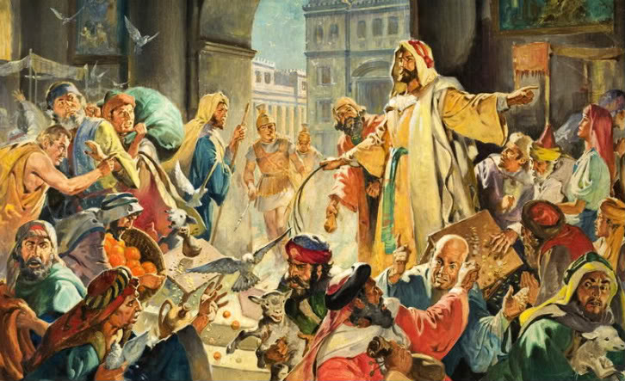

***3.*** “**Hosanna**/ **Save now**!  
‘Blessed *is* He who comes in the name of the Lord!’[[c](http://www.biblegateway.com/passage/?search=Mark+11&version=NKJV#fen-NKJV-24650c)]  
10Blessed *is* the kingdom of our father David  
That comes in the name of the Lord![[d](http://www.biblegateway.com/passage/?search=Mark+11&version=NKJV#fen-NKJV-24651d)]  
Hosanna in the highest!”

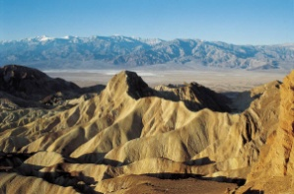

[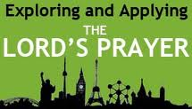](http://www.google.com/imgres?q=pray+to+forgive&start=154&hl=en&authuser=0&biw=1473&bih=683&tbm=isch&tbnid=5_J_JZ2RDVAJFM:&imgrefurl=http://www.lords-prayer.co.uk/forgiveus.html&docid=Ku6XudfPkzj4oM&imgurl=http://www.lords-prayer.co.uk/images/logo.jpg&w=269&h=154&ei=wURdUZHIKOKsiAeP04DYDA&zoom=1&iact=rc&dur=16&page=5&tbnh=123&tbnw=215&ndsp=30&ved=1t:429,r:56,s:100,i:172&tx=118&ty=69)

**4.** “Have faith in God. 23For assuredly, I say to you, whoever says to this mountain, ‘Be removed and be cast into the sea,’ and does not doubt in his heart, but believes that those things he says will be done, he will have whatever he says.

**2.** And He would not allow anyone to carry **wares**/**goods** through the temple. 17Then He taught, saying to them, “Is it not written, ‘My house shall be called a house of prayer for all nations’?[[e](http://www.biblegateway.com/passage/?search=Mark+11&version=NKJV#fen-NKJV-24658e)] But you have made it a ‘den of thieves.’ ”