**C:\Documents and Settings\suzy\Local Settings\Temporary Internet Files\Content.IE5\3JXW24R5\MC900383922[1].wmf Bible study 11** **- 2013**

Name:_______________Class:________________

Chapter Nine

The Gospel of Mark

Learn the Key Words

|  |  |  |
| --- | --- | --- |
| **Transfigured** |  | **transformed the appearance of somebody revealing great beauty, spirituality, and magnificence** |
| **Rabbi** |  | **Jewish leader** |
| **tabernacles** |  | **according to the Hebrew Bible, was the portable dwelling place for the divine presence** |
| **overshadowed** **them** |  | **casted a physical shadow over them** |
| **disputing** |  | **disagreeing** |
| **seizes him** |  | **takes hold of him quickly and firmly** |
| **foams** |  | **A mass of bubbles** |
| **gnashes his teeth** |  | **Grinds his teeth** |
| **rigid** |  | **Not flexible** |
| **convulsed him** |  | **caused him to shake** |
| **wallowed** |  | **lied down and rolled around** |
| **stumble** |  | **Fall/trip** |
| **maimed** |  | **Severely injured** |
| **quenched** |  | **cooled** |
| **Lame** |  | **disable** |
| **seasoned** |  | **experienced** |

KEY VERSE: I Copy and Learn by heart: (Mark 10:45).

__________________________________________________________________________________________________________________________________________

MEMORY VERSE:

II Copy and Learn by heart: (Mark 9:37). _______________________________________________________________________________________________________________________________________________________________________________________________________________

III Find the reference of each verse in Mark

1. Jesus said to him, “If you can believe,all things *are* possible to him who believes.” (Mark9:_______)
2. So He said to them, “This kind can come out by nothing but prayer and fasting.”(Mark9:_______)
3. For He taught His disciples and said to them, “The Son of Man is being betrayed into the hands of men, and they will kill Him. And after He is killed, He will rise the third day.” (Mark9:_______)
4. And He sat down, called the twelve, and said to them, “If anyone desires to be first, he shall be last of all and servant of all.” (Mark9:_______)
5. “Whoever receives one of these little children in My name receives Me; and whoever receives Me, receives not Me but Him who sent Me.” (Mark9:_______)
6. 41For whoever gives you a cup of water to drink in My name, because you belong to Christ, assuredly, I say to you, he will by no means lose his reward. (Mark9:_______)
7. 44where ‘Their worm does not die. And the fire is not quenched.’(Mark9:_______)
8. Salt *is* good, but if the salt loses its flavor, how will you season it? Have salt in yourselves, and have peace with one another.” (Mark9:_______)

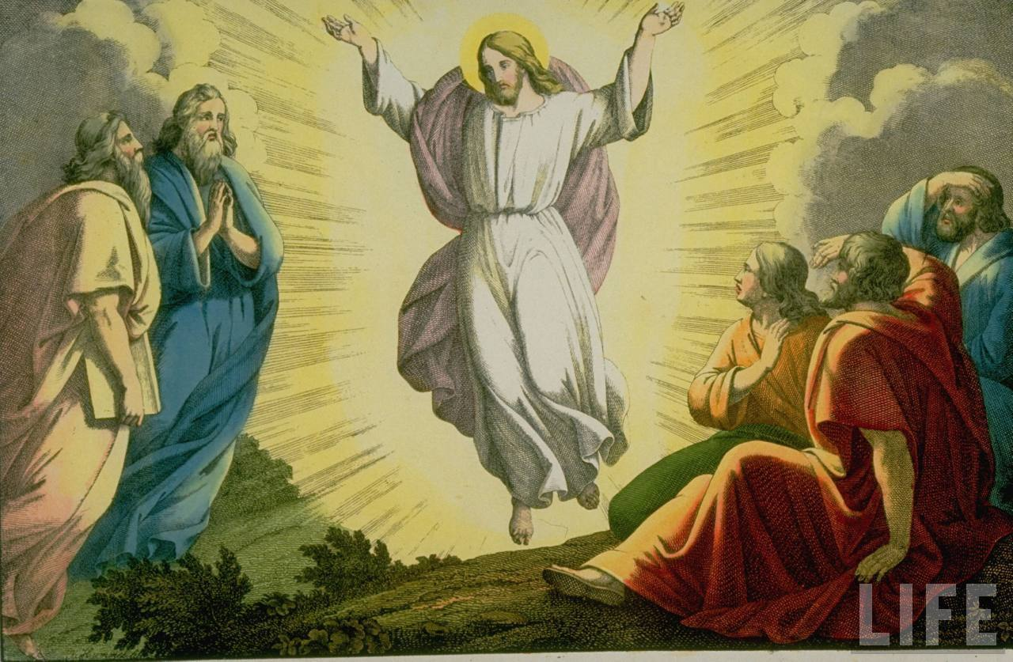

IV Fill in the blanks:

1. Three of Jesus disciples saw Him with __________ and Moses on the Mountain. Those Disciples are _____________, ________________ and _____________.
2. Transfigured means:

______________________________________________________________________________________________________________________________________

1. The Bible says, His clothes became _____________________, exceedingly ___________, like _________________, such as no launderer on ___________________ can whiten them.
   1. Jesus wants all believers **w**_____________ together for Him.

(Mark 9: 38-41)

* 1. When you give something small in the name of Jesus Christ, you will receive a **r**_______________.

1. 1. Where‘ Their worm does not die  
      And the fire is not quenched. This has been repeated __________ times in Chapter 9.
   2. 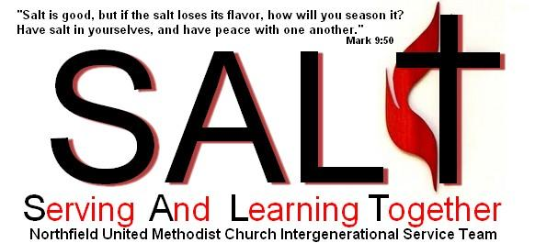Experiences are the S__________ of our spiritual life.