**C:\Documents and Settings\suzy\Local Settings\Temporary Internet Files\Content.IE5\3JXW24R5\MC900383922[1].wmfBible study - 2013**

Name:_____________ Class:________________

The Gospel of Mark

Revision 1-10

**The Gospel according to St Mark was written to the Romans to tell them all about Jesus, the Servant King. St Mark wanted to show how Jesus was *strong*, so he told of the miracles that Jesus did, healing the sick (Mark 1:29-31) and casting out demons (Mark 5:1-20). He wanted to show that Jesus was God, so he wrote about how Jesus calmed the sea (Mark 4:35-41).**

1. Write down the verse from chapter 10 that tells us why Jesus came down to earth (hint: Bible study #2 – introduction, question III):

_________________________________________________________________________________________________________________________________________________________________________________________________________

1. What did St John the Baptist teach in Mark 1:4?

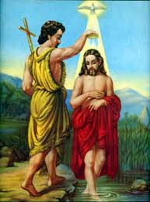____________________________________________________________

____________________________________________________________

1. **True of false (circle the correct answer)**
2. Jesus cared for sinners and He ate with them. True or False
3. Jesus forgave the paralytic man in chapter 2, but He did not heal him! True or False
4. **Who does Jesus say are his mother and brothers? (hint: Mark 3:31-34)**

______________________________________________________________________________________________________________________________________

1. **Jesus tells the parable of the sawer in Mark 4. Write down what each part of the parable means in the space provided on the next page:**

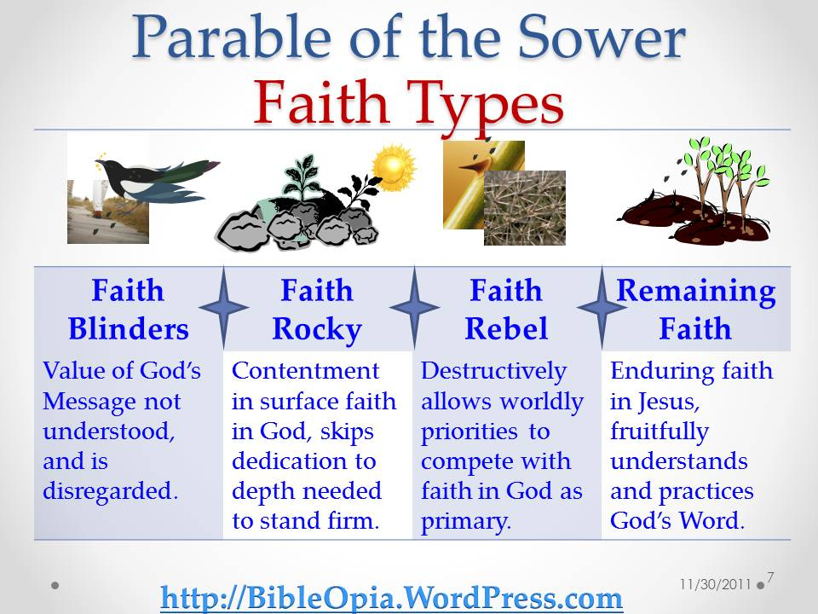

1. **_________ _God_______________ is the sower**
2. **_____________________________ are the seeds that fell by the wayside**
3. **_____________________________ are the seeds that fell on stony ground**
4. **_____________________________ are the seeds that fell among thorns**
5. **_____________________________ are the seeds that fell on good ground**
6. **Chapter 5 taught us many things about who Jesus is. Fill in the blanks:**

**Jesus has authority over cr_ati_n (you, me the birds, plants and animals) because he is G____. He was not just a man who could do special things. He is God, and He has authority over all! We obey Jesus because of who H_____ is. The people He taught and healed did not realize who Jesus truly was, but we do.**

1. **Read the story of the feeding of the 5000 (Mark 6:30-42) then complete passages below:**

**And Jesus, when He came out, saw a great _________ and was moved with ___________ for them, because they were like sheep not having a _________. So He began to teach them many things**

**And when He had taken the ________ loaves and the two _______, He looked up to heaven, _______ and broke the loaves, and gave them to His disciples to set before them; and the two fish He divided among them all. So they all ate and were ________.**

1. Write down the verse Mark 7:15:

______________________________________________________________________________________________________________________________________

___________________________________________________________________

1. Circle the correct answer (hint: Bible study 8 – Chapter 10, question II):
2. The religious leaders of Jesus’ day thought that they were so good that they did not need **(the grace of God / the law)** to save them. As far as they were concerned, as long as they kept to their rituals and ceremonies.
3. In the Bible, "leaven" is used both literally (the yeast that makes bread rise) and figuratively (a relatively small force or amount that makes a major impact). As used by Jesus in Mark 8:15, "leaven" refers to a **(corrupting influence / good influence)**.

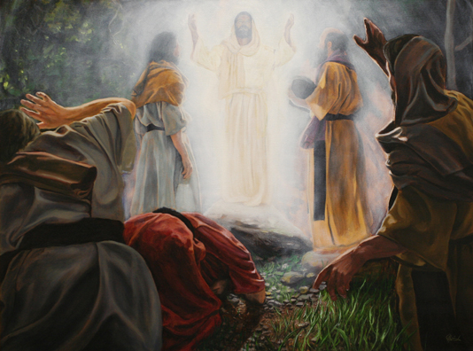

1. In Mark 9, we read that Jesus was transfigured on a high mountain. Who appeared next to Him, and what was heard from Heaven?

______________________________________________________________________________________________________________________________________

___________________________________________________________________

______________________________________________________________________________________________________________________________________

___________________________________________________________________

**In *chapter 10* we read how John and James (the brothers) who were the disciples of Jesus, asked Him to make them sit (in the places of glory) on His right and on His left in heaven. Jesus was upset with them because they wanted the glory for themselves.**

1. What did Jesus say to the disciples about becoming great among them?

______________________________________________________________________________________________________________________________________

___________________________________________________________________