**C:\Documents and Settings\suzy\Local Settings\Temporary Internet Files\Content.IE5\3JXW24R5\MC900383922[1].wmf Bible study 6** **- 2013**

Name:_______________Class:________________

Chapter Four

The Gospel of Mark

Learn the Key Words

|  |  |  |
| --- | --- | --- |
| **devoured** |  | **Ate something quickly** |
| **sprang up** |  | **germinated** |
| **scorched** |  | **dry as a bone** |
| **yielded** |  | **produced** |
| **thirtyfold** |  | **Times thirty (X30)** |
| **revealed** |  | **made known** |
| **Take heed** |  | **Be careful** |
| **scatter** |  | **fly away** |
| **He puts in the sickle** |  | **indicating being ready for harvest** |
| **liken** |  | **compare** |
| **Parables** |  | **moral or religious stories** |
| **the stern** |  | **unstressed** |
| **perishing** |  | **freezing** |
| **exceedingly** |  | **extremely** |

KEY VERSE:

I Copy and Learn by heart: (Mark 10:45).

__________________________________________________________________________________________________________________________________________

MEMORY VERSE:

II Copy and Learn by heart: (Mark 4:20). _______________________________________________________________________________________________________________________________________________________________________________________________________________

**III Fill in the Blank.**

**Then, Cut the pictures and Paste each next to the relevant text:**

Master – Growing Seed – Mustard Seed - Sower

* The parable of the ________________________________ explains why different people have different responses when they hear the teachings of Jesus.
* The parable of the _________________________________ explains how the seed grows, exactly like Faith in the hearts.
* Cod’s Servant, Jesus Christ is the _______________________ of every situation and all things, if we trust Him and follow His orders,

we need never be afraid.

* The parable of the _________________________________ Jesus compares the Kingdom of God to the smallest of all seeds.

**The Parable of the Growing Seed**

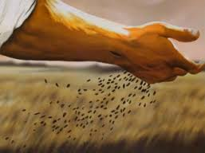 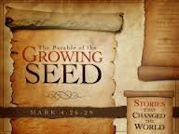

**The Parable of the Sower**

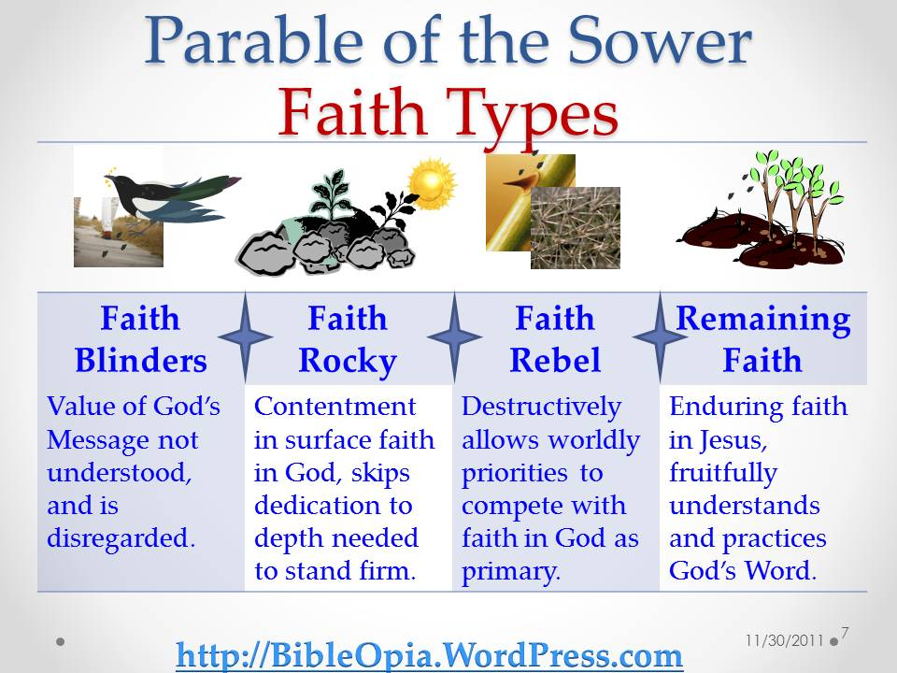

### http://joesaubert.files.wordpress.com/2012/02/jesus-calms-the-storms.jpgWind and Wave Obey Jesus

### The Parable of the Mustard Seed

