**C:\Documents and Settings\suzy\Local Settings\Temporary Internet Files\Content.IE5\3JXW24R5\MC900383922[1].wmfBible study 5 – 2013**

Chapter Three

The Gospel of Mark

|  |  |  |
| --- | --- | --- |
| **synagogue** |  | **(The place of worship for The Jews)** |
| **withered hand** |  | **(shrunken hand)** |
| **lawful** |  | **(legal)** |
| **Herodians** |  | **(Jews who followed King Herod)** |
| **afflictions** |  | **(distress or sufferings)** |
| **sternly** |  | **(strictly)** |
| **cast out** |  | **(throw out)** |
| **stand** |  | **(last/stay)** |
| **Unpardonable** |  | **(unforgivable)** |
| **blasphemies** |  | **(disrespect for God or sacred things)** |
| **condemnation** |  | **(conviction)** |

Name:_______________Class:________________

Learn the Key Words

Big Sale

7 points for

Handing the Bible Study in Time!!!!

WOW!!!!!!!

I Chose the correct answer:

1. And when He had looked around at them with anger, being grieved by the hardness of their hearts, He said to the man,
2. 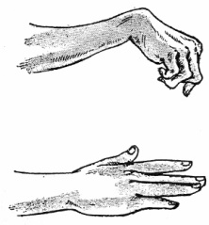**Come back on Sunday** 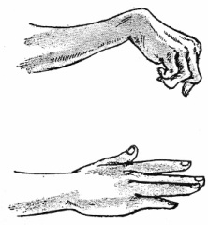
3. **“Stretch out your hand.”**
4. 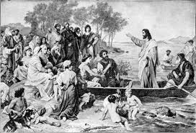**Neither of the above.**
5. A great multitude followed Jesus, when they heard how many things He was doing. So He told His disciples that a small boat should be kept ready for Him because of the multitude, lest they should __________ Him.
6. **crush b. touch c. hurt**
7. 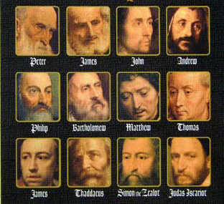Then He appointed twelve that they might be with Him and that He might send them out:
8. to preach
9. have power to heal sicknesses
10. to cast out demons
11. All of the above
12. If a kingdom is divided against itself, that kingdom:
13. Will be the greatest one.
14. Cannot stand

II Think with us!!!!?

1. And He went up on the mountain and called to *Him* those He Himself ***(left/wanted)***. And they came to Him.
2. Our Love for our families should ***(be/not be)*** greater than our love for God.
3. Who blasphemes against the Holy Spirit ***(has/has not)*** unclean spirit.
4. Boanerges, means ***“Sons of Thunder/Sons of Love”***.
5. And the ***(Pharisees/scribes)*** who came down from Jerusalem said, “He has Beelzebub,” and, “By the ruler of the demons He casts out demons.”

KEY VERSE:

III Copy and Learn by heart: (Mark 10:45).

_______________________________________________________________________________________________________________________________________________________________________________________________________________

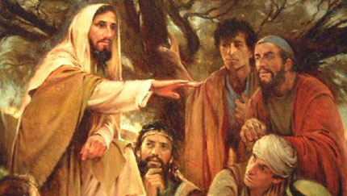MEMORY VERSE:

IV Copy and Learn by heart: (Mark 3:35).

_________________________________________________________________________________________________________________________________________________________________________________________________