**C:\Documents and Settings\suzy\Local Settings\Temporary Internet Files\Content.IE5\3JXW24R5\MC900383922[1].wmf Bible study 4 - 2013**

Name:_______________Class:________________

Chapter Two

The Gospel of Mark

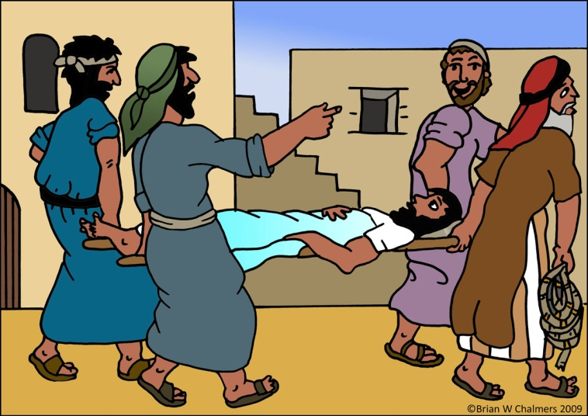 Learn the Key Words

**paralytic** (someone who can’t move)

**scribes** (copiers of the Old Testament and other Jewish

religious documents)

**Pharisees** (Jewish religious leaders)

**Physician** (doctor)

**Sabbath** (Saturday – The day of Rest)

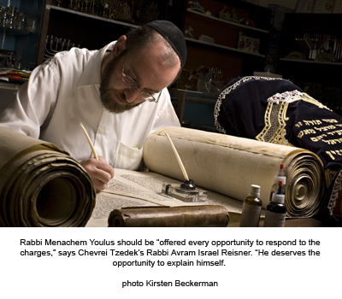

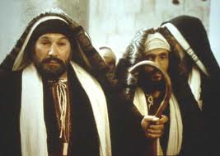

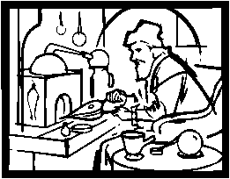

You might get some of them in the Bible competition!!

I True or False

1. Jesus cared for sinners and He ate with them. True or False
2. Mathew arose and followed Jesus when He asked him to follow Him. True or False
3. Jesus forgave the paralytic man, however He did not heal him! True or False
4. Jesus is Lord of the Sabbath. True or False
5. Jesus’ disciples did not fast because they had The Groom with them. True or False

II Think with us!!!!?

1. **Jesus healed the paralytic man to teach us that He came to serve and to (Forget/Forgive) sins.**
2. **We must admire certain people in Chapter 2, they are (the paralytic’s friends/the Pharisees).**
3. **Jesus proved Himself to be (God/ man) by reading their hearts and telling them what they were thinking.**
4. **Who is the Physician in this chapter? (Jesus/an old priest).**

KEY VERSE:

III Copy and Learn by heart: (Mark 10:45).

____________________________________________________________________________________________________________________________________________________________________________________________________________________________________________________________________________________

MEMORY VERSE:

IV Copy and Learn by heart: (Mark 2:17).

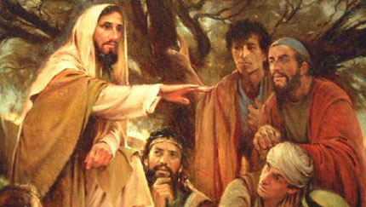________________________________________________________________________________________________________________________________________________________________________________________________________________________________

**V Bonus question: Jesus teaches that fasting is necessary for some things. What are they? (Read Mathew 17:21)**

**__________________________________________________________________________________________________________________________**