**C:\Documents and Settings\suzy\Local Settings\Temporary Internet Files\Content.IE5\3JXW24R5\MC900383922[1].wmf Bible study 3 - 2013**

Name:_______________Class:________________

Chapter One

The Gospel of Mark

I Match ‘Who am I?’ with “I said: …” by joining with a line.

**1** “There comes One after me who is mightier than I, whose sandal strap I am not worthy to stoop down and loose. 8I indeed baptized you with water, but He will baptize you with the Holy Spirit.”

**2** “The time is fulfilled, and the kingdom of God is at hand. Repent, and believe in the gospel.”

**3** “Let *us* alone! What have we to do with You, Jesus of Nazareth? Did You come to destroy us? I know who You are—the Holy One of God!”

**4** “Everyone is looking for You.”

**5** “If You are willing, You can make me clean.”

**6** “See that you say nothing to anyone; but go your way, show yourself to the priest, and offer for your cleansing those things which Moses commanded, as a testimony to them.”

**Jesus**

**Jesus**

**The unclean spirit**

**A leper**

**John the Baptist**

**The disciples**

II Who are the 4 fishermen?

* Peter, John, Philip and Thomas
* Peter, Andrew, John and James
* Peter, Andrew, Matthew and Mark

III Complete - **The Main Points in Chapter one are:**

1. **Jesus came to John to be baptised in the J__________ R_________**
2. **Jesus went into the Wilderness. There Satan (the devil) tempted Jesus to sin. Jesus would not obey _____________.**

KEY VERSE:

IV Copy and Learn by heart: (Mark 10:45).

____________________________________________________________________________________________________________________________________________________________________________________________________________________________________________________________________________________

MEMORY VERSE:

IV Copy and Learn by heart: (Mark 1:15).

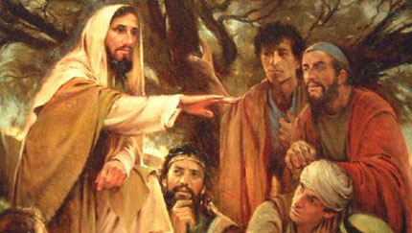________________________________________________________________________________________________________________________________________________________

**VI Bonus question - Complete:**

The New Testament was first written in Greek, and the word repent comes from a Greek word meaning “to turn around”, or change your mind. So r_____________ does not mean simply being sorry for your sins!

Repentance means changing your m______________ about how you’re going to live. You used to live for yourself. Now you’ll live for J________________.

