**C:\Documents and Settings\suzy\Local Settings\Temporary Internet Files\Content.IE5\3JXW24R5\MC900383922[1].wmfBible study 2 - 2013**

Name:_______________Class:________________

Introduction to

The Gospel of Mark

I Chose a correct word for each blank from the boxes:

1 WRITER: The writer was ________, a relative of B______________, Mark traveled with Barnabas and Paul. He also worked closely with ___________. The reference to "a young _____________" in Mark 14:51, 52 may refer to Mark.

**Peter man Mark Barnabas**

2 TITLE: Saint Mark wrote this Gospel probably to readers who were R_________. They were more interested in what ______________ DID than in fulfilled prophecies. And so Mark's Gospel is a book of _____________, it tells what Jesus DID in His ministry. It is a short Gospel, in which the events move very quickly. Mark sees Jesus as "the _____________”.

**Jesus Servant Romans action**

LOCATION & Main People:

II **True/False**

1. **Mark is the second of the four Gospels and the second book of the New Testament. True/False**
2. **The main people are Jesus and Saint Mary. True/False**

KEY VERSE:

III Copy and Learn by heart: (Mark 10:45).

____________________________________________________________________________________________________________________________________________________________________________________________________________________________________________________________________________________

OUTLINE:

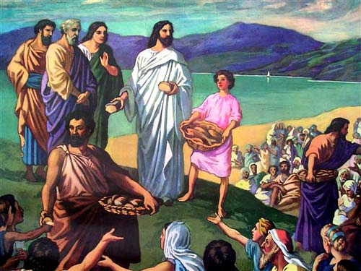IV Complete

□ Jesus, the Servant: Serving ____________

(Mark 1—10)

* His family
* The altar
* people

□ Jesus, the Servant: Giving His ________________ to save others

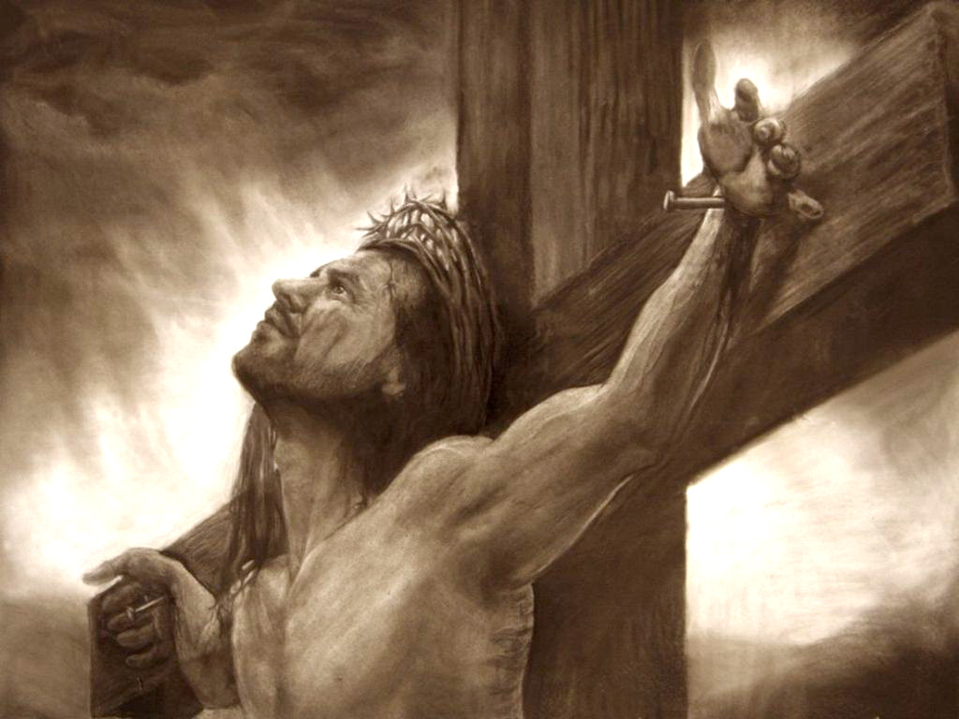(Mark 11 — 16)

* His money
* life
* land

**V Bonus question:**

How many chapters are there in the Gospel of Mark?! _____________________