**C:\Documents and Settings\suzy\Local Settings\Temporary Internet Files\Content.IE5\3JXW24R5\MC900383922[1].wmfBible study 18 – 2013**

Chapter Sixteen – the Last Chapter!

The Gospel of Mark

Learn the Key Words

|  |  |  |  |  |  |
| --- | --- | --- | --- | --- | --- |
| **alarmed** |  | **worried** | **accompanying** |  | **additional** |
| **mourned** |  | **expressed sadness** | **confirming** |  | **proving** |

Name:_______________Class:________________

I Choose the correct answer:

1. “12After that, He appeared in another form to two of them as they walked and went into the country. 13And they went and told *it* to the rest, *but* they did not believe them either.” Those two people were: a.John and Peter

b. Phillip and Andrew

c. The Emmaus disciples

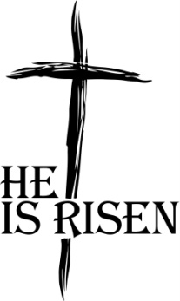2. Later He appeared to the eleven as they sat at the table; and He rebuked their unbelief and hardness of heart, because they:

a. did not believe those who had seen Him after He had risen.

b. did not visit His tomb.

c. did not pray enough.

3. And He said to them, “Go into all the world and: a. perform miracles first,

b. preach the gospel to every creature.

c. tell them about politics.

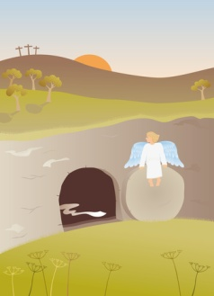II Answer the questions.

A “And entering the tomb, they saw a young man clothed in a long white robe sitting on the right side; and they were alarmed.” What did the man say to Mary Magdalene, Mary *the mother* of James, and Salome who bought spices, that they might come and anoint Him? _______________________________________________________________________________________________________________________________________________________________________________________

B Complete the verse and mention the reference for it.

And they went out and _______________ everywhere, the Lord working with *them* and ________________________ the word through the _________________signs. Amen

(Mark____:_____)

KEY VERSE:

III Write the Key Verse of the Gospel of Mark:

_______________________________________________________________________________________________________________________________________________________________________________________________________________

MEMORY VERSE:

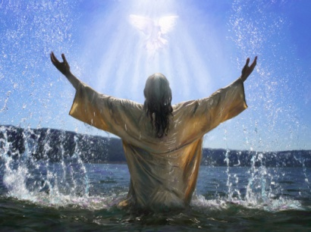IV Copy and Learn by heart: (Mark 16:16).

_______________________________________________________________________________________________________________________________