**C:\Documents and Settings\suzy\Local Settings\Temporary Internet Files\Content.IE5\3JXW24R5\MC900383922[1].wmfBible study 17 – 2013**

Name:_______________Class:________________

Chapter Fifteen

The Gospel of Mark

The beginning of the Passion

Learn the Key Words

|  |  |  |  |  |  |  |  |  |
| --- | --- | --- | --- | --- | --- | --- | --- | --- |
| consultation |  | **meeting** | scourged |  | **whipped** | Transgressors |  | **crimes’ doers** |
| bound |  | **forced** | Garrison |  | **defense force** | Wagging |  | **moving from side to side** |
| marveled |  | **was impressed** | Compelled |  | **forced** | forsaken |  | **isolated** |
| rebellion |  | **uprising** | mingled |  | **mixed** | reed |  | **a stalk of a long plant** |
| Envy |  | **jealousy** | garments |  | **clothes** | summoning |  | **Call somebody into court** |
| gratify |  | **please** | determine |  | **find out** | hewn out |  | **cut down** |

KEY VERSE:

I Write the Key verse and mention the reference: (Mark_____:_____)

________________________________________________________________________________________________________________________________________________________________________________________

MEMORY VERSE:

II Copy and Learn by heart (Mark 15:28). ________________________________________________________________________________________________________________________________________________________________________________________

**III Fill in the spaces:**

1. But Pilate answered them, saying, “Do you want me to release to you the King of the Jews? **Mark 15:_____**
2. Then Pilate said to them, “Why, what evil has He done?” But they cried out all the more, “Crucify Him!” **Mark 15:_____**
3. Then they struck Him on the head with a reed and spat on Him; and bowing the knee, they worshiped Him. And when they had mocked Him, they took the purple off Him, put His own clothes on Him, and led Him out to crucify Him. Then they struck Him on the head with a reed and spat on Him; and bowing the knee, they worshiped Him. And when they had mocked Him, they took the purple off Him, put His own clothes on Him, and led Him out to crucify Him. **Mark 15:_____ & ______**

**IV The Centurion is a Hero of Faith – Refer to Chapter 15 and Complete the Following.**

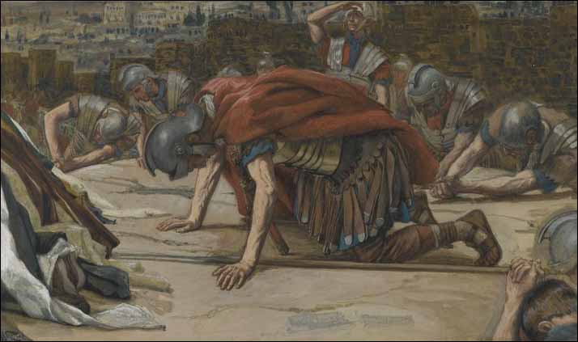37And Jesus cried out with a _________ voice, and breathed His ___________.

38Then the veil of the temple was ______ in two from top to bottom. 39So when the __________, who stood opposite Him, saw that He cried out like this and breathed His last,he said, “__________ this Man was the _________ of _________!”

40There were also women looking on from afar, among whom were Mary ________, Mary the mother of James the Less and of Joses, and ______________, 41who also followed Him and ministered to Him when He was in ______________, and many other women who came up with Him to Jerusalem.42Now when __________ had come, because it was the _______________ Day, that is, the day before the ___________, 43____________ of Arimathea, a prominent council __________, who was himself waiting for the ______________ of God, coming and taking courage, went in to _________and asked for the body of ____________. 44Pilate marveled that __________ was already dead; and summoning the ____________, he asked him if He had been dead for some time. 45So when he found out from the centurion, he ________________ the body to ______________.

**V Cut the pictures and Paste each according to the order above.**

