**C:\Documents and Settings\suzy\Local Settings\Temporary Internet Files\Content.IE5\3JXW24R5\MC900383922[1].wmfBible study 16 – 2013**

Name:_______________Class:________________

Chapter Fourteen

The Gospel of Mark

The beginning of the Passion

Learn the Key Words

|  |  |  |  |  |  |  |  |  |
| --- | --- | --- | --- | --- | --- | --- | --- | --- |
| Plot |  | Conspiracy | criticized |  | disapproved | covenant |  | promise |
| uproar |  | argument | woe to |  | misery to | exceedingly |  | very |
| alabaster flask |  | a container made of white alabaster stone | burial |  | funeral | lest |  | in case |
| spikenard |  | an ancient oil perfume | sought |  | wanted | Sanhedrin |  | Jewish Court |
| indignant |  | angry | conveniently |  | suitably | porch |  | veranda |

KEY VERSE: Halleluiah

I Write the Key verse:

________________________________________________________________________________________________________________________________________________________________________________________

MEMORY VERSE:

II Copy and Learn by heart: (Mark 14:24). ________________________________________________________________________________________________________________________________________________________________________________________

**III True or False**

1. The chief priests and the scribes wanted to trick Jesus and put *Him* to death. But they said, “Not during *the Feast* of Unleavened Bread, in case there is an argument of the people. **True/False**
2. Jesus said: She has done what she could. She has come beforehand to anoint My body for burial. Assuredly, I say to you, wherever this gospel is preached in the whole world, what this woman has done will also be told as a memorial to her.” **True/False**
3. In Old Testament times, kings were anointed as a sign that they had been chosen by God and had a unique relationship with him.  The word 'Messiah' means 'anointed one'. **True/False**
4. Judas Iscariot refused to betray the Lord and went and told Him about the Jew’s conspiracy. **True/False**
5. When Jesus celebrated the Passover with His disciples that was the first Holy Communion. **True/False**
6. When Jesus went to pray in Gethsemane, He was very happy and took with Him Peter, Phillip and Matthew. **True/False**
7. Jesus warned Peter that he would deny Him three times before the rooster crows twice. **True/False**

**IV Peter Denies Jesus, and Weeps. Choose the correct word/phrase.**

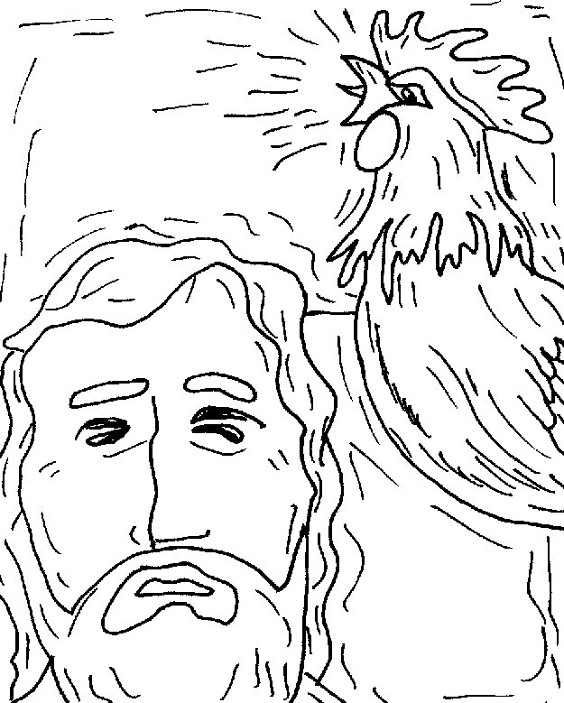66Now as Peter was below in **[Gethsemane / the courtyard]**, one of the servant girls of **[Herod / the high priest]** came. 67And when she saw Peter warming himself, she looked at him and said, “You also were with **[Jesus of Nazareth / Judas Iscariot]**.” 68But he denied it, saying, “I neither know nor understand what you are saying.” And he went out on the porch, and a rooster crowed. 69And the servant girl saw him again, and began to say to those who stood by, “This is *one* of them.” 70But he **[confirmed it / denied it]** again. And a little later those who stood by said to Peter again, “Surely you are *one* of them; for you are a **[Samaritan /Galilean]**, and your speech shows *it.*”[[g](http://www.biblegateway.com/passage/?search=Mark+14&version=NKJV#fen-NKJV-24825g)] 71Then he began to **[curse and swear / sing and praise]**, “I do not know this Man of whom you speak!” 72A second time *the* rooster crowed. Then Peter called to mind the word that **[John /Jesus]** had said to him, “Before the rooster crows **[three times / twice]**, you will deny Me **[twice /three times]**.” And when he thought about it, he **[was happy / wept]**. **Colour in the picture**

**(2 points Bonus)**

**V Cut the pictures and Paste each according to the order above.**

