**C:\Documents and Settings\suzy\Local Settings\Temporary Internet Files\Content.IE5\3JXW24R5\MC900383922[1].wmfBible study 15 – 2013**

Chapter Thirteen

The Gospel of Mark

Learn the Key Words

|  |  |  |  |  |  |
| --- | --- | --- | --- | --- | --- |
| **Deliver** |  | **bring** | **endures** |  | **tolerates suffering** |
| **councils** |  | **church assembly** | **abomination of desolation** |  | **horrible sadness** |
| **beforehand** |  | **in advance** | **flee** |  | **escape** |
| **premeditate** |  | **think carefully** | **woe to** |  | **misery to** |

Name:_______________Class:________________

I Chose the correct answer:

1. The beginnings of sorrows are:

**a.** famines and wars

b. earthquakes in various places

c. nation will rise against nation, and kingdom against kingdom

d. All of the above

2. And unless the Lord had shortened those days, no flesh would be ___________; but for the elect’s sake, whom He chose, He shortened the days.

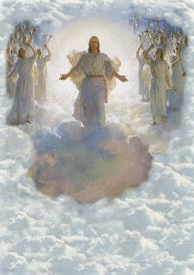a. found b. dead c. saved

3. Then they will see the Son of Man coming:

a. in the clouds with great power and glory.

b. And then He will send His angels,

c. and gather together His elect from the four winds, from the farthest part of earth to the farthest part of heaven.

d. All of the above

II Think with us!!!!?

1. The prophet who wrote about **abomination of desolation** was ***(Moses / Daniel)****.*
2. 21“Then if anyone says to you, ‘Look, here *is* the Christ!’ or, ‘Look, *He is* there!’ ***(believe it / do not believe it).***
3. 24“But in those days, after that **(tribulation / celebration)**, the sun will be ***(shining / darkened),*** and the moon ***(will not / will)*** give its light; 25the stars of heaven ***(will not / will)*** fall, and the powers in the heavens ***(will be / will not be)*** shaken.
4. 32“But of that day and hour no one knows, not even the angels in heaven, nor ***(the Holy Spirit / the Son)***, but only ***(the Father / the Son).*** 33Take heed, watch and pray; for you ***(do / do not)*** know when the time is.

KEY VERSE:

III Copy and Learn by heart: (Mark 10:45).

_______________________________________________________________________________________________________________________________________________________________________________________________________________

MEMORY VERSE:

IV Copy and Learn by heart: (Mark 13:31).

