**C:\Documents and Settings\suzy\Local Settings\Temporary Internet Files\Content.IE5\3JXW24R5\MC900383922[1].wmf Bible study 12 - 2013**

Name:_______________Class:________________

Chapter Ten

The Gospel of Mark

Learn the Key Words

|  |  |
| --- | --- |
| **Precept** | **rule** |
| **commits adultery** | **Unfaithful to a wife/husband** |
| **inherit eternal life** | **come into eternal life** |
| **defraud** | **cheat/deceive** |
| **lack** | **don’t have** |
| **sorrowful** | **sad** |
| **Assuredly** | **surely** |
| **Persecutions** | **unfair treatment** |
| **betrayed to** | **handed to the enemy** |
| **condemn** | **convict** |
| **scourge** | **curse** |
| **Rabboni** | **Lord** |

I True or False

1. Jesus said: **Therefore what God has joined together, let not man separate.** True or False

1. He also said: Let the little children come to Me, and do not forbid them; for of such is the kingdom of God. True or False
2. The young ruler agreed to carry his cross and follow Jesus. True or False
3. But Jesus looked at them and said, “With men *it is* impossible, but not with God; for with God all things are possible.” True or False
4. Peter and John asked the Lord to grant them that they may sit, one on His right hand and the other on His left, in His glory. True or False
5. Jesus taught that a truly great person is one who serves others. True or False

II Where did it happen?

1 Jesus healed blind Bartimaeus in **(Jerusalem/Jericho).**

2 Jesus a third time predicted His Death and Resurrection in **(Jerusalem/Jericho).**

3 (**In the house His disciples/on the Mountain of Olives)** also asked Him again about the same *matter.* 11So He said to them, “Whoever divorces his wife and marries another commits adultery against her. 12And if a woman divorces her husband and marries another, she commits adultery.”

KEY VERSE:

III Copy and Learn by heart: (Mark 10:45).

_______________________________________________________________________________________________________________________________________________________________________________________________________________

MEMORY VERSE:

IV Copy and Learn by heart: (Mark10:43).

_______________________________________________________________________________________________________________________________________________________________________________________________________________

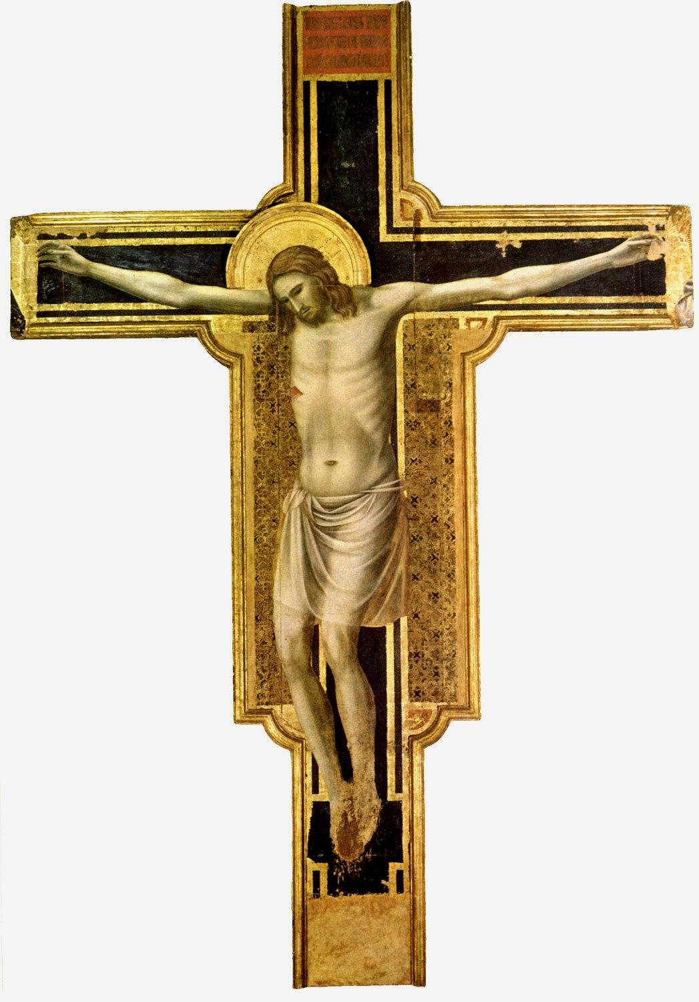V Complete:

If Jesus Christ followed **this pattern of humbleness** in accomplishing the great work of salvation, then surely there is no other pattern for us to **f______w.**