**C:\Documents and Settings\suzy\Local Settings\Temporary Internet Files\Content.IE5\3JXW24R5\MC900383922[1].wmfBible study 10 – 2013**

Chapter Eight

The Gospel of Mark

|  |  |  |
| --- | --- | --- |
| **Take heed** |  | **Be careful** |
| **leaven** |  | **yeast** |
| **perceive** |  | **recognize** |
| **Fragments** |  | **remains** |
| **rebuke** |  | **scold** |

Learn the Key Words

Name:_______________Class:________________

Big Sale

7 points for

Handing the Bible Study in Time!!!!

WOW!!!!!!!

I Chose the correct answer:

1. Jesus called His disciples *to Him* and said to them, 2“I have compassion on the multitude, because they have now continued with Me _______ days and have nothing to eat.

* 1. 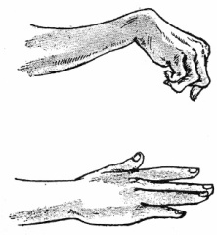**three b. five c. seven**

2. 12But He sighed deeply in His spirit, and said,

1. **Why do I bother to teach them?**
2. **Why does this generation seek a sign?**
3. **Why are they here?**

3. 15Then He charged them, saying, “**Take heed**, beware of the **leaven** of the Pharisees and the leaven of Herod.” 16And they reasoned among themselves, saying,

1. *It is* because we have no bread.
2. He does not want to make a sign today
3. neither of the above

4. 25Then He put *His* hands on his eyes again and made him look up. And he was

1. Still blind b. restored

c. dead

II Think with us!!!!?

1. The religious leaders of Jesus’ day thought that they were so good that they did not need **(the grace of God / the law)** to save them. As far as they were concerned, as long as they kept to their rituals and ceremonies,
2. Jesus Predicts His Death and **(appearance / Resurrection)** in Mark 8: 26- 33
3. Jesus rebuked Peter when he was unintentionally interfering with Jesus' plan to save mankind. Peter was not looking at things from God's mind, but from a **(Satan /human)** basis.
4. In the Bible, "leaven" is used both literally (the yeast that makes bread rise) and figuratively (a relatively small force or amount that makes a major impact). As used by Jesus in Mark 8:15, "leaven" refers to a **(corrupting influence / good influence).**
5. 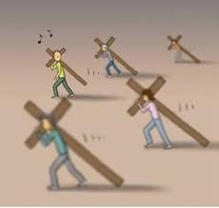He said to them, “Whoever desires to come after Me, let him deny himself, and take up his **(bag / cross)**, and follow Me. 35For whoever desires to save his life will lose it, but whoever loses his life for My sake and the gospel’s will **(save / lose)** it.

KEY VERSE:

III Copy and Learn by heart: (Mark 10:45).

_______________________________________________________________________________________________________________________________________________________________________________________________________________

****MEMORY VERSE:

IV Copy and Learn by heart: (Mark 8:36).

_________________________________________________________________________________________________________________________________________________________________________________________________