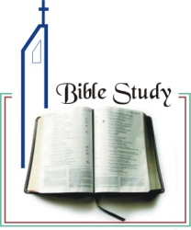
Bible study 1 - 2013
Name:_______________Class:________________
Why Should We Read and
Study the Holy Bible?
1 Read and complete 2 Timothy 3: 16-17
¹⁶ All ____________ is given by inspiration of _________, and is profitable for doctrine, for reproof, for correction, for instruction in ____________, ¹⁷ that the ______________ of God may be ______________, thoroughly equipped for every _________________ work.
2 There are so many questions that philosophers have asked that God answers for us in Scripture. One of them is:
__________________________________________________________________________________________________________________________________________
3 How would you answer the question?
__________________________________________________________________________________________________________________________________________
4 Complete with the correct word.
We should read and study the Bible because it is totally ____________ and without error. The Bible is _______________ among so-called "holy" books in that it does not merely give moral teaching and say, "__________________."
First blank is: a. straight b. reliable c. wise
Second blank is: a. unique b. solid c. fine
Third blank is: a. Be good b. Trust me c. Obey me

