C:\Documents and Settings\suzy\Local Settings\Temporary Internet Files\Content.IE5\3JXW24R5\MC900383922[1].wmfSunday 11th February, 2018

Finish Date: Saturday 17th February, 2018

Name:

Class:

Completed Bible Study = 15 points

Email Homework by the due date = 5 points

**Year 4 Bible Study Jonah 2**

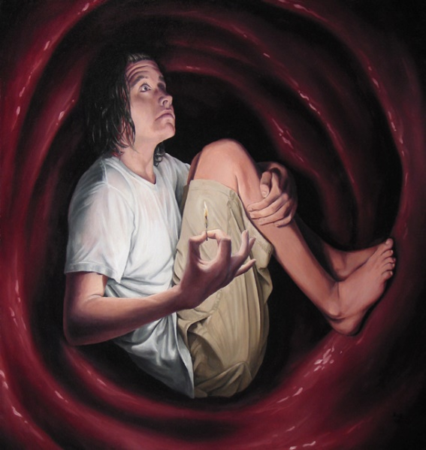

* **Monday: Read Jonah 2:1-3**

***2****Then Jonah prayed to the Lord his God from the fish’s belly.****2****And he said:*

*“I cried out to the Lord because of my affliction,  
And He answered me.*

*“Out of the belly of Sheol I cried,  
And You heard my voice.****3****For You cast me into the deep,  
Into the heart of the seas,  
And the floods surrounded me;  
All Your billows and Your waves passed over me.*

Question 1. Who does Jonah say in v3 cast him into the deep?_________________________

Question 2a. Write Psalm 42:7 _______________________________________________________________________________________________________________________________________________________________________________________________________________________________________________________________________________________________________________________

Question 2b. Which verse in Jonah chapter 2 matches Psalm 42:7? __________________________

So, we can see in Jonah’s case, he had learned by memory this Psalm. When he was in trouble, he called on this Psalm. Can you recall any of the Psalm’s we learned two weeks ago? It is a great comfort to have memorised the Psalm’s to use whenever we are in need. Try to aim to learn the Psalms that will be coming up after two weeks.

* **Tuesday: Read Jonah 2:4-5**

***4****Then I said, ‘I have been cast out of Your sight;  
Yet I will look again toward Your holy temple.’****5****The waters surrounded me, even to my soul;  
The deep closed around me;  
Weeds were wrapped around my head.*

Question 3.a Write down Psalm 69:1 ____________________________________________________________________________________________________________________________________________________________

Question 3b. Which verse in Jonah Chapter 2 is similar to this?___________________

Question 3c. What circumstance made Jonah pray?_____________________________

Sometimes, we the people of God are stuck in a situation, so that we may learn not to trust in ourselves, but in our powerful God that raises the dead.

* **Wednesday: Read Jonah 2:6-7**

***6****I went down to the moorings of the mountains;  
The earth with its bars closed behind me forever;  
Yet You have brought up my life from the pit,  
O Lord, my God.*

***7****“When my soul fainted within me,  
I remembered the Lord;  
And my prayer went up to You,  
Into Your holy temple.*

Question 4a: Quote two lines from above that shows Jonah was sinking into despair:_______________________________________________________________________________________________________________________________________________________________________________________________________

Question 4b: Quote two lines from above that shows Jonah’s faith, which controlled his fear and despair: _______________________________________________________________________________________________________________________________________________________________________________________________________

Notice, If we have faith that the Lord is our God, he will save us from any despair.

* **Thurdsay: Read Jonah 2:8**

***8****“Those who regard worthless idols  
Forsake their own Mercy.*

Question 5a Who in the boat worshiped other gods?________________________________

Question 5b. What does Jonah say will happen to people that worship worthless idols? ______________________________________________________________________________

* **Friday: Read Jonah 2:9**

***9****But I will sacrifice to You  
With the voice of thanksgiving;  
I will pay what I have vowed.  
Salvation is of the Lord.”*

Question 6a. What does Jonah say he will do, now that he is thankful? __________________________________________________________________________________________________________________________________________________________________________________________________________________

Question 6b. Gratitude is here expressed by a sacrifice. Can you think of how you can show God you’re thankful to Him? __________________________________________________________________________________________________________________________________________________________________________________________________________________

Question 6c. Who does Jonah say Salvation comes from?________________________________

Notice, we can truly depend and trust on God to save us. We can see in all ages God is the God that saves those that belong to Him.

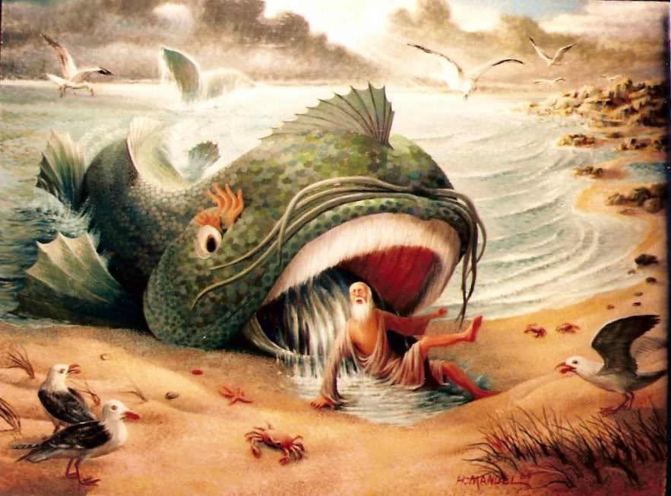

* **Saturday: Read Jonah 2:10**

***10****So the Lord spoke to the fish, and it vomited Jonah onto dry land.*

Question 7. How does this verse show that God has power over all the creatures? __________________________________________________________________________________________________________________________________________________________________________________________________________________

Question 8. True or False

1. God caused these events to happen to humble Jonah, causing Jonah to pray and be ready to listen to God’s command. ____________________________________
2. God was merciful to Jonah by sending the whale, protecting Jonah inside it, and commanding the whale to vomit Jonah out_____________________________
3. Jonah here is a figure of Christ’s resurrection. Christ died and was buried, layed in the grave, as Jonah did, three days and three nights, a prisoner for our debt; but the third day he came forth, as Jonah did, by his messengers to preach repentance, and remission of sins,._____________________________________________

**What to do when you finish your Bible Study.**

**Send it by email to your class email address or print and hand it to your servants next Sunday.**

* **Year 4A St Makarious StMakarios4A@gmail.com**
* **Year 4B St Bakhomious StBakhomios4B@gmail.com**
* **Year 4C St Anthony StAnthony4C@gmail.com**