C:\Documents and Settings\suzy\Local Settings\Temporary Internet Files\Content.IE5\3JXW24R5\MC900383922[1].wmfSunday 4th February 2018

Finish Date: Saturday 10th February, 2018

Name:

Class:

Completed Bible Study = 15 points

Email Homework by the due date = 5 points

**Year 4 Bible Study Jonah 1**

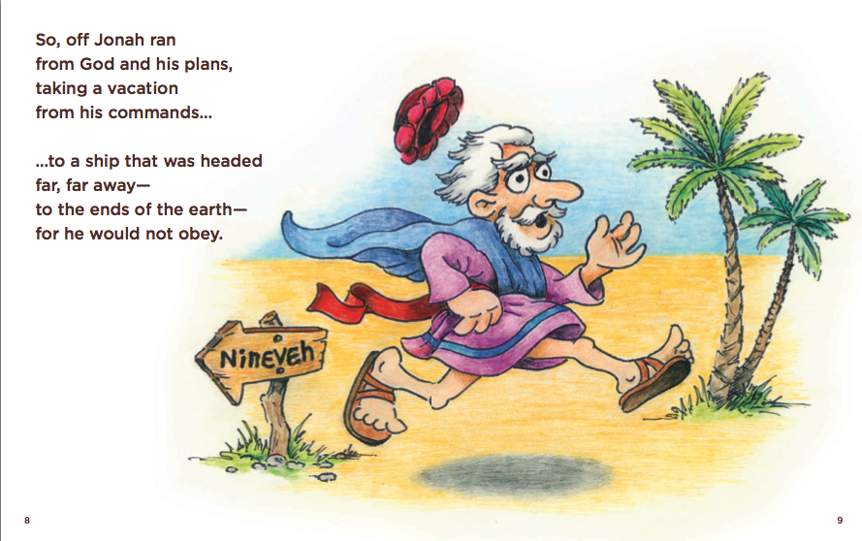

* **Monday: Read Jonah 1:1-2**

***Jonah’s Disobedience***

***1 Now the word of the Lord came to Jonah the son of Amittai, saying, 2“Arise, go to Nineveh, that great city, and cry out against it; for their wickedness has come up before Me.”***

Nineveh was at this time the metropolis of the Assyrian monarchy, *that great city*, forty-eight miles in compass, great in the number of the inhabitants, great in wealth and great in power. Nineveh was a great city but a heathen city, without the knowledge and worship of the true God.

**Question1:**

What was God’s request to Jonah? ____________________________________________________________________________________________________________________________________________________________

* **Tuesday: Read Jonah 1:3**

***3But Jonah arose to flee to Tarshish from the presence of the Lord. He went down to Joppa, and found a ship going to Tarshish; so he paid the fare, and went down into it, to go with them to Tarshish from the presence of the Lord.***

**Question 2:**

a.What was the name of the port where Jonah got on the ship?__________________________

b.What was the name of the town that Jonah was sailing to?____________________________

* **Wednesday: Read Jonah 1:4-6**

***The Storm at Sea***

***4But the Lord sent out a great wind on the sea, and there was a mighty tempest on the sea, so that the ship was about to be broken up.***

***5Then the mariners were afraid; and every man cried out to his god, and threw the cargo that was in the ship into the sea, to lighten the load.[***[***a***](https://www.biblegateway.com/passage/?search=Jonah+1&version=NKJV#fen-NKJV-22537a)***] But Jonah had gone down into the lowest parts of the ship, had lain down, and was fast asleep.***

***6So the captain came to him, and said to him, “What do you mean, sleeper? Arise, call on your God; perhaps your God will consider us, so that we may not perish.”***

**Question 3**

1. What did every man on the ship do when there was a mighty tempest on the sea, what was the effect of their fear?

_________________________________________________________________

( Do you notice that sometimes we do the same, and only pray when we are frightened?)

1. What was Jonah doing at this time? __________________________________

(Are we sometimes asleep to our sins against God, perhaps in a way, needing a storm to wake us up)

* **Thursday: Read Jonah 1:7-10**

***7And they said to one another, “Come, let us cast lots, that we may know for whose cause this trouble has come upon us.” So they cast lots, and the lot fell on Jonah. 8Then they said to him, “Please tell us! For whose cause is this trouble upon us? What is your occupation? And where do you come from? What is your country? And of what people are you?”***

***9So he said to them, “I am a Hebrew; and I fear the Lord, the God of heaven, who made the sea and the dry land.”***

***10Then the men were exceedingly afraid, and said to him, “Why have you done this?” For the men knew that he fled from the presence of the Lord, because he had told them.***

**Question 4:**

a.When the mariners cast lots, who did the lot fall on?

b.Who did Jonah say he believes in/ fears?

The storm is sent after Jonah, because God has work for him to do, and it is sent to fetch him back to it. Note, God has many ways of bringing to light hidden sins and making obvious that which is hidden from the eyes of all living.

* **Friday: Read Jonah 1:11-16**

***11Then they said to him, “What shall we do to you that the sea may be calm for us?”—for the sea was growing more tempestuous.***

***12And he said to them, “Pick me up and throw me into the sea; then the sea will become calm for you. For I know that this great tempest is because of me.”***

***13Nevertheless the men rowed hard to return to land, but they could not, for the sea continued to grow more tempestuous against them. 14Therefore they cried out to the Lord and said, “We pray, O Lord, please do not let us perish for this man’s life, and do not charge us with innocent blood; for You, O Lord, have done as it pleased You.” 15So they picked up Jonah and threw him into the sea, and the sea ceased from its raging. 16Then the men feared the Lord exceedingly, and offered a sacrifice to the Lord and took vows.***

**Question 5:**

a.What did Jonah tell the mariners to do to calm the sea?

b.What happened as soon as they did this?

c. What did the men do as soon as the sea ceased from raging?

* **Saturday: Read Jonah 1:17**

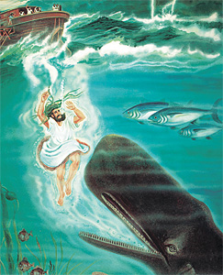

***17Now the Lord had prepared a great fish to swallow Jonah. And Jonah was in the belly of the fish three days and three nights.***

**Question 6:**

1. How did God protect Jonah?

Did you notice God has power over the creatures of the sea, to do as He wishes.

1. How many days and nights was Jonah in the whale’s belly?
2. Who else in the bible was buried three days and nights?

( hint: both were to do with repentence and forgiveness)

**What to do when you finish your Bible Study.**

**Send it by email to your class email address or print and hand it to your servants next Sunday.**

* **Year 4A St Makarious StMakarios4A@gmail.com**
* **Year 4B St Bakhomious StBakhomios4B@gmail.com**
* **Year 4C St Anthony StAnthony4C@gmail.com**